**Admin**

**Dashboard**

1) Click on “**Dashboard**” from Side Menu.

2) “**Pending Sign-off**” Contains Number of Approved Contracts.

3) Click on “**Pending Sign-off**” navigates to Approved and Pending for sign-off table.

4) “**Pending Approval**” Contains Numbers of Pending Approval Contracts.

5) Click on “**Pending Approval**” navigates to Pending Approval table.

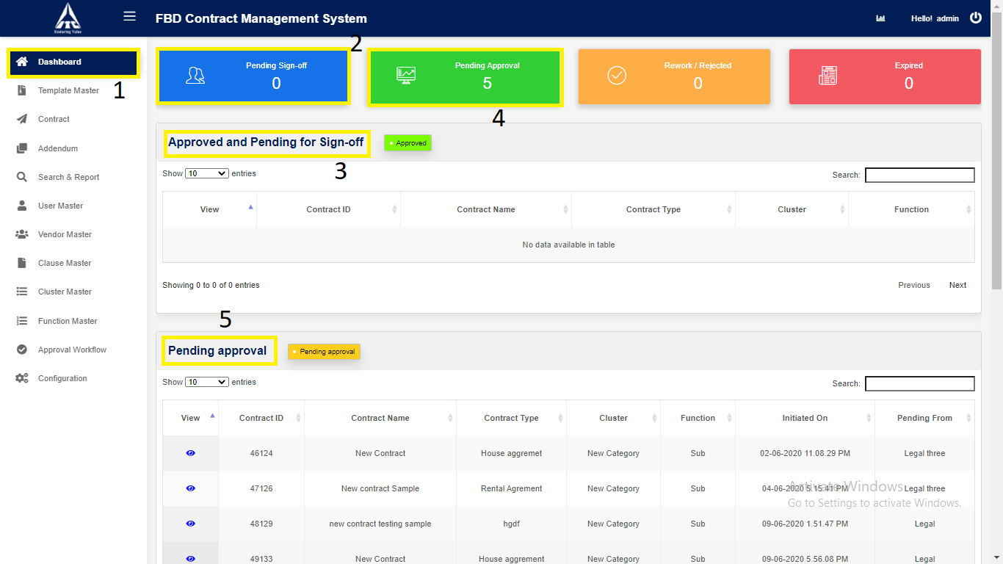

6) “**Rework/Reject**” Contains Number of Rejected or Rework Contracts.

7) Click on “**Rework/Reject**” navigates to Rejected or Rework table.

8) “**Expired**” Contains Number of Expired Contracts.

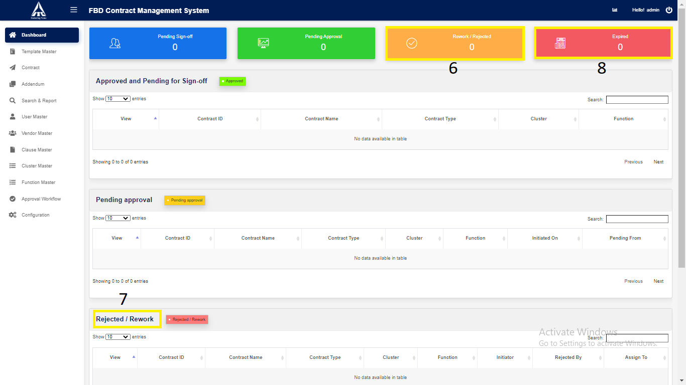

9) Click on “**Expired**” navigates to Expired table.

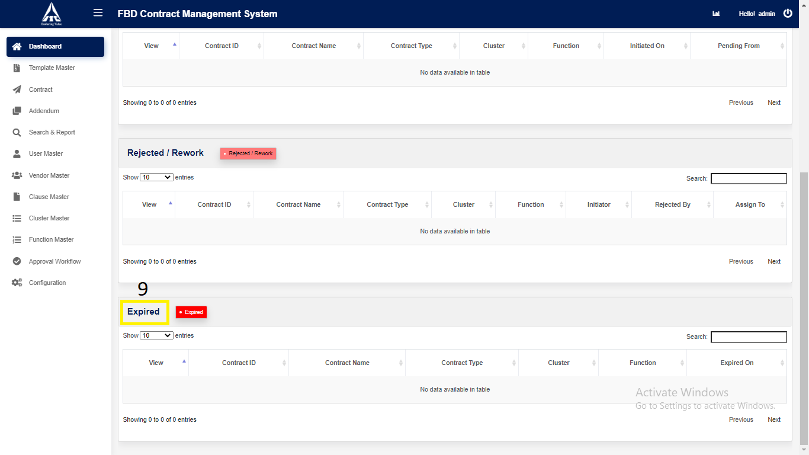

10) Click on “**Analytics**”.

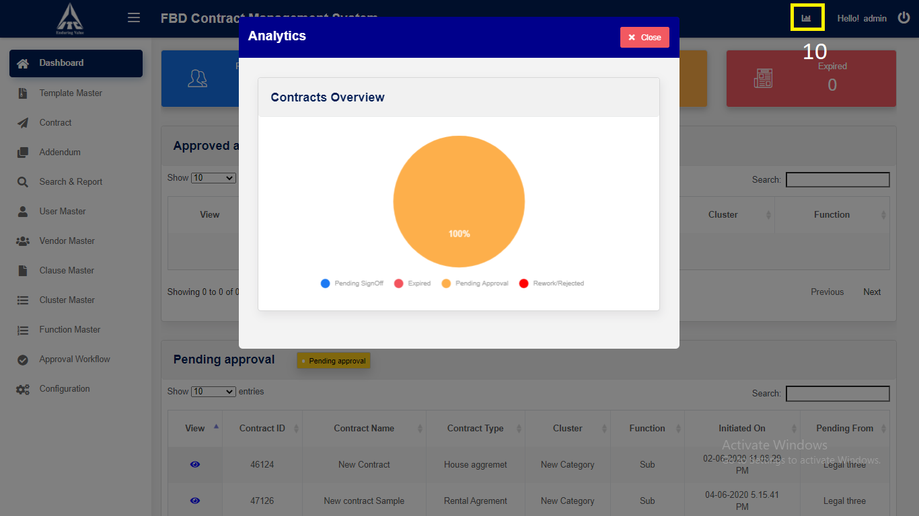

*Graphical representation*

**Template**

**1. Template Creation**

1. Click on “**Template Master**” in side menu.
2. Click on “**Create New Template**” button to **create** the new Template.

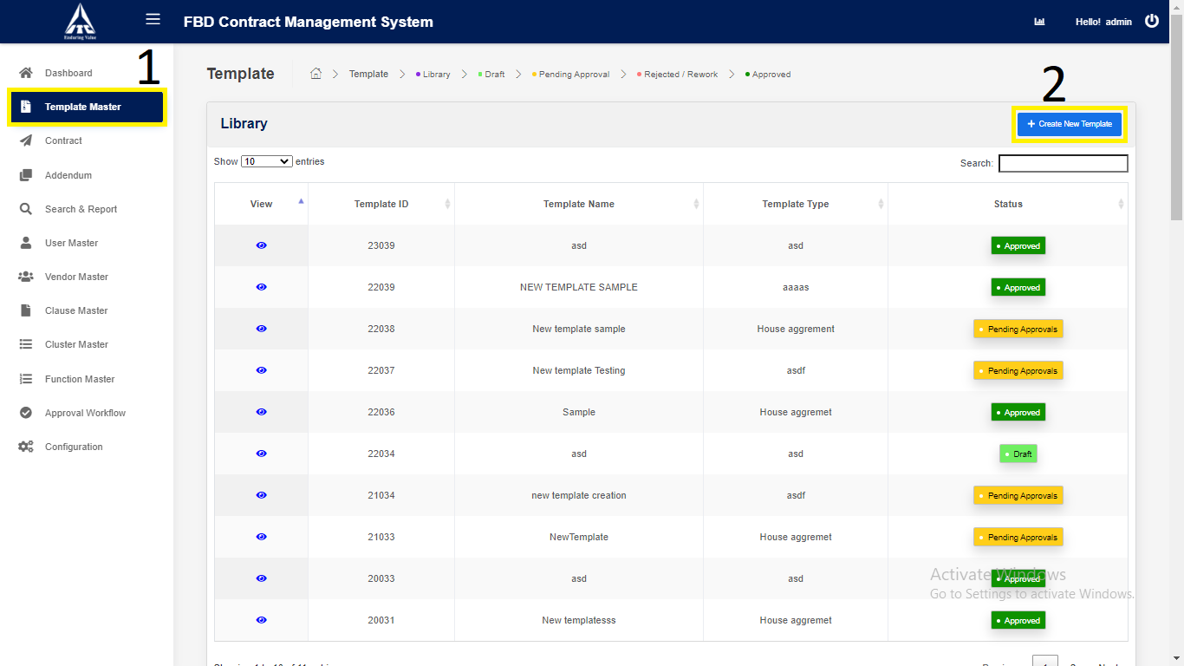

*Application will redirect to “****New Template****” page.*

1. Enter the **Template** details,
2. Enter “**Template Name**”*. (Alphabets and space only).*
3. Enter **“Type Of Contract”.**
4. Enter “**Template Description**”. (*Numbers only)*

4) Click on “**Search**”:

1. Reporting Manager **ID** (*Numbers Only*).

2. Reporting Manager **Name** (*Characters Only*).

3. Reporting Manager **Email** (*Characters Numbers and Email validation only*).

5) Click on “**Remove**”

5.1. Select the Checkbox and click on “**Remove**” Approval fields

will be removed.

6) Click on “**Save and Continue**” button to **save** the new Template.

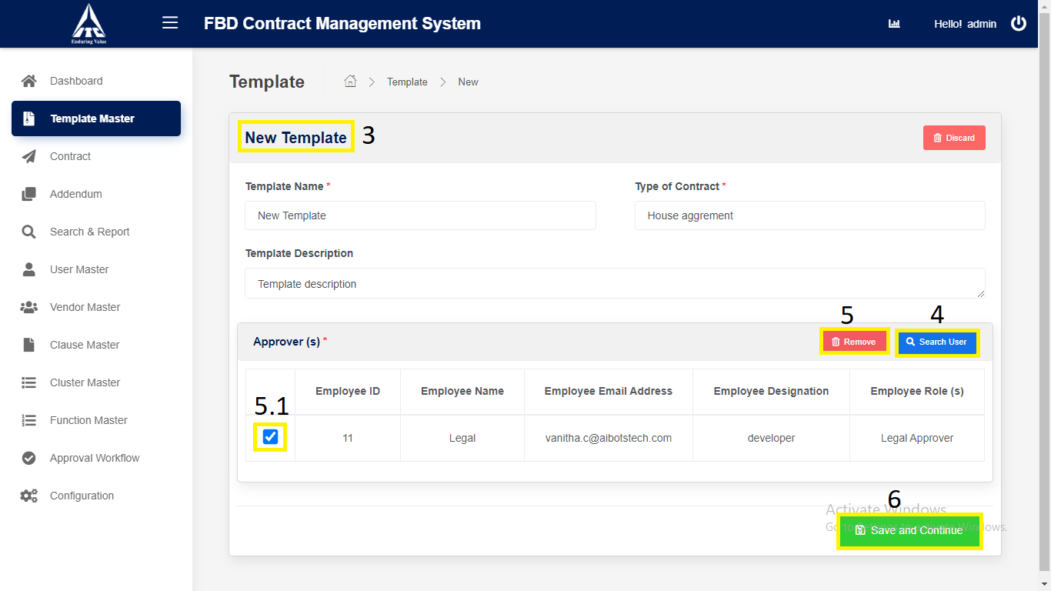

*Application will redirect to “****Template Draft****” page.*

**2. Template Initiate**

1. Click on “**Edit Content**” button to **edit** the Template.

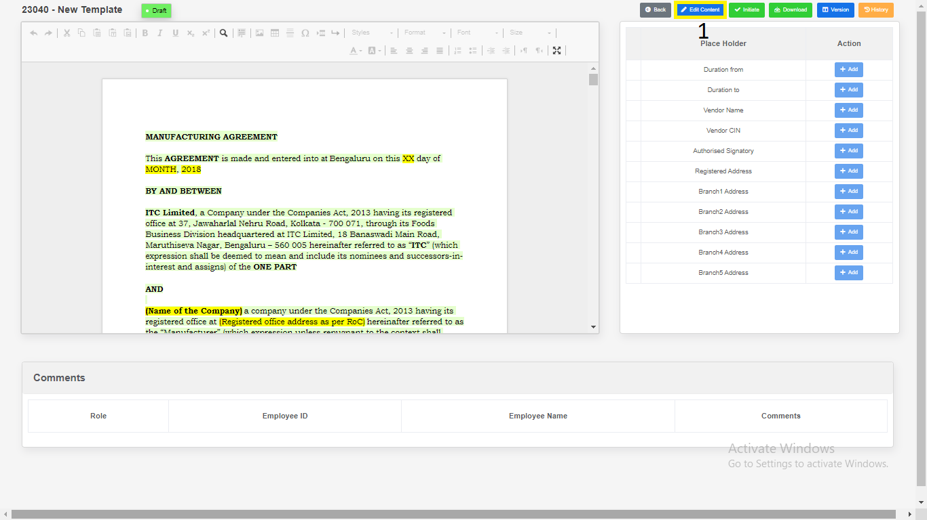

1. Click on “**Draft**” button to **draft** the Template.

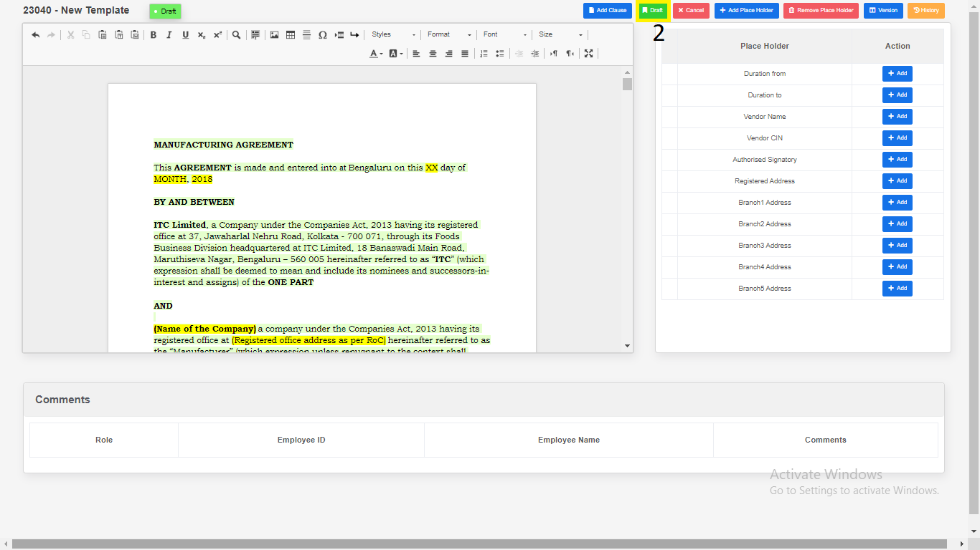

*Application will redirect to same page.*

1. Place Holders

1. Click on “**Add Place Holder**”.

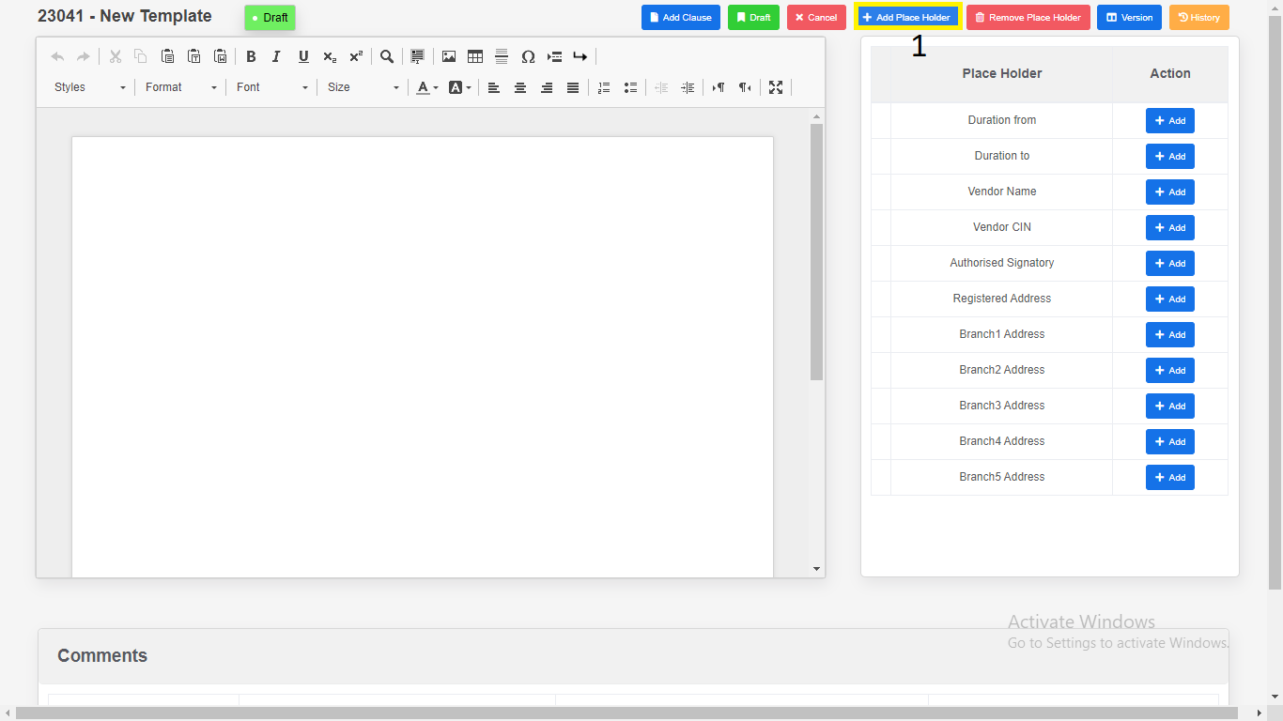

2. Enter “**Place Holder**”.

3. Click on “**Add**”. New variables will be add in place holder table.

4. Click on “**Cancel**”.

*Modal will redirect to “****Template Draft view****” page.*

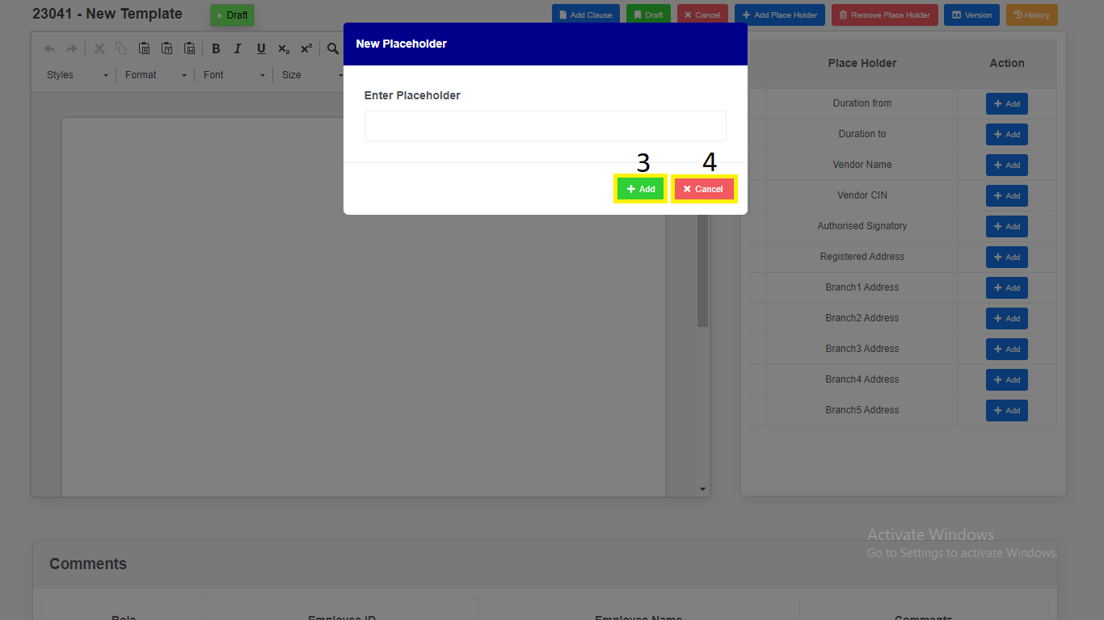

1. Remove Place Holders.
2. Select Checkbox.
3. Click on “**Remove Placeholders**” variables will be removed.

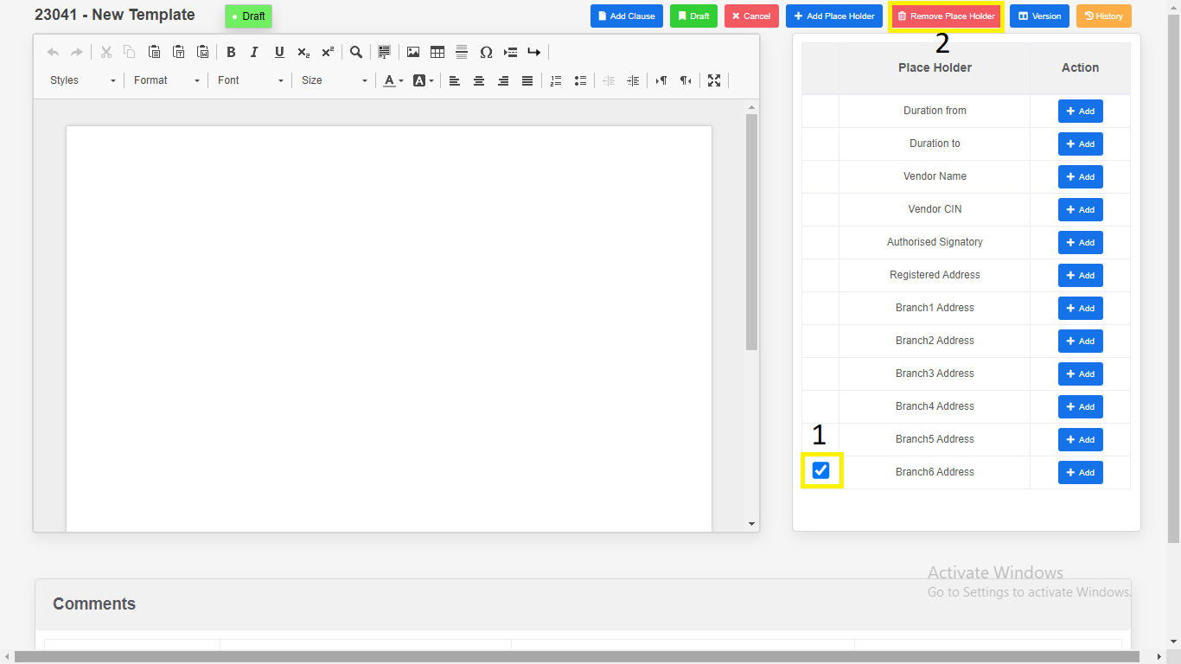

1. Click on “Add Clause”.

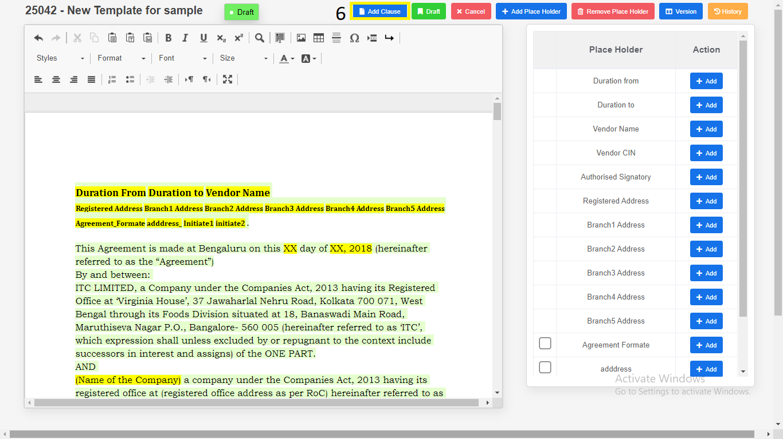

1. Click on “**Preview**” button.
2. Click on “**Select this clause**” button. Selected clause will be added to the Editor.

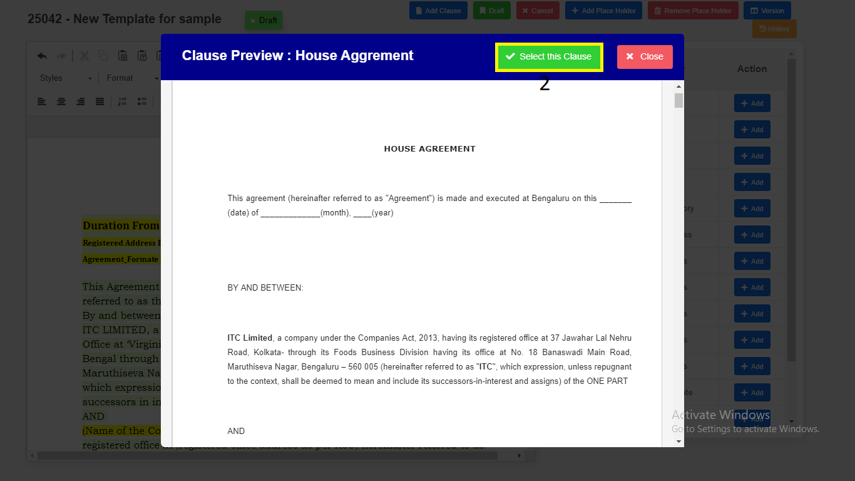

1. Click on “**Add Clause**” Selected Clause” button will be added to Editor.

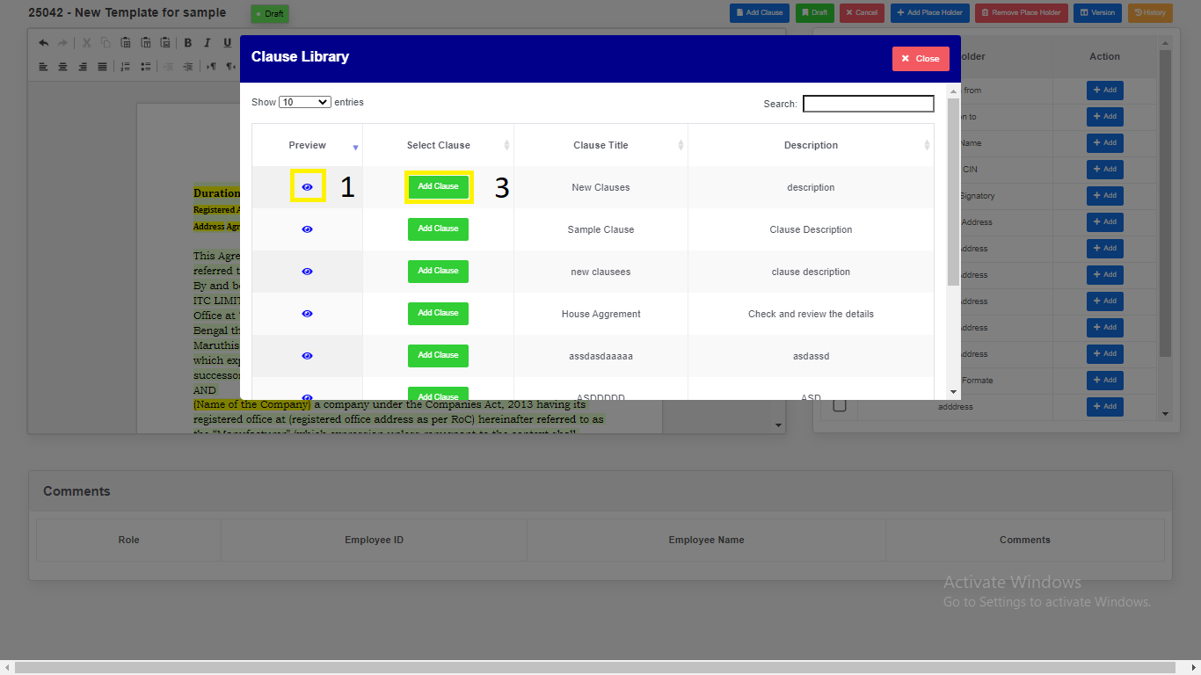

1. Click on “**Initiate**” button to **initiate** the Template.
2. Enter Comments.
3. Click on “**Yes, Initiate**” button to **initiate** the Template.

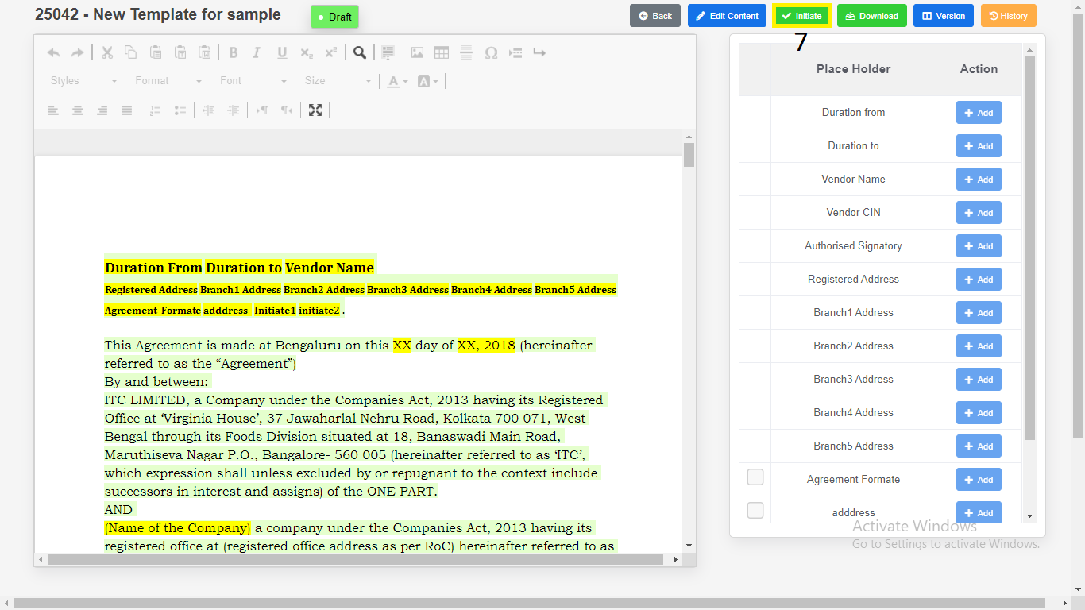

*Application will redirect to same page.*

1. Click on “Version Compare”.

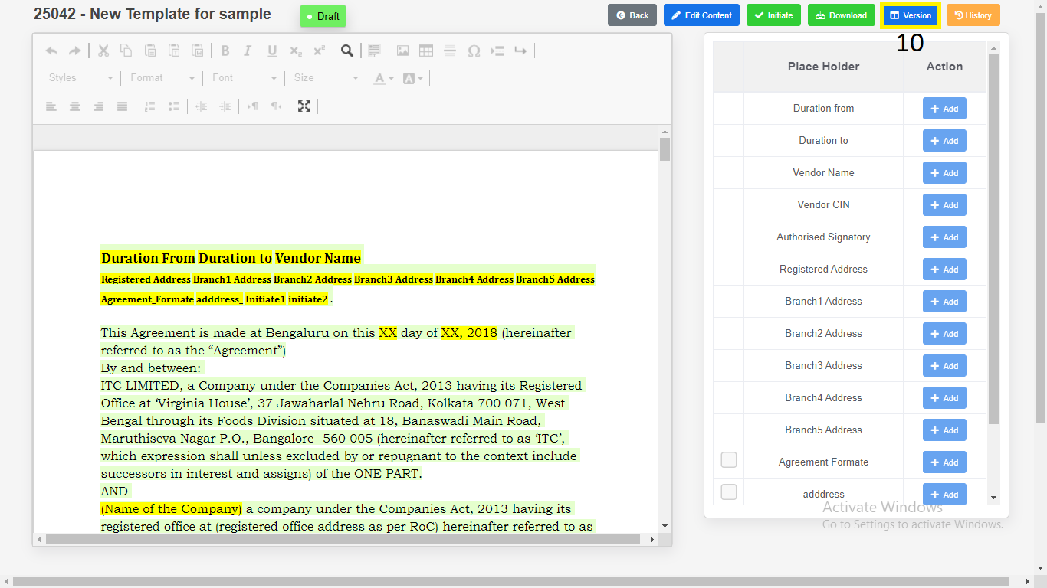

* + - 1. Select the “**Version”**.
      2. Click on “**Download**”.

2.1) Download as “**PDF**”.

2.2) Download as “**Word Document**”.

* + - 1. Click on “**Restore**”. It restores the content which version has been selected.
      2. Click on “**Close**”.

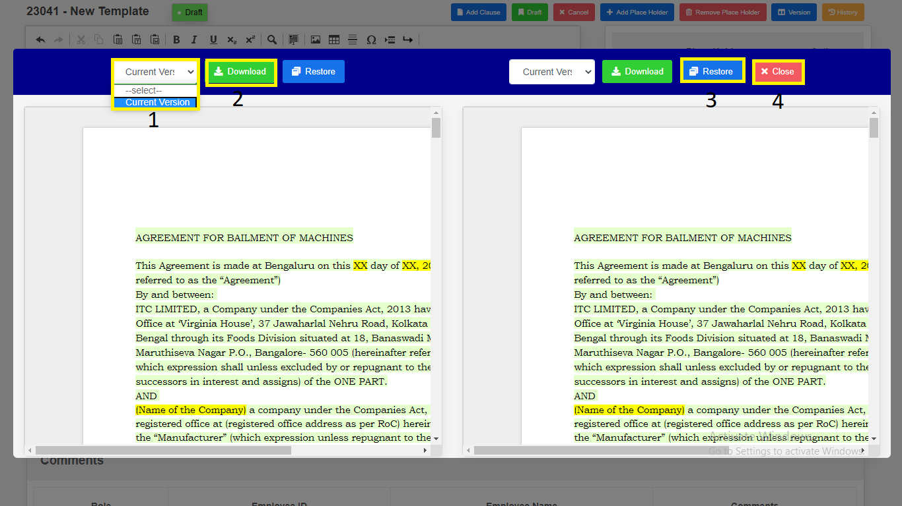

*Modal will redirect to “****Template Draft View****” Page.*

1. Click on “**Download**”.

1) Download as “**PDF**”.

2) Download as “**Word Document**”.

3) Click on “**Close**”.

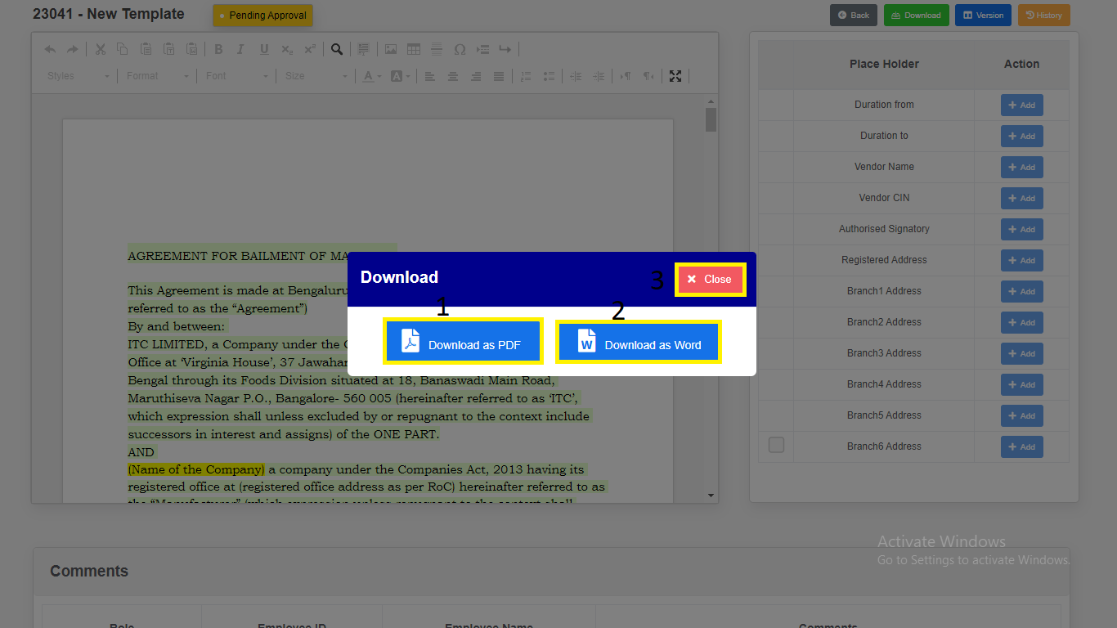

*Modal will redirect to “****Template Draft View****” Page.*

1. Click on “**History**”. Changes done in the template will be recorded in history.

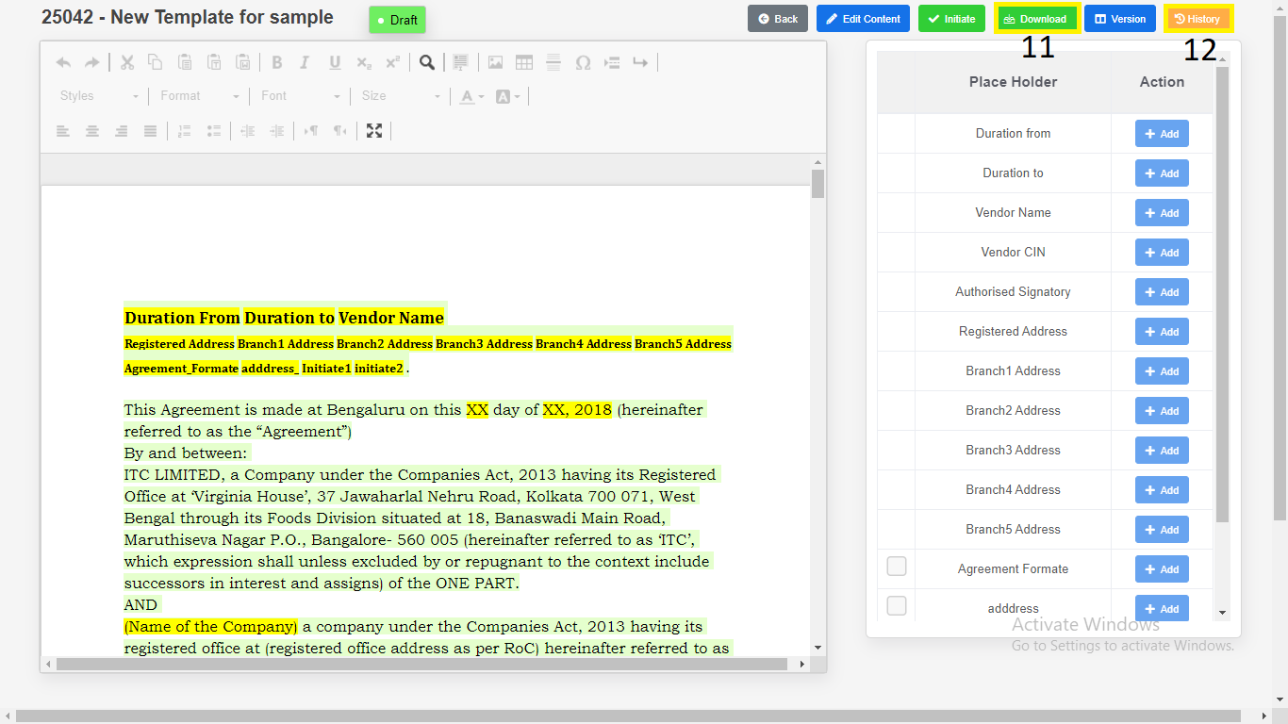

**Contract**

1. **Contract Creation**
2. Click on “**Contract**” in side menu.
3. Click on “**Create New Contract**” button to **create** new Contract

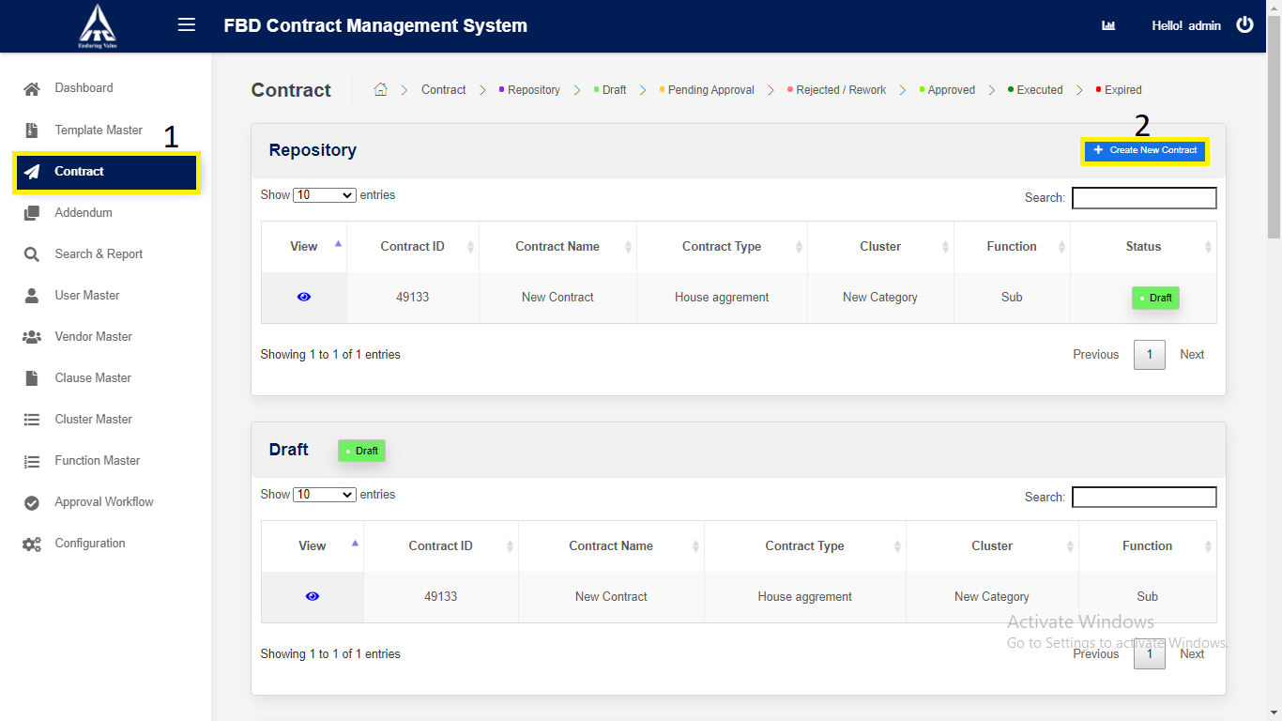

*Application will redirect to “****New Contract****” page.*

1. Enter **Contract** details,
2. Enter “**Contract Name**”. *(Alphabets and Space only).*
3. Enter “**Contract Type**”. *(Alphabets and Space only).*
4. **Approval Workflow** will auto generate based on Department and Sub Department.
5. Choose **Create Contract Using**.
6. Select **Category**.
7. Select **Sub Category**.
8. Click on “**Search**”:

1. Reporting Manager **ID** (*Numbers Only*).

2. Reporting Manager **Name** (*Characters Only*).

3. Reporting Manager **Email** (*Characters Numbers and Email validation only*).

1. Click on “**Remove**”
2. Select the Checkbox and click on “**Remove**” Approval fields will

be removed.

1. Click on “**Save and Continue**” button to **save** the new Contract.

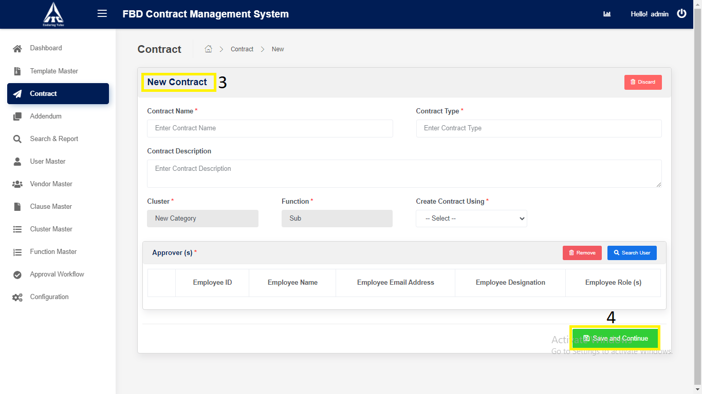

*Application will redirect to “****Contract Draft View****” page.*

1. **Contract Initiate**
2. Click on “**Edit Content**” button to **edit** the Contract.
3. Click on “**Draft**” button to **draft** the Contract.
4. Click on “**Attachments**” button to **Upload** supporting files.

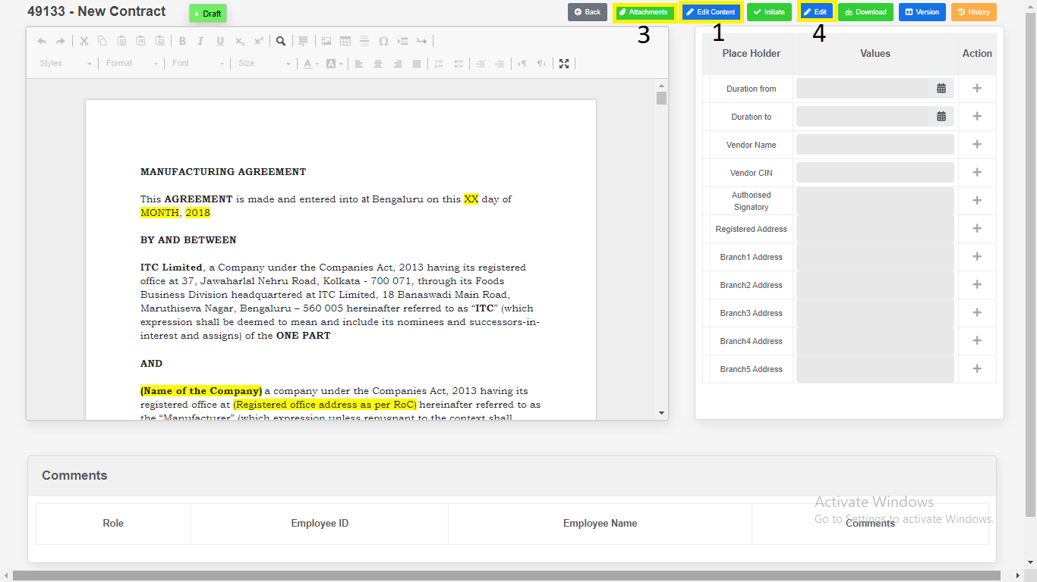

1. Click on “**Edit**” button to  **edit**  the Variables.
2. Click on “**Draft**” button to **save** the Variables.

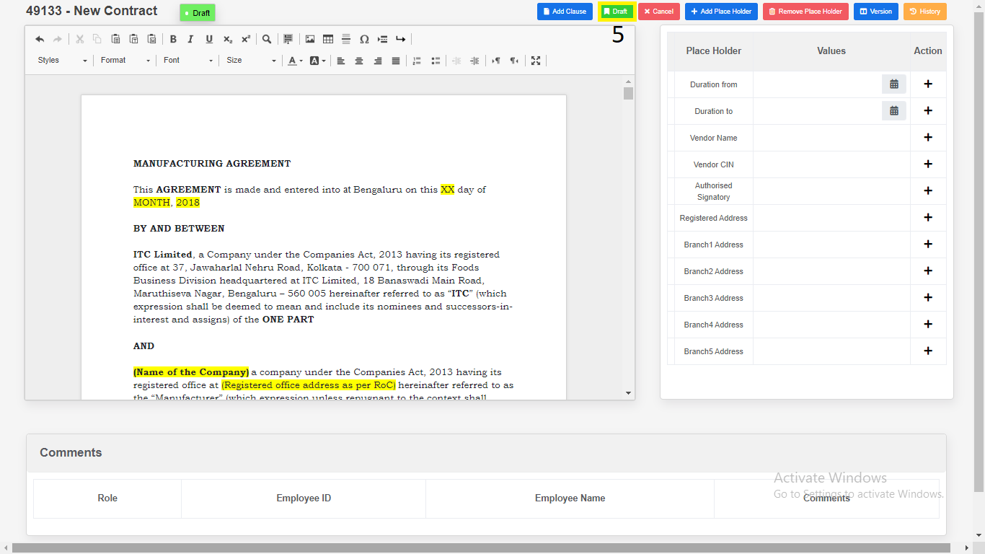

1. Place Holders

1. Click on “**Add Place Holder**”.

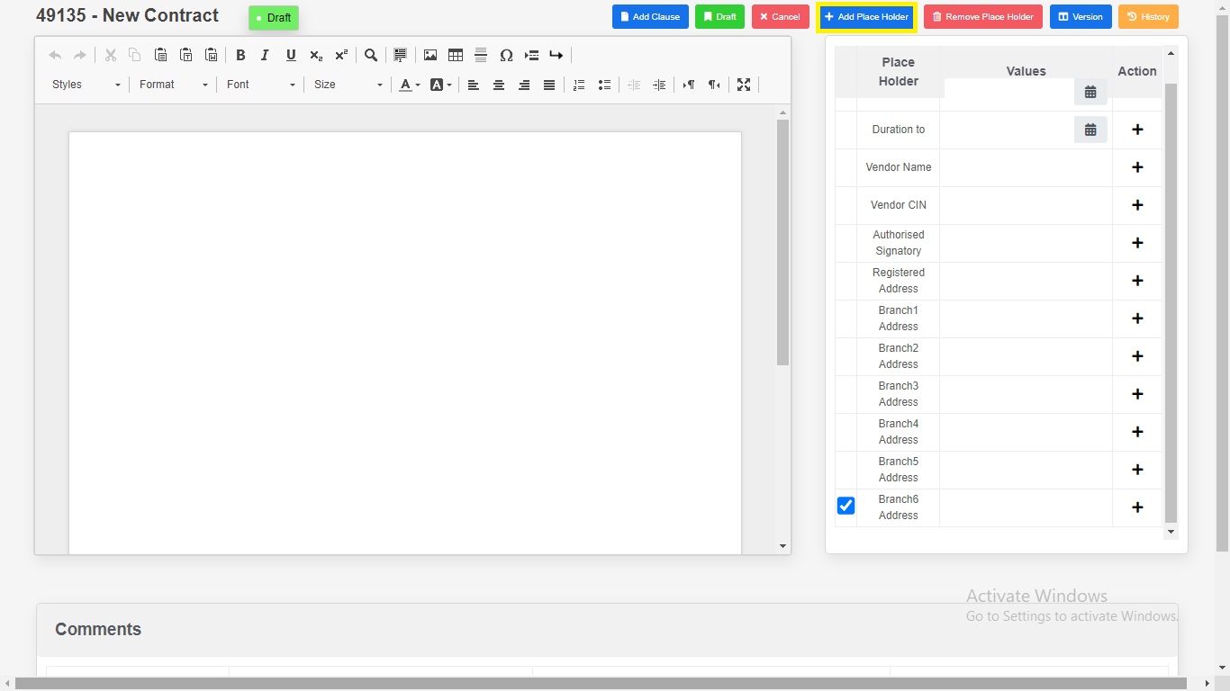

2. Enter “**Place Holder**”.

3. Click on “**Add**”. New variables will be add in place holder table.

4. Click on “**Cancel**”.

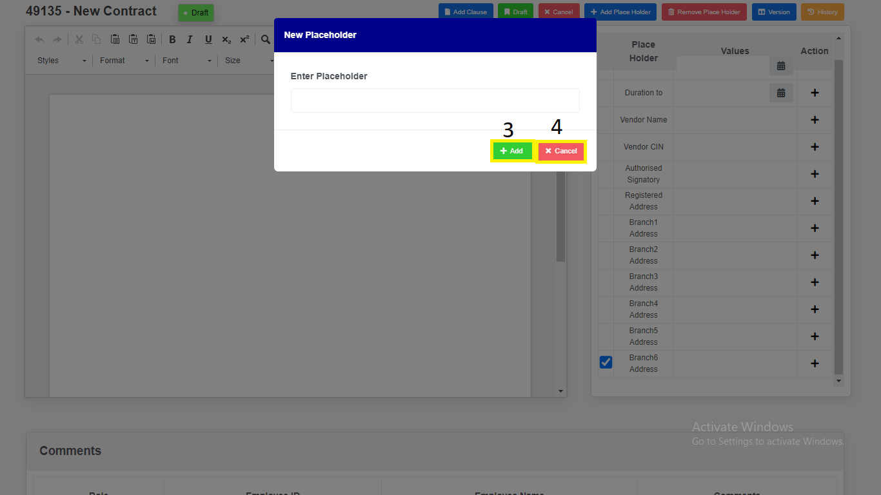

*Modal will redirect to “****Contract Draft view****” page.*

1. Remove Place Holders.

1. Select Checkbox.

2. Click on “**Remove Placeholders**” variables will be removed.

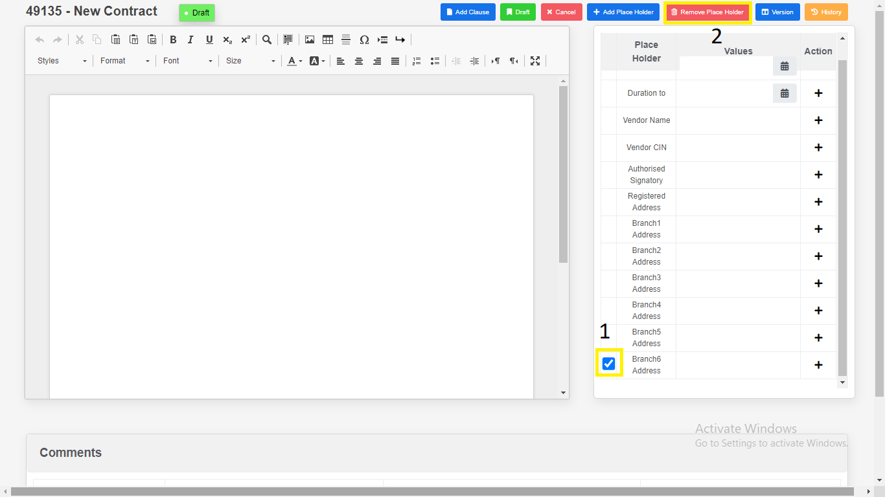

1. Click on “Version Compare”.

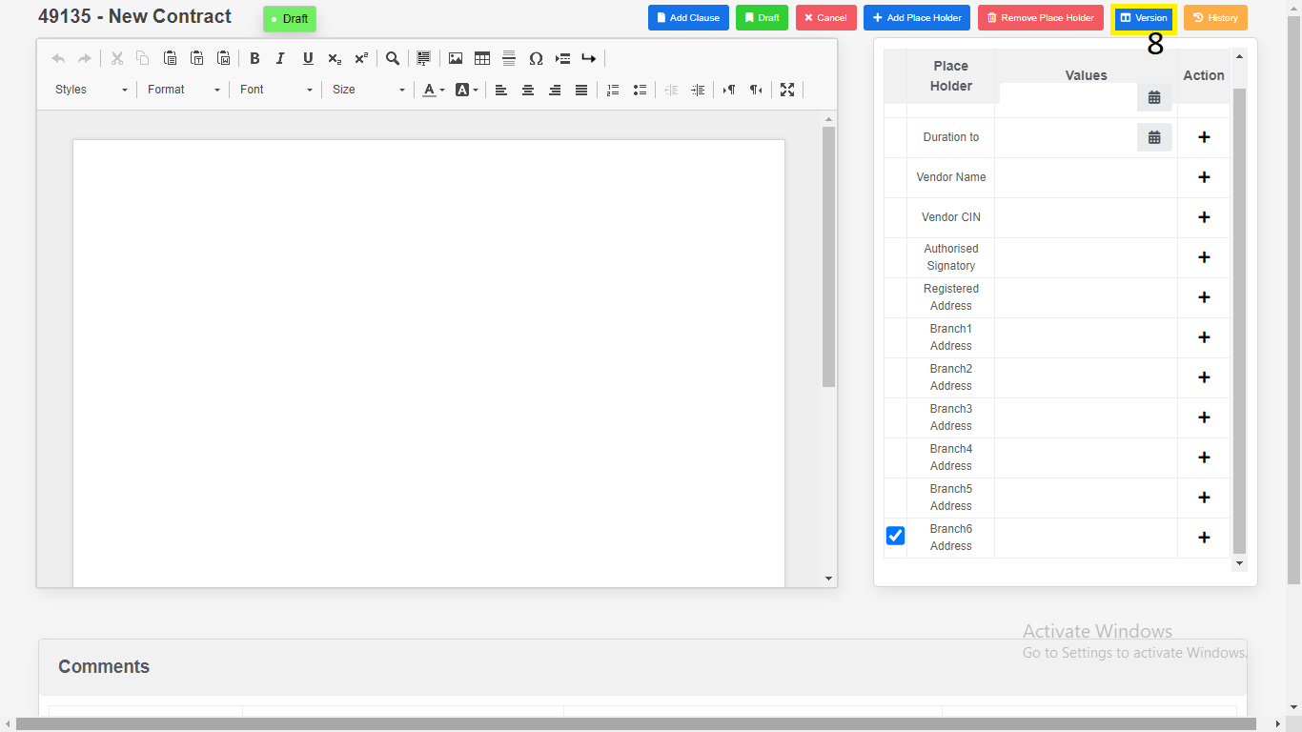

1. Select the “**Version”**.
2. Click on “**Download**”.

a) Download as “**PDF**”.

b) Download as “**Word Document**”.

1. Click on “**Close”.**

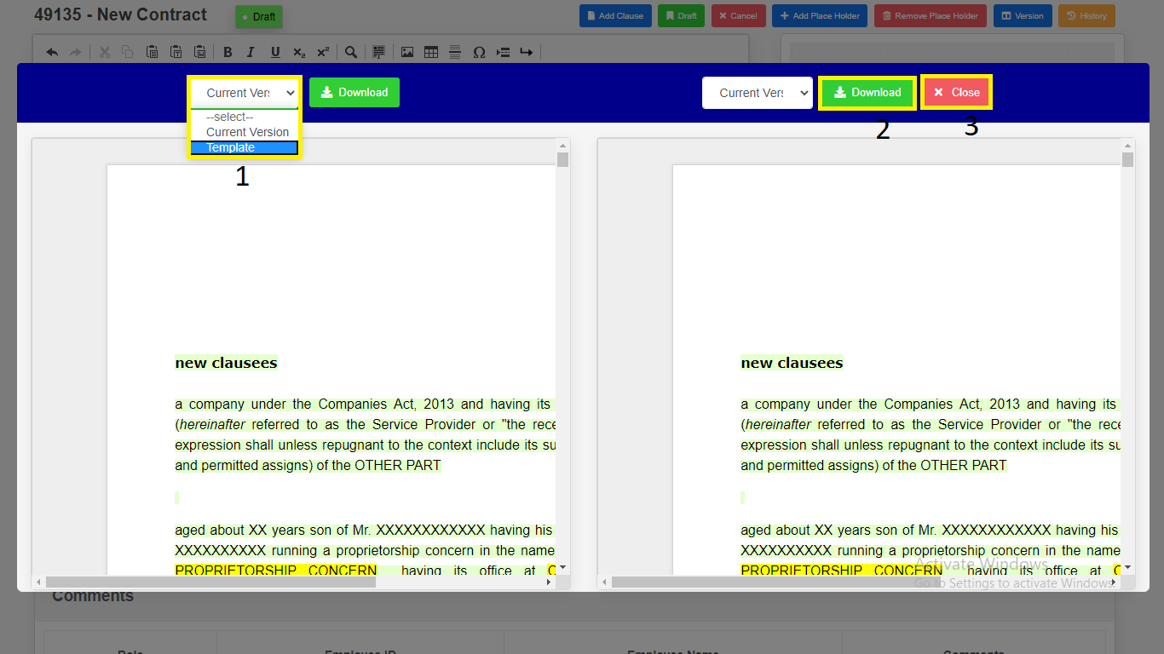

*Modal will redirect to “****Contract Draft View****” Page.*

1. Click on “**Attachments**”.

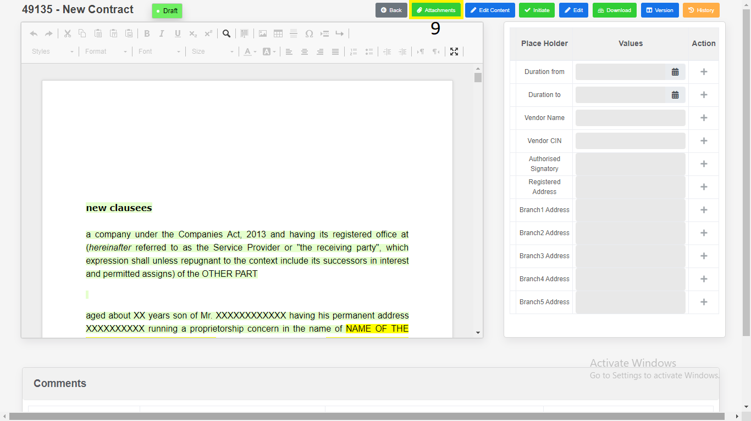

10) Click on “**choose file**”.

1. “**Upload**”.

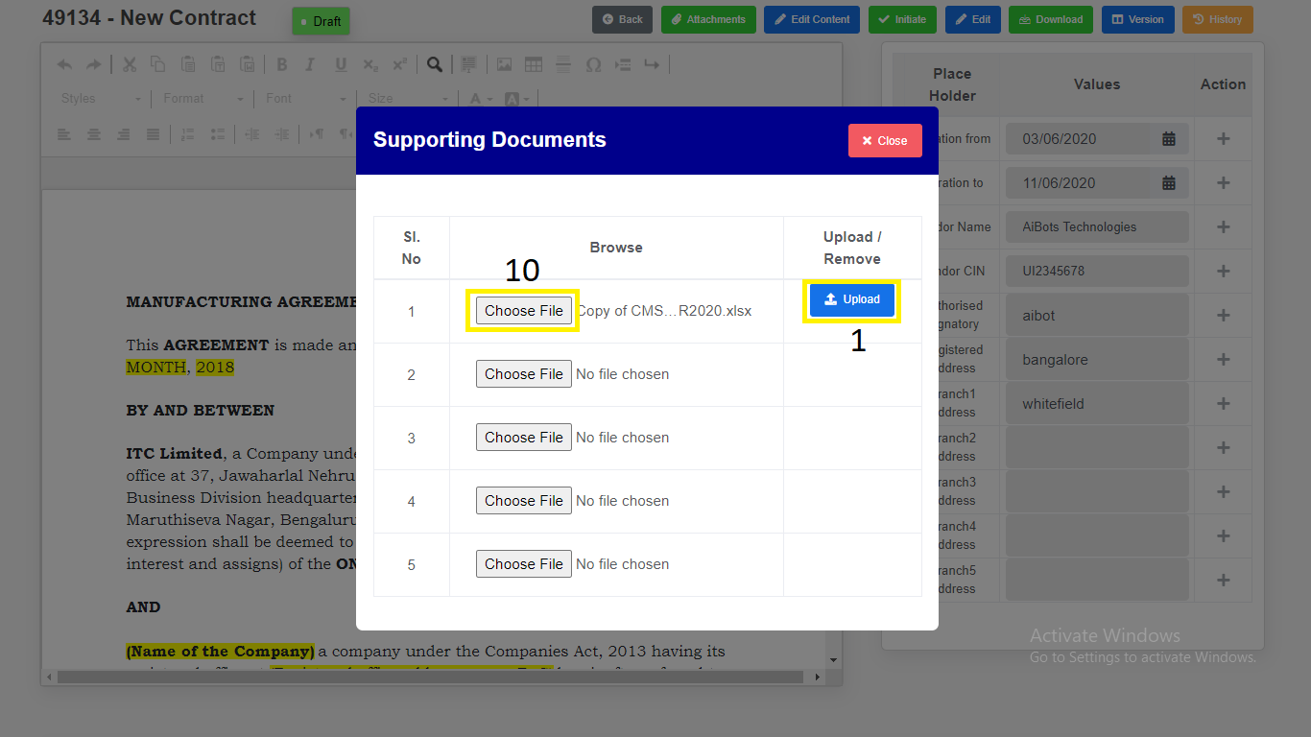

2. “**Download**”.

3. “**Remove**”.

4. “**Close**”.

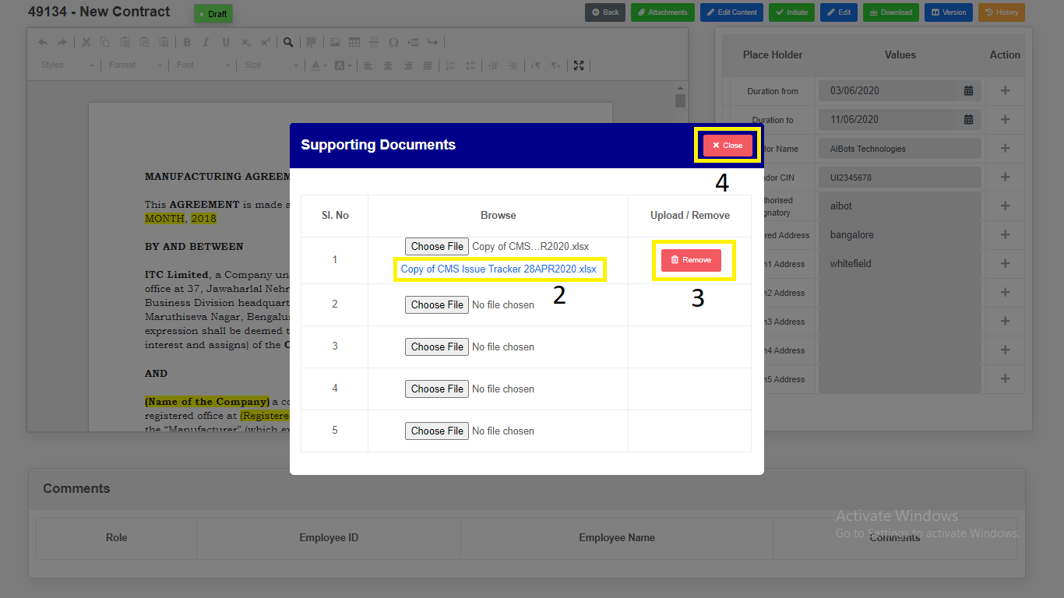

1. Click on “**Add Clause**” Clause Details can be added to contract.

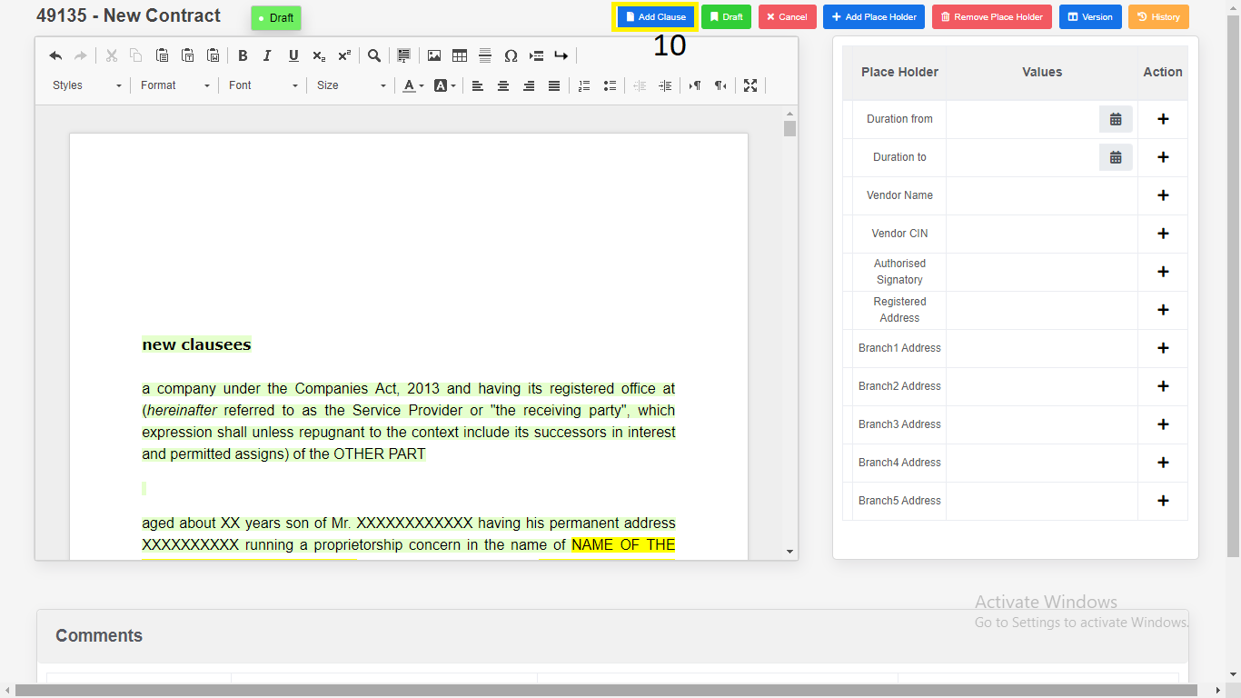

1. “**Preview**”.

2. “**Select**”.

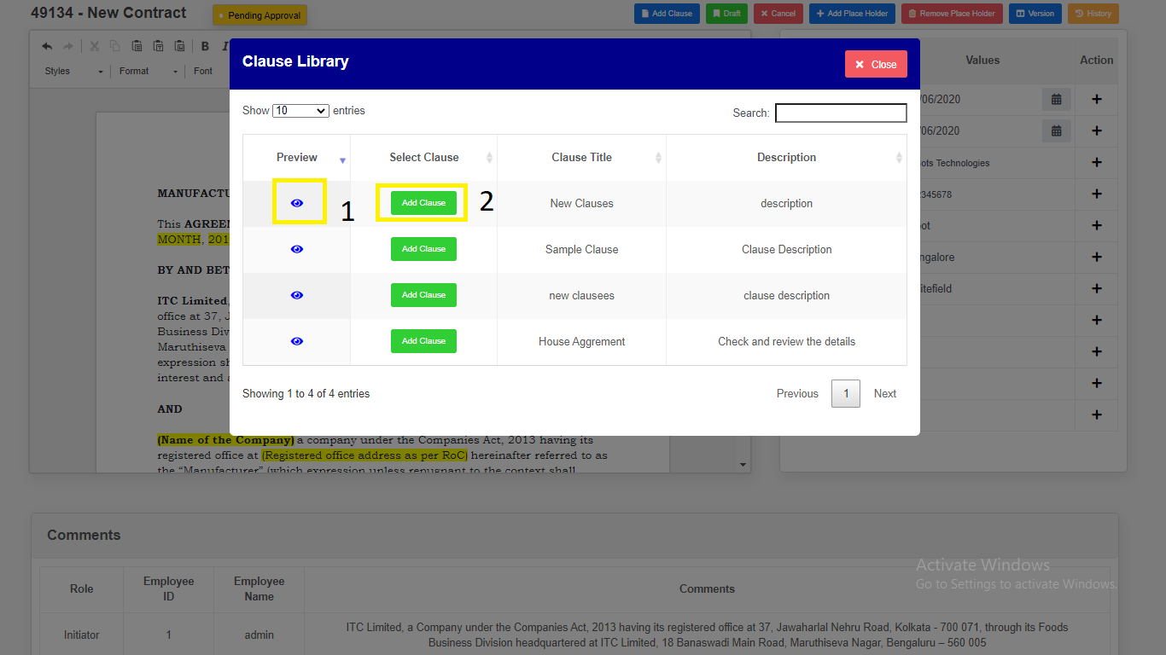

12) Click on “**Initiate**’ button to **initiate** the Contract.

13) Enter the Comments.

14) Click on “**Yes, Initiate**” button to **initiate** the Contract.

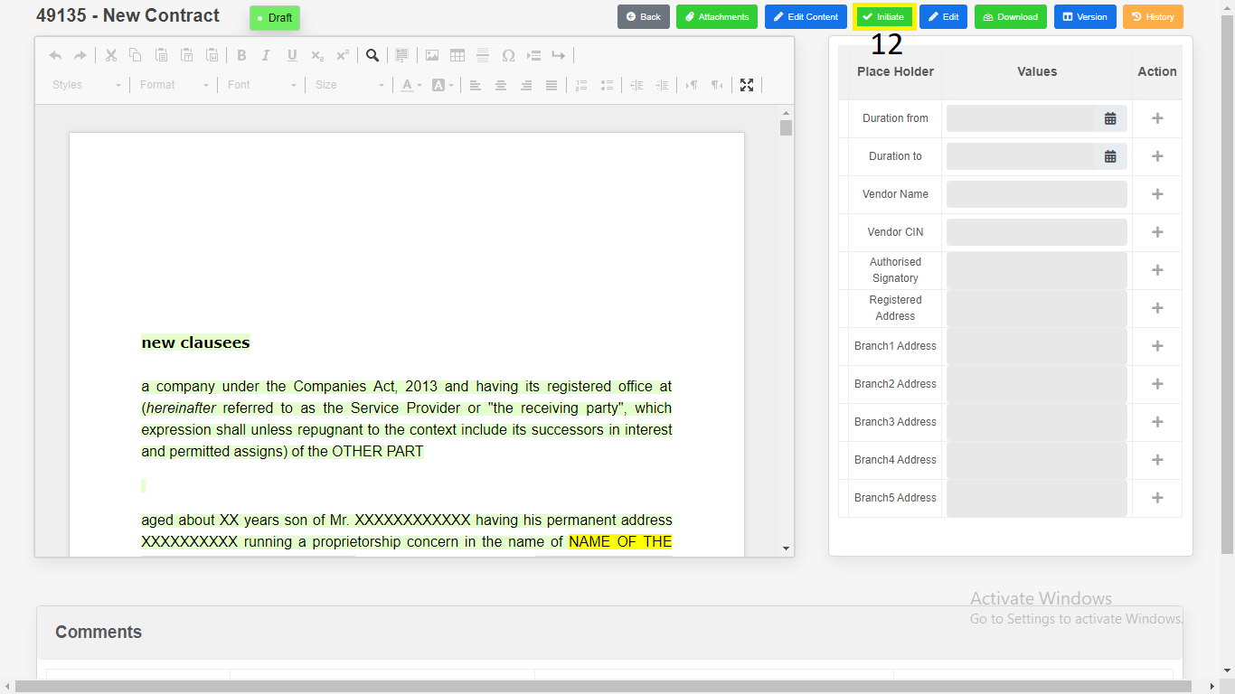

*Application will redirect to same page.*

15) Click on “**Download**”.

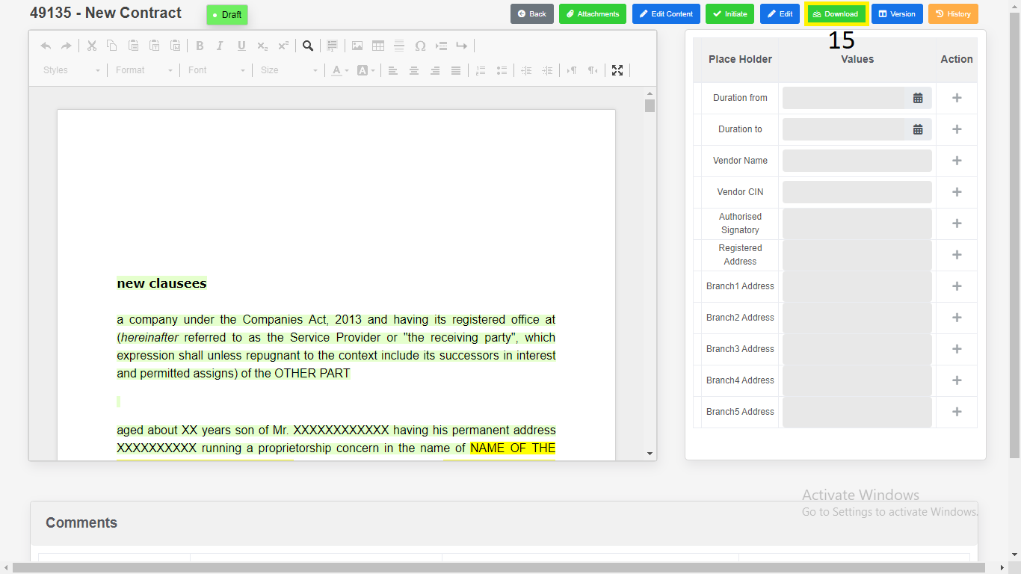

1) Download as “**PDF**”.

2) Download as “**Word Document**”.

3) Click on “**Close**”.

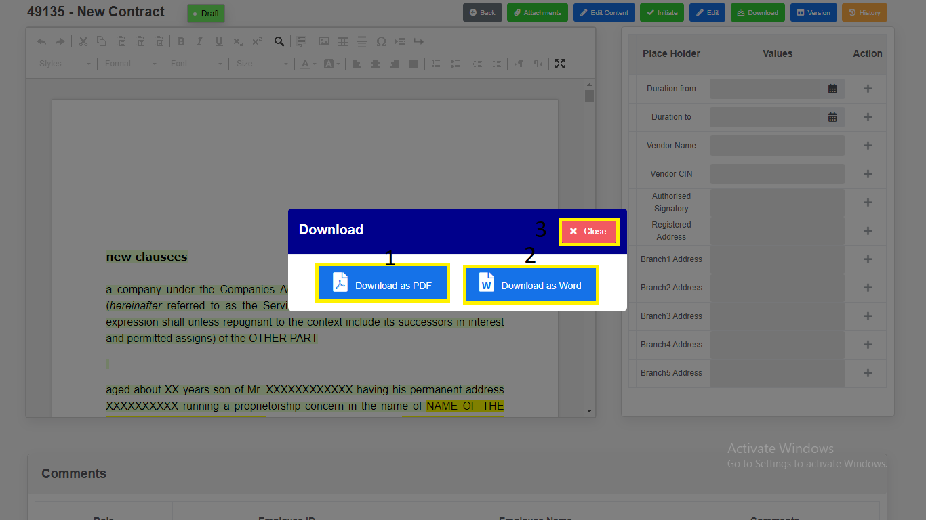

*Modal will redirect to “****Contract Draft View****” Page.*

16) Click on “**History**”. Changes done in the contract will be recorded in

History.

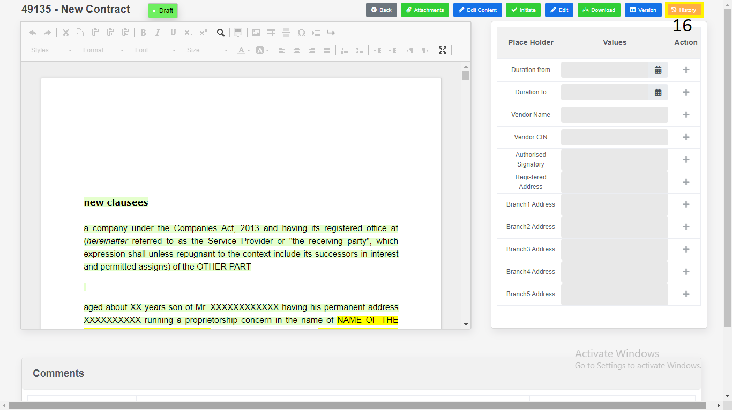

**Contract - Addendum**

1. **Contract Addendum Creation:**
2. Click on “**Contract**” in side menu.
3. Click on “**Executed**” navigational link for **Executed** table.
4. Click on **View** icon to **view** the Contract which is in **Executed.**

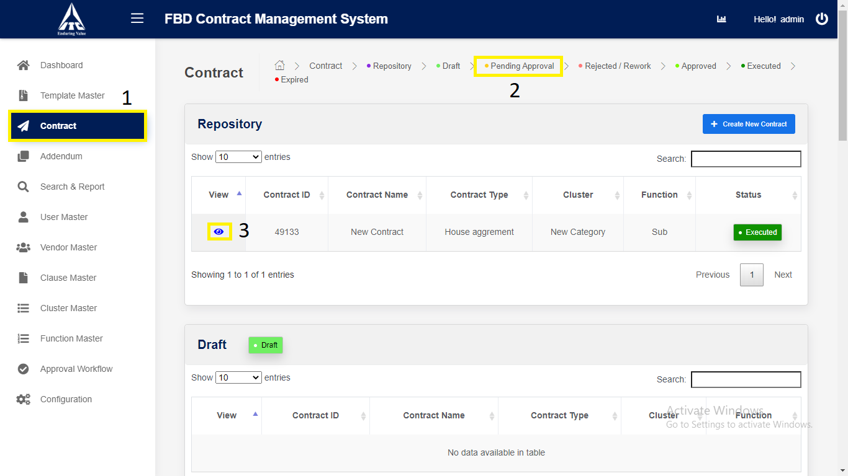

*Application will redirect to “****Contract Details****” page.*

1. Click on “**Next**” button.

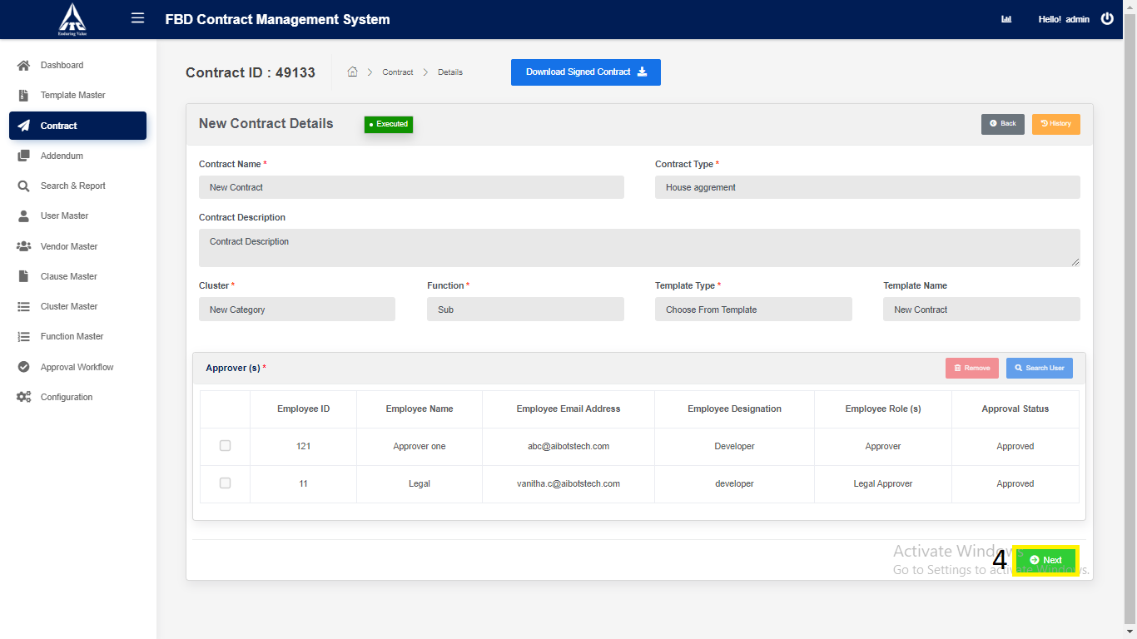

*Application will redirect to “****Contract Draft View****” page.*

1. Click on **select** dropdown and choose type of **Addendum.**
2. Click on selected **Addendum type** button.

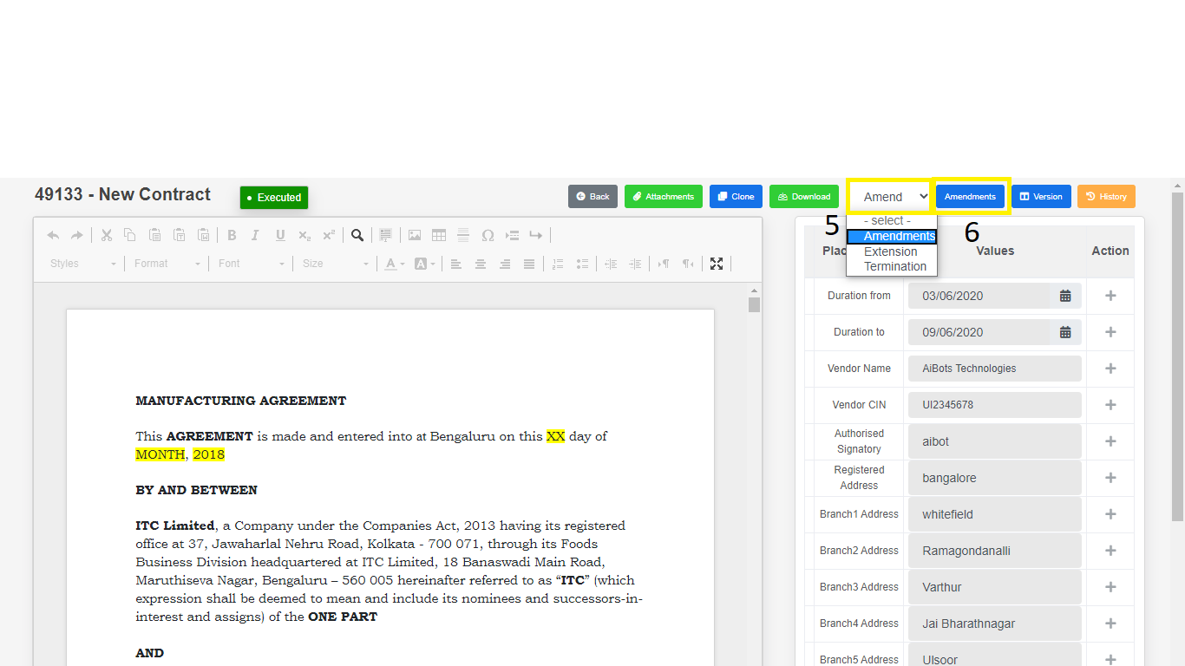

*Application will redirect to “****Contract Addendum Draft View****” page.*

1. Click on “**Edit Content**” button to **edit** the Contract.
2. Click on “**Draft**” to **draft** the Contract.

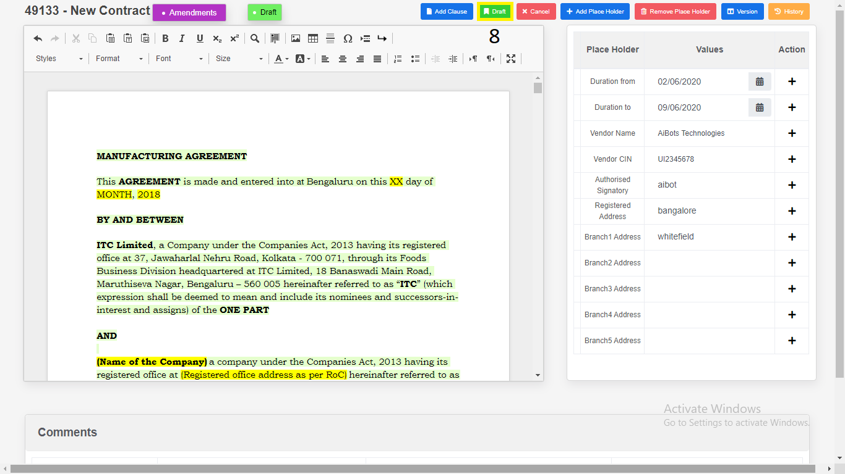

1. Place Holders

1. Click on “**Add Place Holder**”.

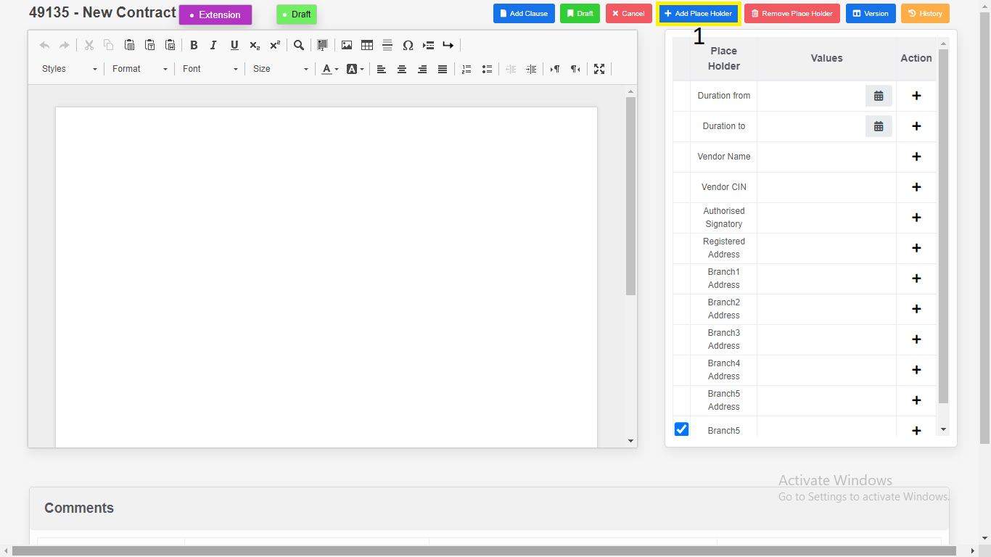

2. Enter “**Place Holder**”.

3. Click on “**Add**”. New variables will be add in place holder

table.

1. Click on “**Cancel**”.

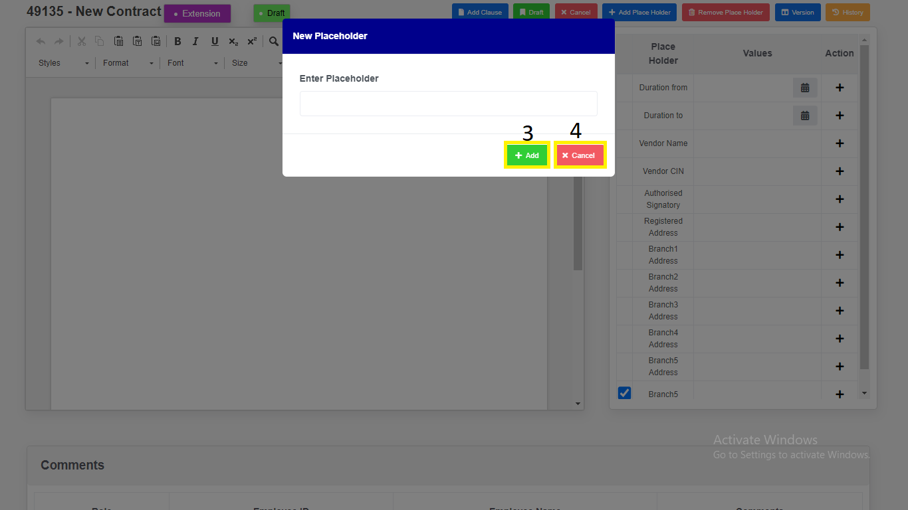

*Modal will redirect to “****Contract Addendum Draft view****” page.*

1. Remove Place Holders.

1. Select Checkbox.

2. Click on “**Remove Placeholders**” variables will be removed.

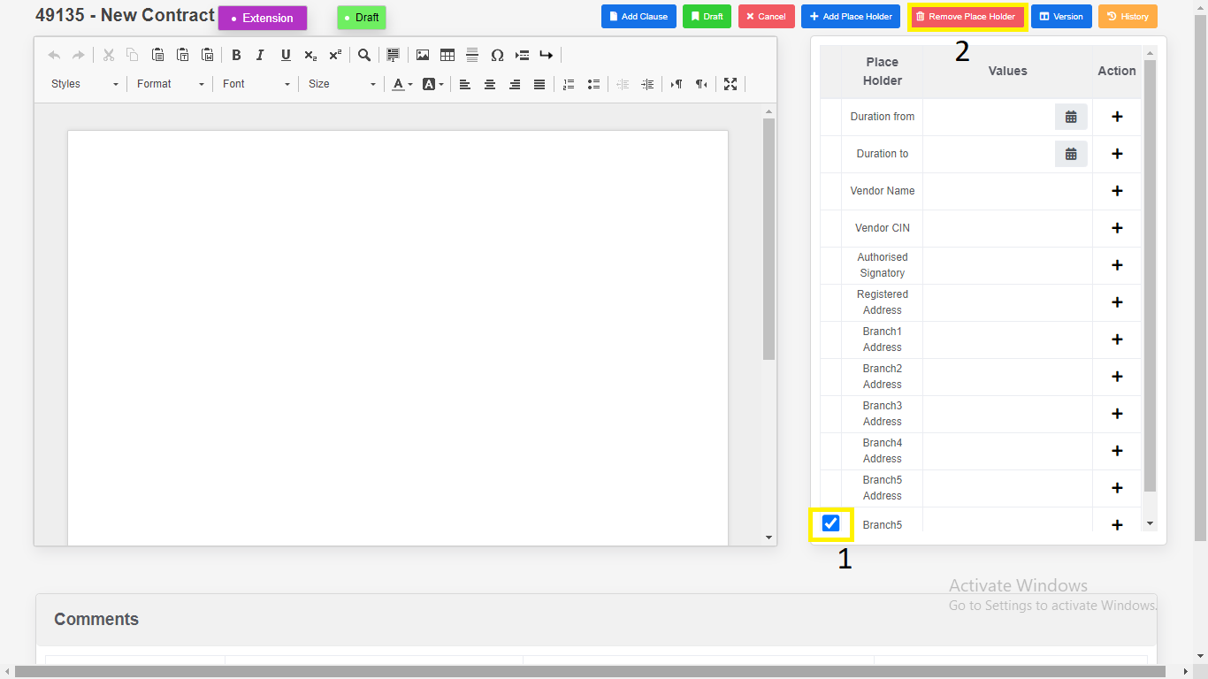

1. Click on “Version Compare”.

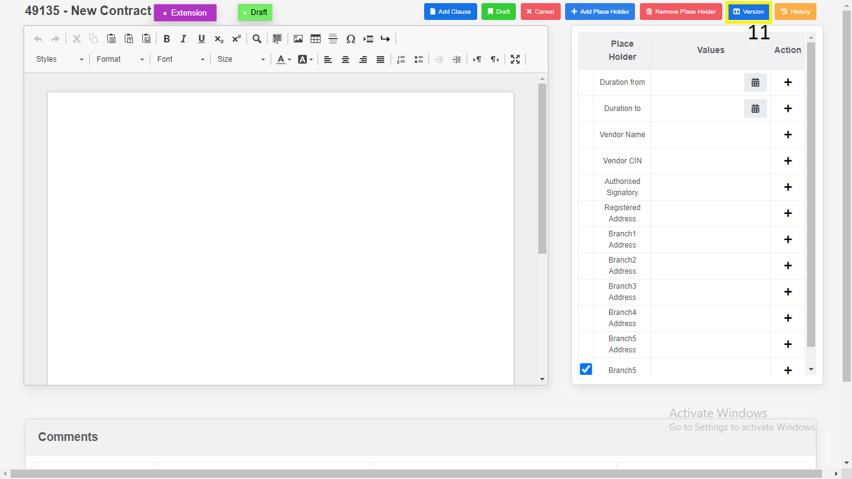

1. Select the “**Version”**.

2. Click on “**Download**”.

a) Download as “**PDF**”.

b) Download as “**Word Document**”.

3. Click on “**Close”.**

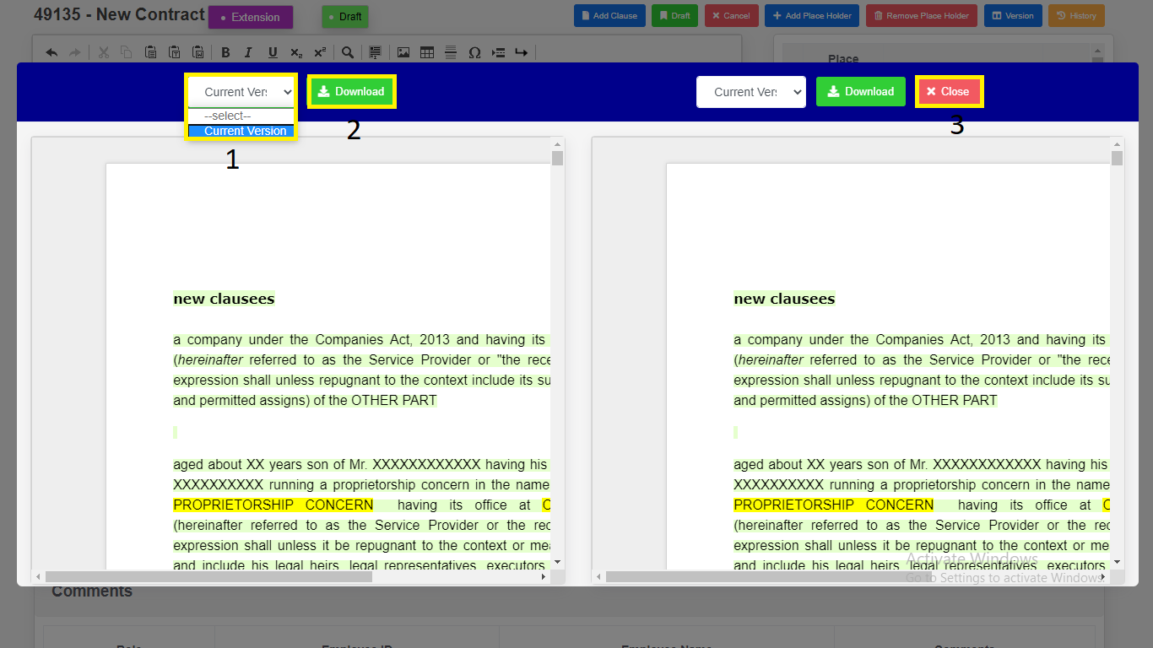

*Modal will redirect to “****Contract Addendum Draft View****” Page.*

1. Click on “**Initiate**” button to **initiate** the Modified Contract.
2. Enter the Comments.
3. Click on “**Yes, Initiate**” button to **initiate** the Modified Contract.

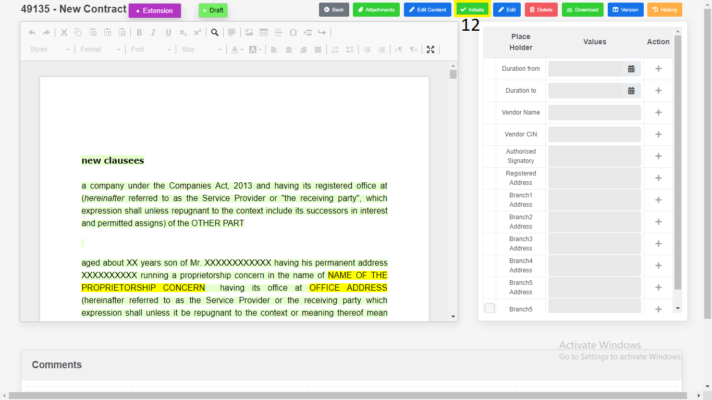

*Application will redirect to same page.*

1. Click on “**Download**”.

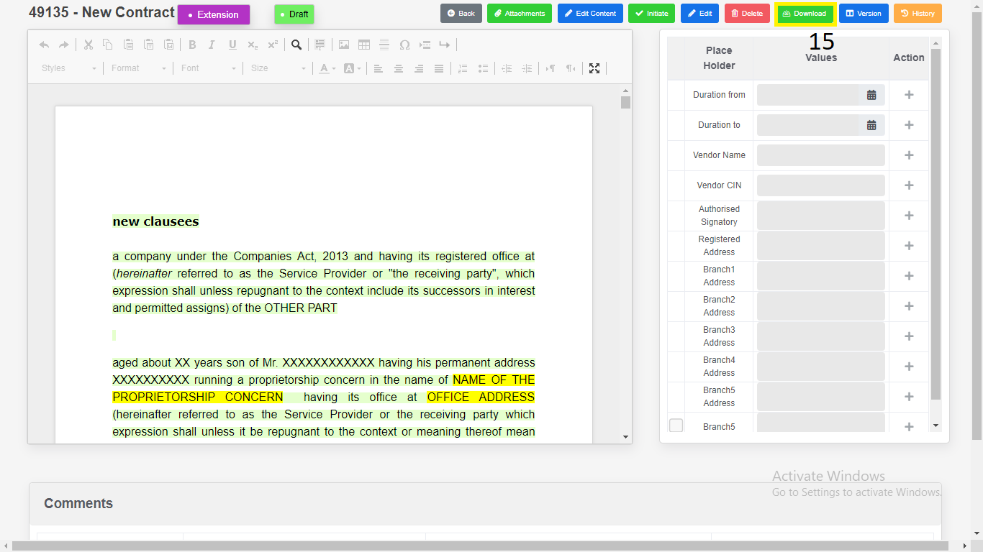

1) Download as “**PDF**”.

2) Download as “**Word Document**”.

3) Click on “**Close**”.

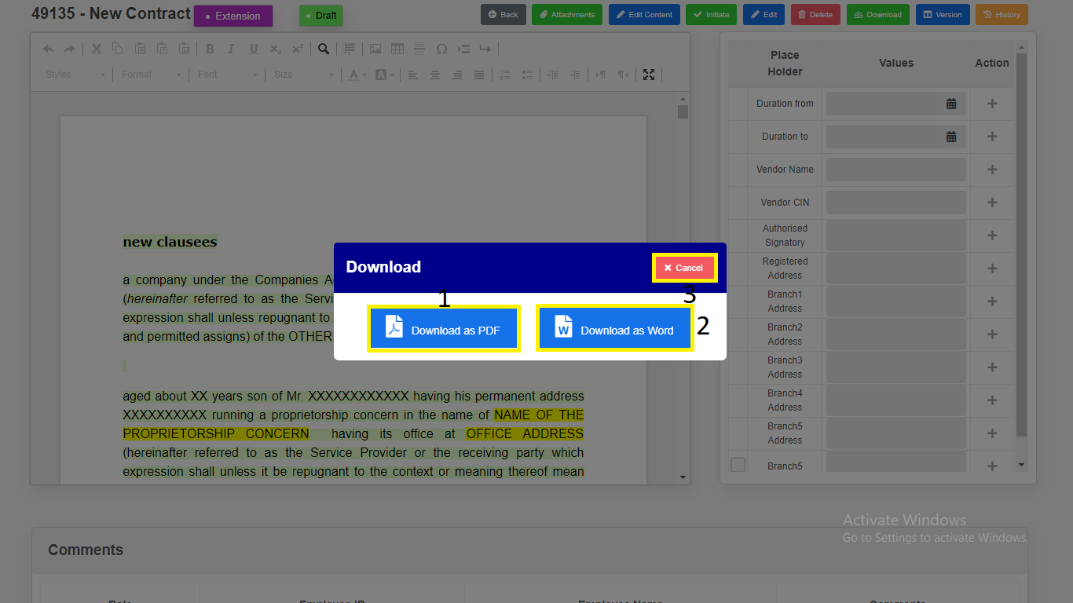

*Modal will redirect to “****Contract Addendum Draft View****” Page.*

1. Click on “**History**”. Changes done in the Contract will be recorded in history.

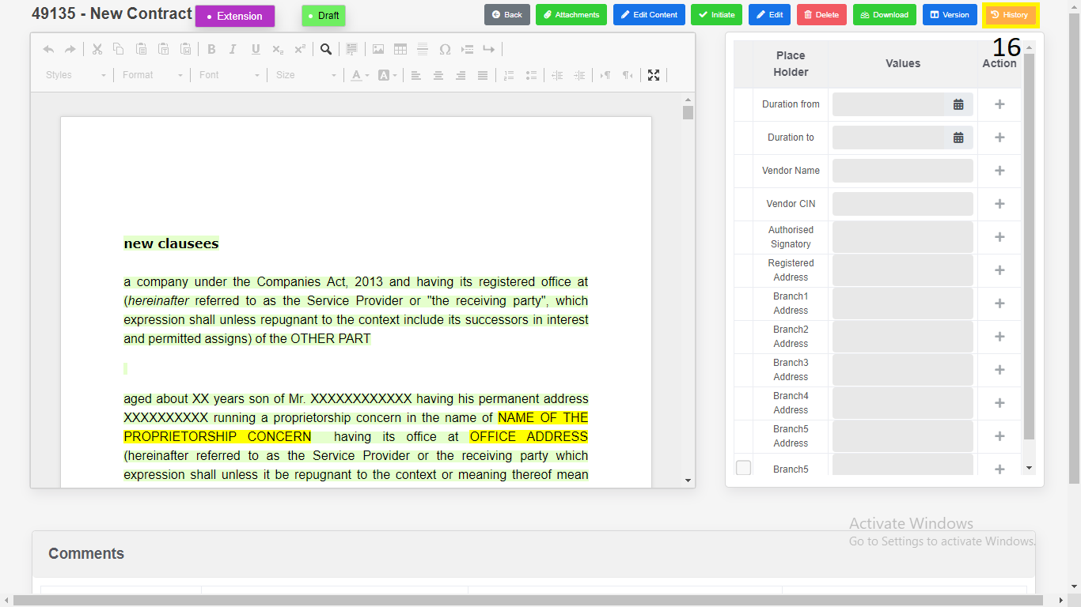

**Search & Report**

1. Click on “**Search & Report**” from Side Menu (Access to Admin Only).

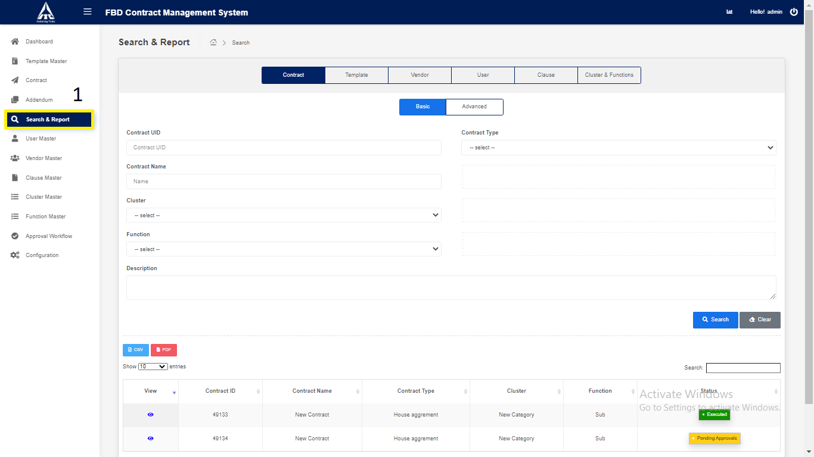

1) Click on “**Contract**” tab.

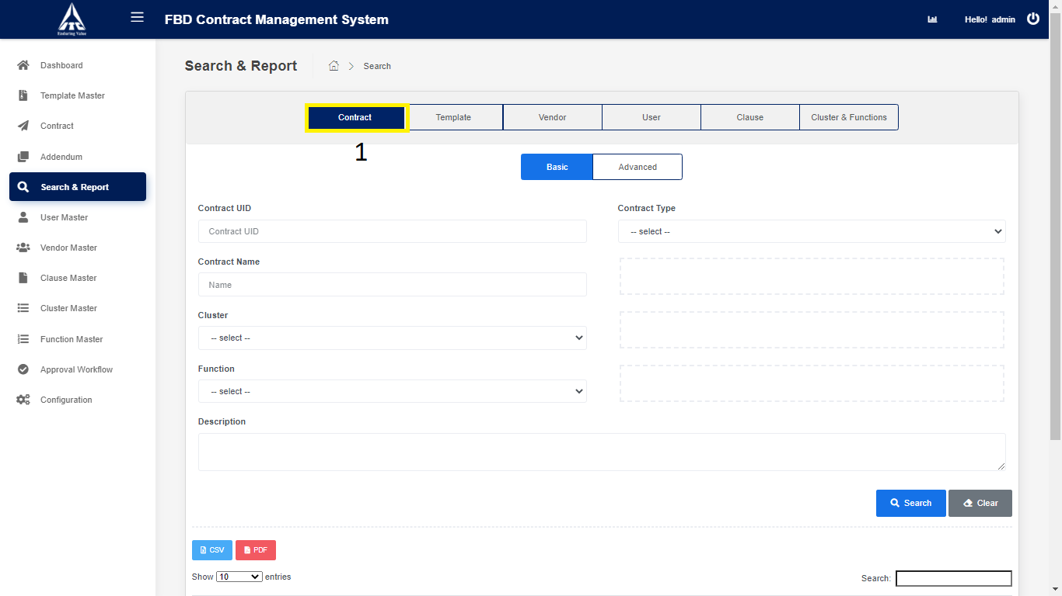

1. Click on Basic Contract.
2. Enter Basic Contract Details.
3. Enter **“Contract UID”** *(Only Numbers are allowed).*
4. Enter **“Contract Name”** *(Only Characters are allowed).*
5. Select **“Contract Type”***.*
6. Select “**Cluster**”.
7. Select “**Function**”.
8. Click on “**Search**”.
9. Search the contract details and displays in the contract table.
10. Click on “**CSV**”.
11. **CSV** downloads the contract details in Excel format.
12. **PDF** downloads the contract details in PDF format.
13. Click on **“Clear”.**

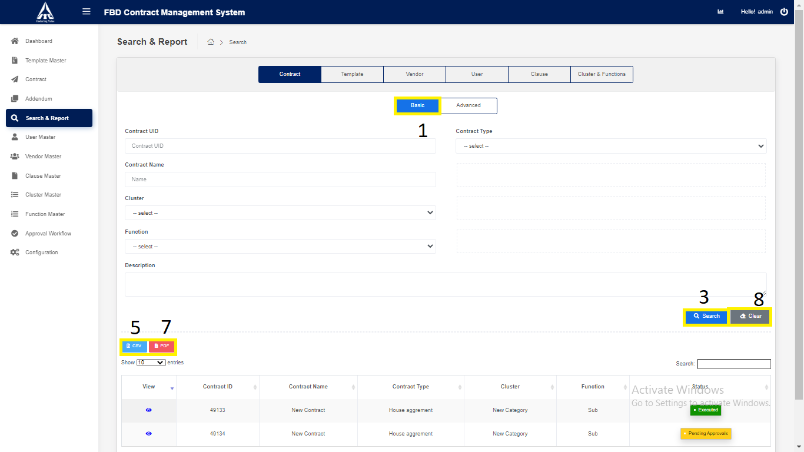

*Application will redirect to “****Search & Report****” page.*

1. Click on “**Advance**” Contract.
2. Enter Advance Contract Details.
3. Enter **“Contract UID”** *(Only Numbers are allowed).*
4. Enter **“Contract Name”** *(Only Characters are allowed).*
5. Select **“Contract Type”***.*
6. Select “**Cluster**”.
7. Select “**Function**”.
8. Select “**Vendor Name**”.
9. Enter “**Execution** Date”.
10. Enter “**Termination** Date”.
11. Enter “**Description**” *(Only Characters & Numbers are allowed).*
12. Click on “**Search**”.
13. Search the contract details and displays in the contract table.
14. Click on “**CSV**”.
15. **CSV** downloads the contract details in Excel format.
16. **PDF** downloads the contract details in PDF format.
17. Click on **“Clear”.**

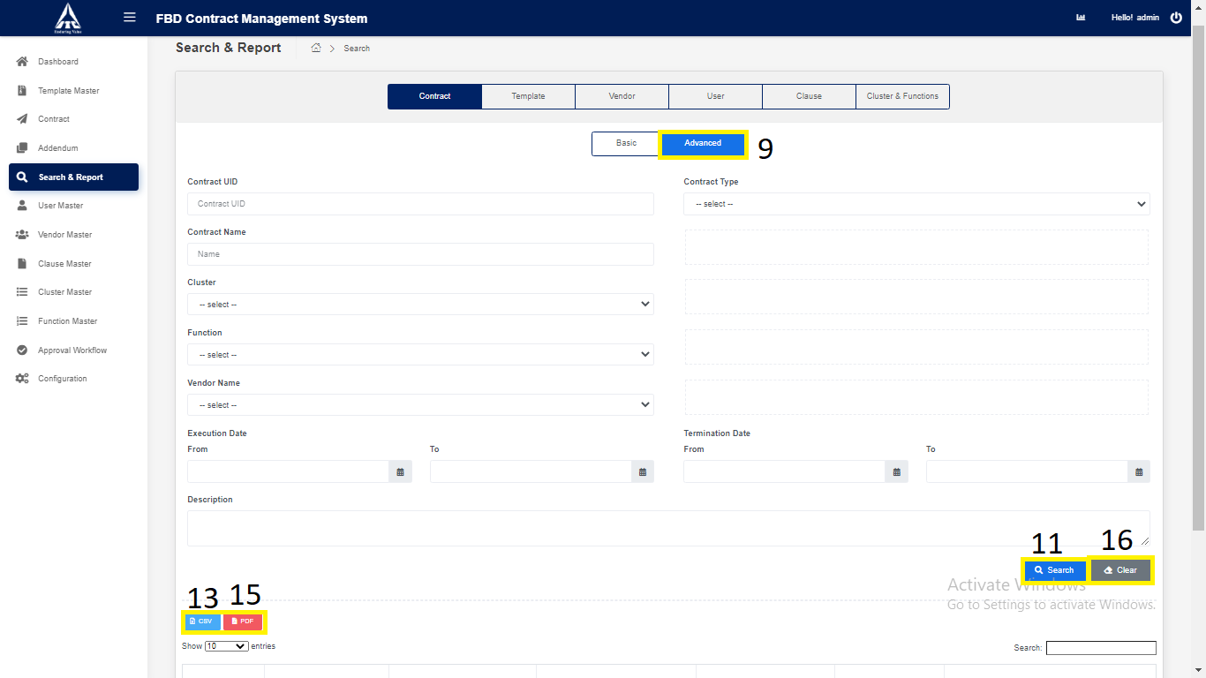

*Application will redirect to “****Search & Report****” page.*

1. Click on “**Template**” tab.

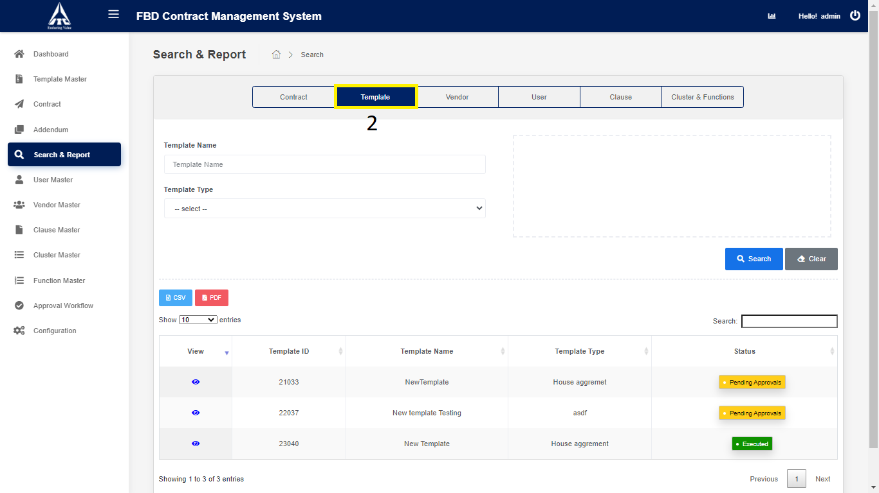

1. Click on “**Template**”.
2. Enter Basic Template Details.
3. Enter “Template Name”.
4. Enter “Template Type”.
5. Click on “**Search**”.
6. Search the Template details and displays in the Template table.
7. Click on “**CSV**”
8. **CSV** downloads the Template details in Excel format.
9. Click on **“PDF”** downloads the Template details in PDF format.
10. Click on **“Clear”.**

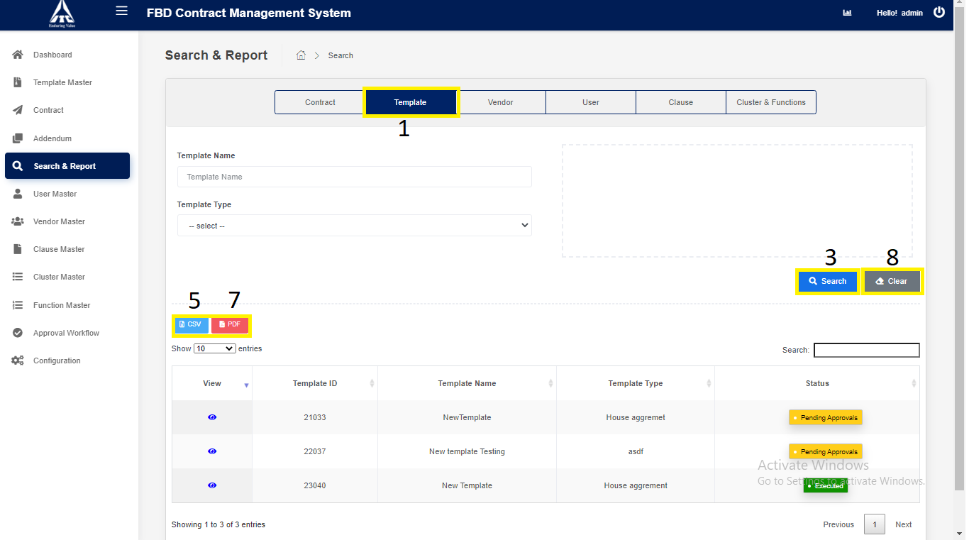

*Application will redirect to “****Search & Report****” page.*

1. Click on “**Vendor**” tab.

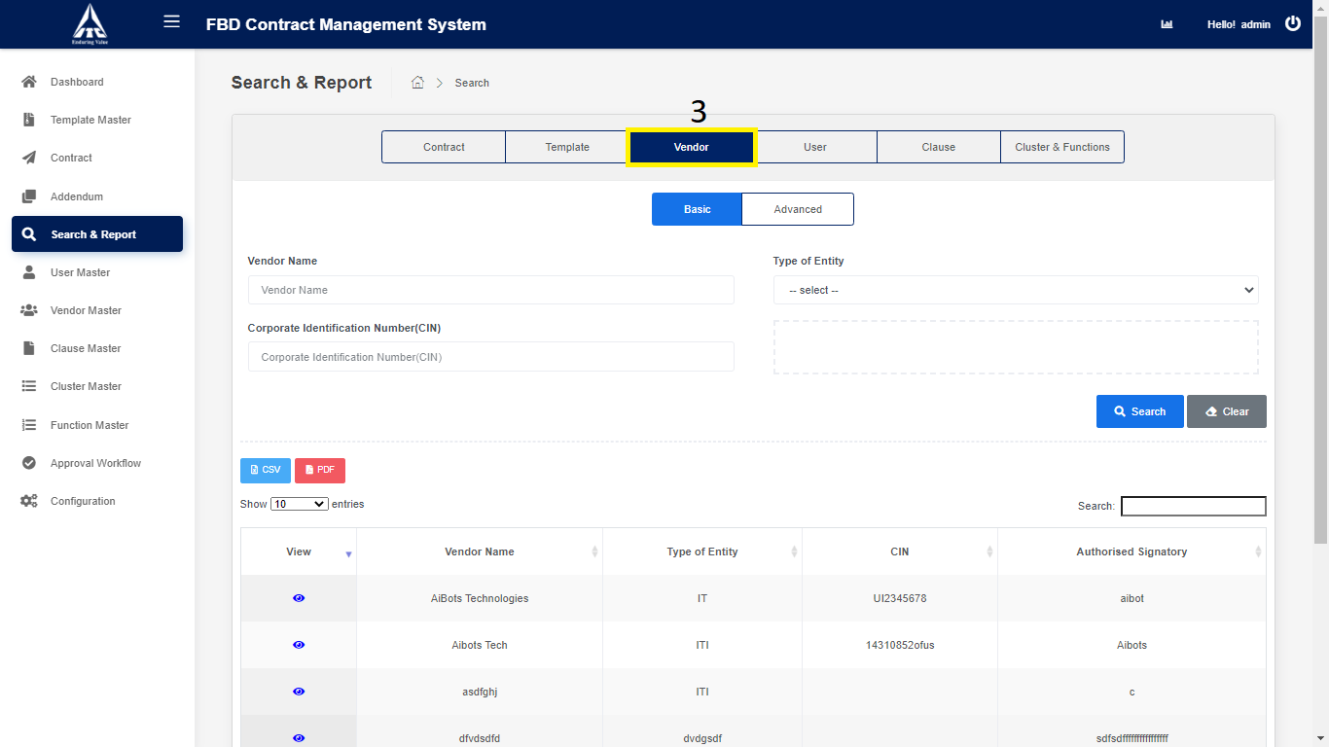

1. Click on “**Basic**” Vendor.
2. Enter Basic Vendor Details.
3. Enter “Vendor Name”.
4. Select “Type of entity”.
5. Enter “Corporate Identification Number(CIN)”
6. Click on “**Search**”.
7. Search the Vendor details and displays in the Vendor table.
8. Click on “**CSV**”.
9. **CSV** downloads the Vendor details in Excel format.
10. Click on **“PDF”** downloads the Vendor details in PDF format.
11. Click on **“Clear”.**

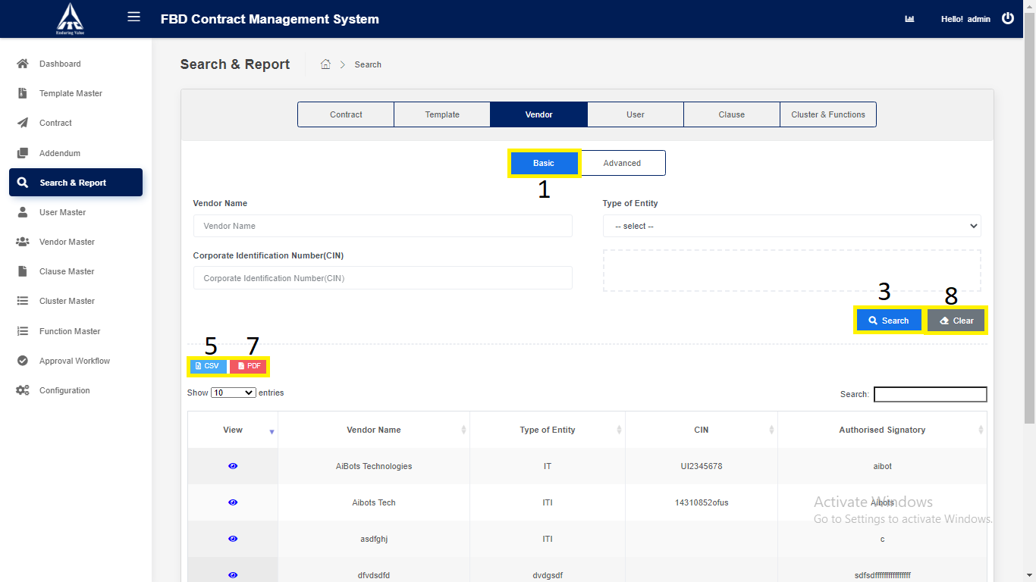

*Application will redirect to “****Search & Report****” page.*

1. Click on “**Advance**” Vendor.
2. Enter Advance Vendor Details.
3. Enter “Vendor Name”.
4. Select “Type of entity”.
5. Enter “Corporate Identification Number(CIN)”
6. Enter “Authorized Signature”.
7. Enter “Address”.
8. Click on “**Search**”.
9. Search the Vendor details and displays in the Vendor table.
10. Click on “**CSV**”.
11. **CSV** downloads the Vendor details in Excel format.
12. Click on **“PDF”** downloads the Vendor details in PDF format.
13. Click on **“Clear”.**

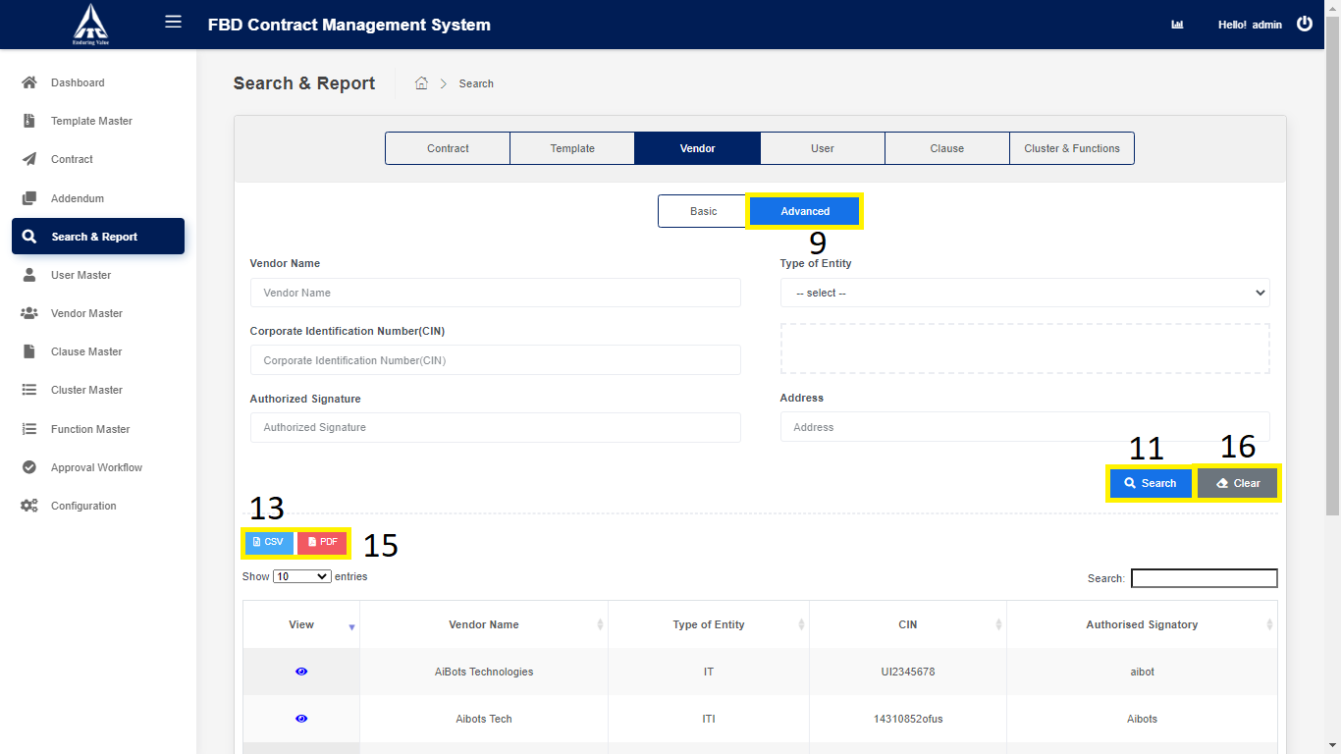

*Application will redirect to “****Search & Report****” page.*

1. Click on “**User**” tab.

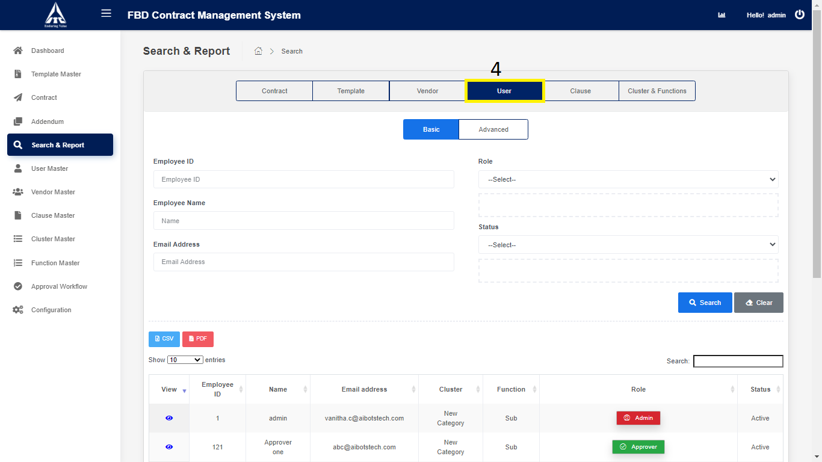

1. Click on “**Basic**” User.
2. Enter Basic User Details.
3. Enter “Employee ID”.
4. Enter “Employee Name”.
5. Select “Role”.
6. Enter “Email Address”.
7. Select “Status”.
8. Click on “**Search**”.
9. Search the User details and displays in the User table.
10. Click on “**CSV**”.
11. **CSV** downloads the User details in Excel format.
12. Click on **“PDF”** downloads the User details in PDF format.
13. Click on “**Clear**”.

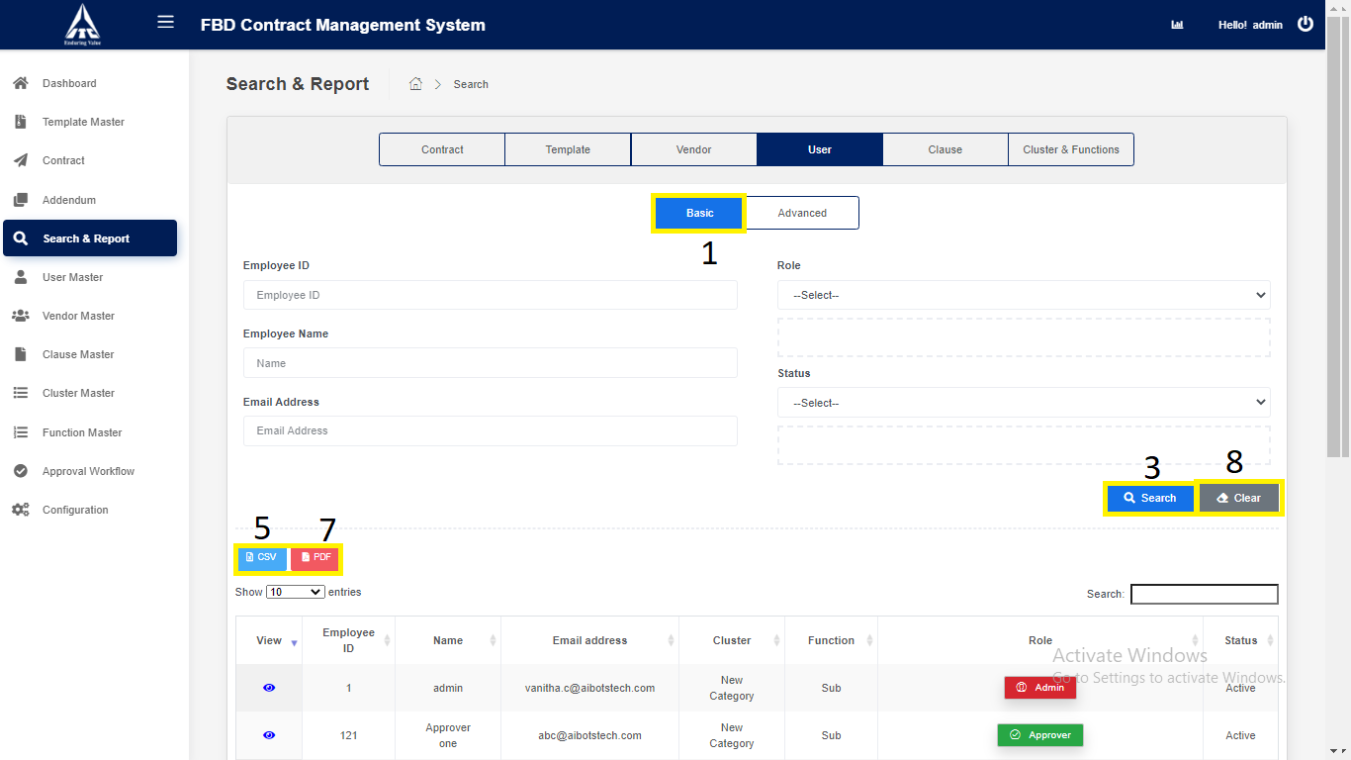

*Application will redirect to “****Search & Report****” page.*

1. Click on “**Advance**” User.
2. Enter Advance User Details.
3. Enter “Employee ID”.
4. Select “Cluster”.
5. Select “Function”.
6. Select “Role”.
7. Enter “Employee Name”.
8. Enter “Email Address”.
9. Select “Designation”.
10. Select “Status”.
11. Click on “**Search**”.
12. Search the User details and displays in the User table.
13. Click on “**CSV**”.
14. **CSV** downloads the User details in Excel format.
15. Click on **“PDF”** downloads the User details in PDF format.
16. Click on “**Clear**”.

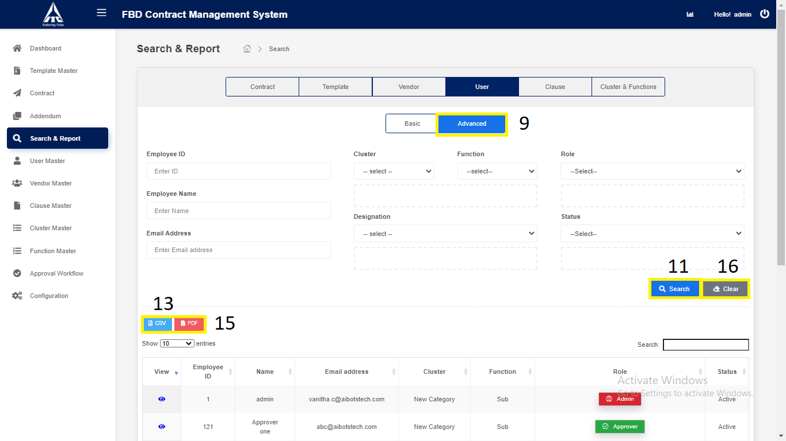

*Application will redirect to “****Search & Report****” page.*

1. Click on “**Clause**” tab.

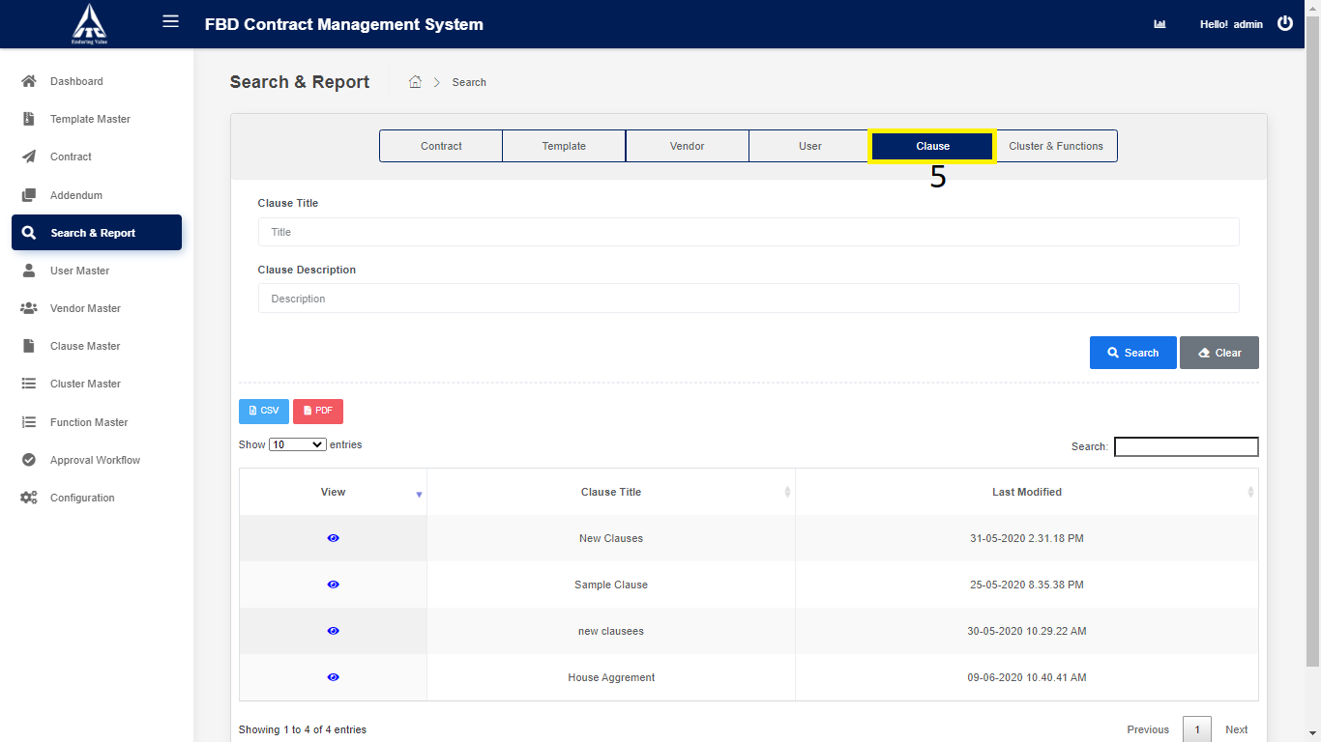

1. Click on “**Clause**”.
2. Enter Clause Details.
3. Enter “Clause Tittle”.
4. Enter “Clause Description”.
5. Click on “**Search**”.
6. Search the Clause details and displays in the Clause table.
7. Click on “**CSV**”.
8. **CSV** downloads the Clause details in Excel format.
9. Click on **“PDF”** downloads the Clause details in PDF format.
10. Click on “**Clear**”.

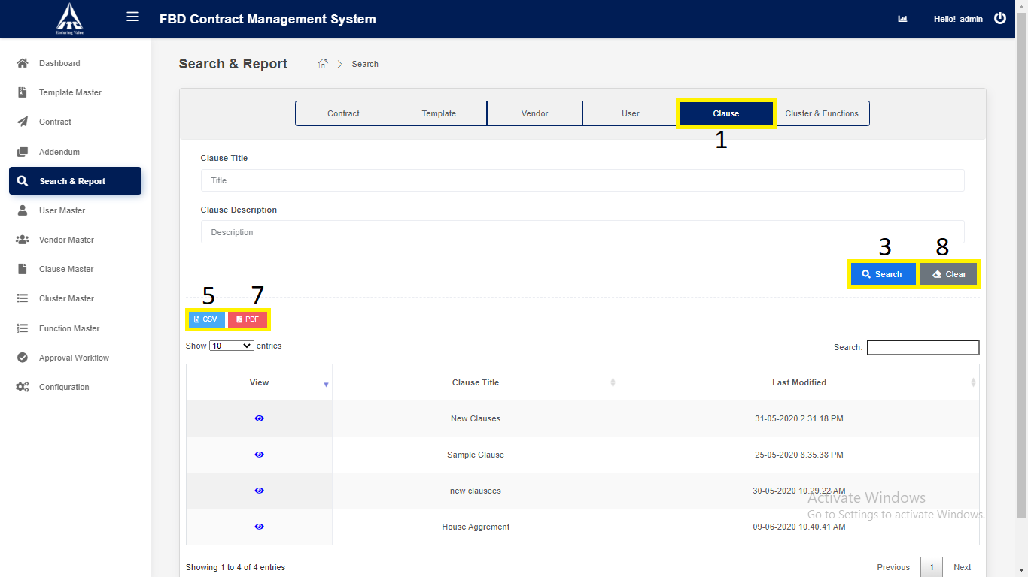

*Application will redirect to “****Search & Report****” page.*

1. Click on “**Cluster & Function**” tab.

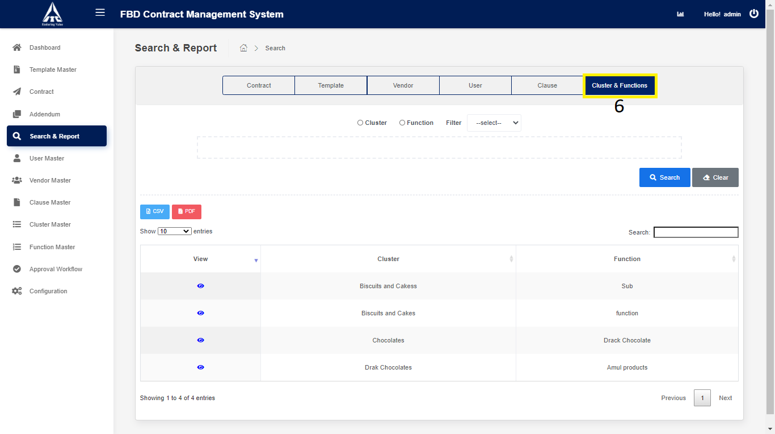

1. Click on “**Cluster and Function**”.
2. Enter Cluster and Function Details.
3. Select “**Cluster**”.

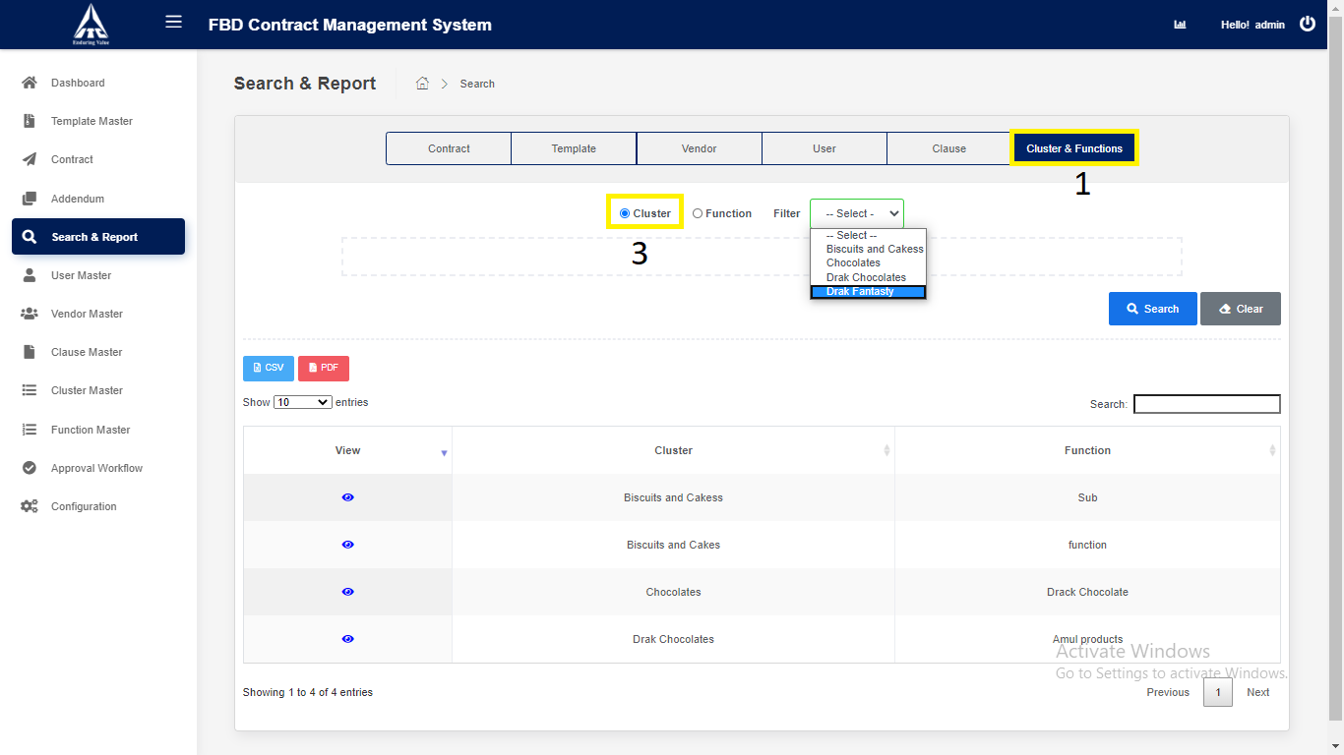

1. Select “**Function**”.

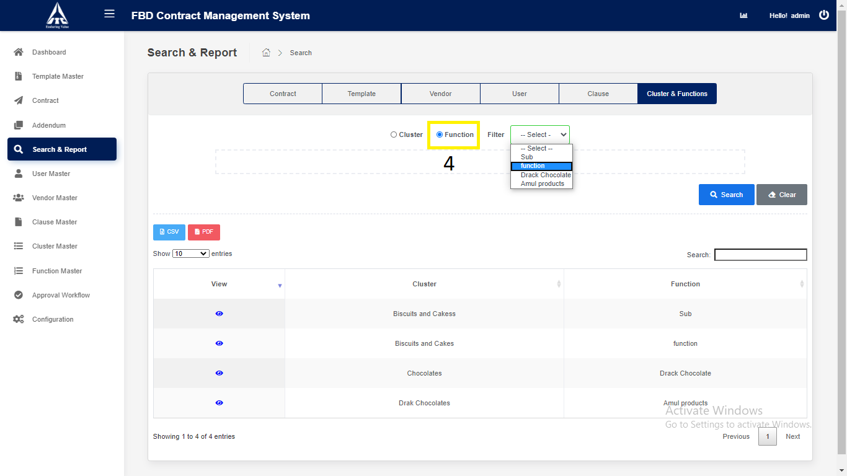

1. Click on “**Search**”.
2. Search the Cluster and Function details and displays in the Cluster and Function table.
3. Click on “**CSV**”.
4. **CSV** downloads the Cluster and Function details in Excel format.
5. Click on **“PDF”** downloads the Cluster and Function details in PDF format.
6. Click on “**Clear**”.

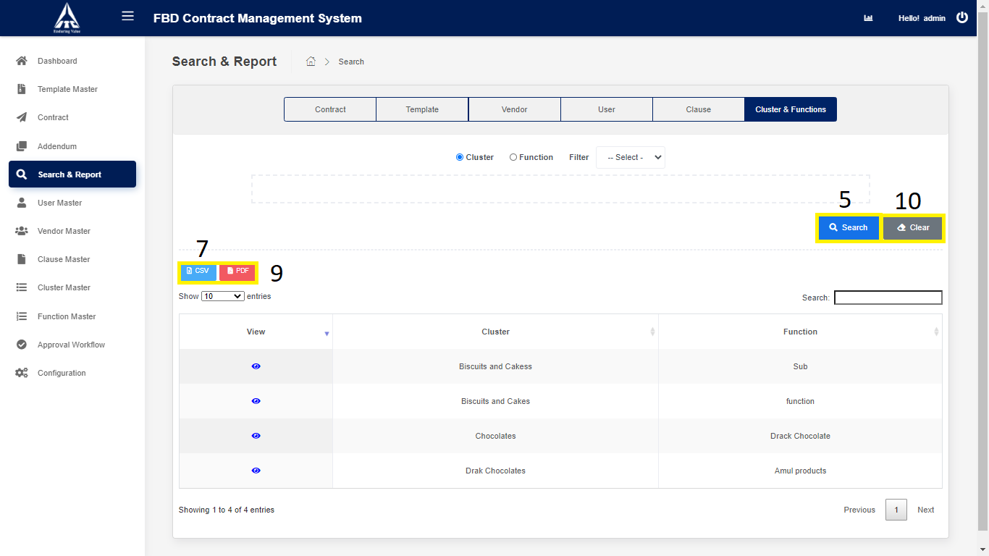

*Application will redirect to “****Search & Report****” page.*

**User Master:**

1. **User Creation:**
2. Click on “**User Master**” from Side Menu (Access to Admin Only).
3. Click on “**Create New User**” button.

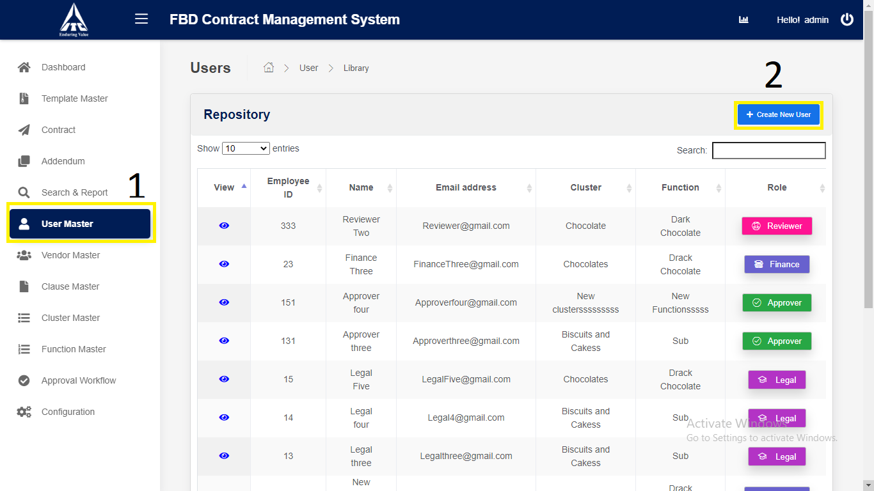

*Application will redirect to “****New User****” page*

1. Enter the **User** Details,
2. Enter “**Employee** **ID**” (*Numbers only*).
3. Enter “**Employee Full Name**” (*Characters only*).
4. Enter“**Employee** **Email** **Address**” (*Characters Numbers and Email Validation Only)*.
5. Enter “**Designation**” (*Characters Only*).
6. Select **Cluster**.
7. Select **Function**.
8. Select **Status**
9. Search:
10. Reporting Manager **ID** (*Numbers Only*).
11. Reporting Manager **Name** (*Characters Only*).
12. Reporting Manager **Email** (*Characters Numbers and Email validation only*).

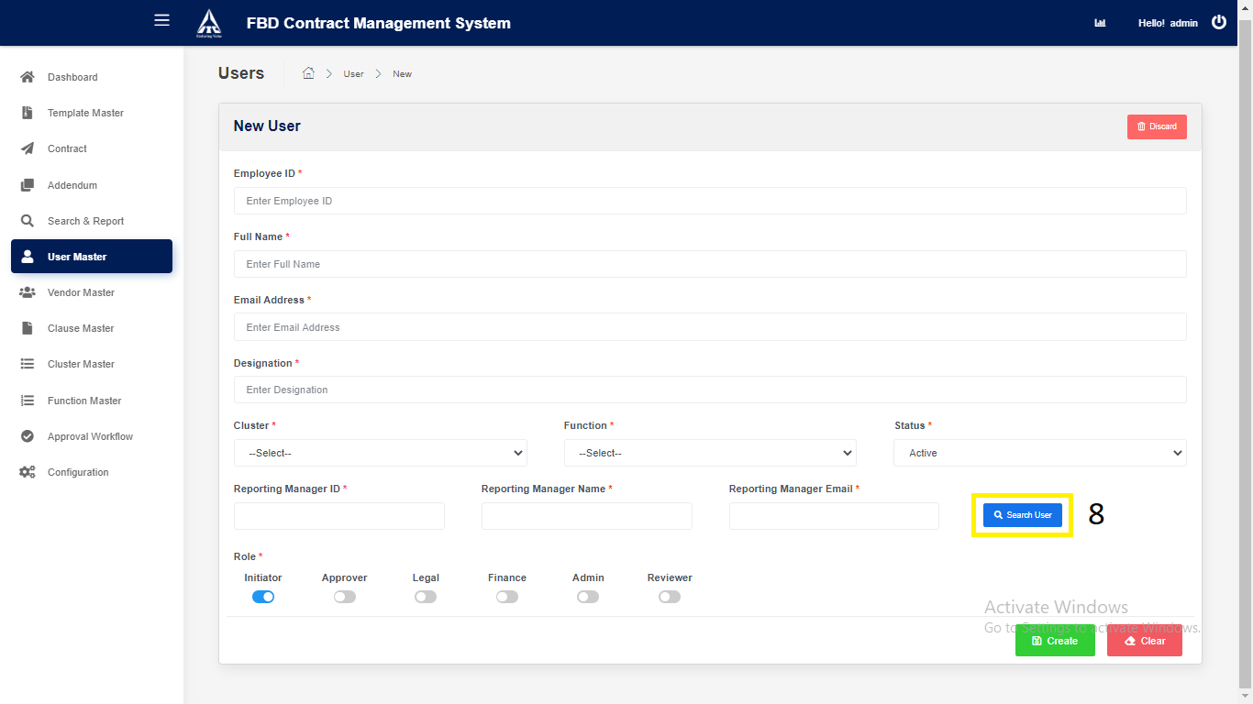

1. Select **Role**:
2. Initiator.
3. Approver.
4. Legal.
5. Finance.
6. Admin.
7. Reviewer.

4) Click on “Create” button.

*Application will redirect to “****User Repository****” page.*

5) Click on “Clear” button.

Clears all User Input Fields.

*Application will redirect to “****User Create****” page.*

6) Click on “**Discard** “button.

1. Yes Discard.

*Application will redirect to “****User Repository****” page.*

1. Cancel.

*Application will redirect to “****User Creation****” page.*

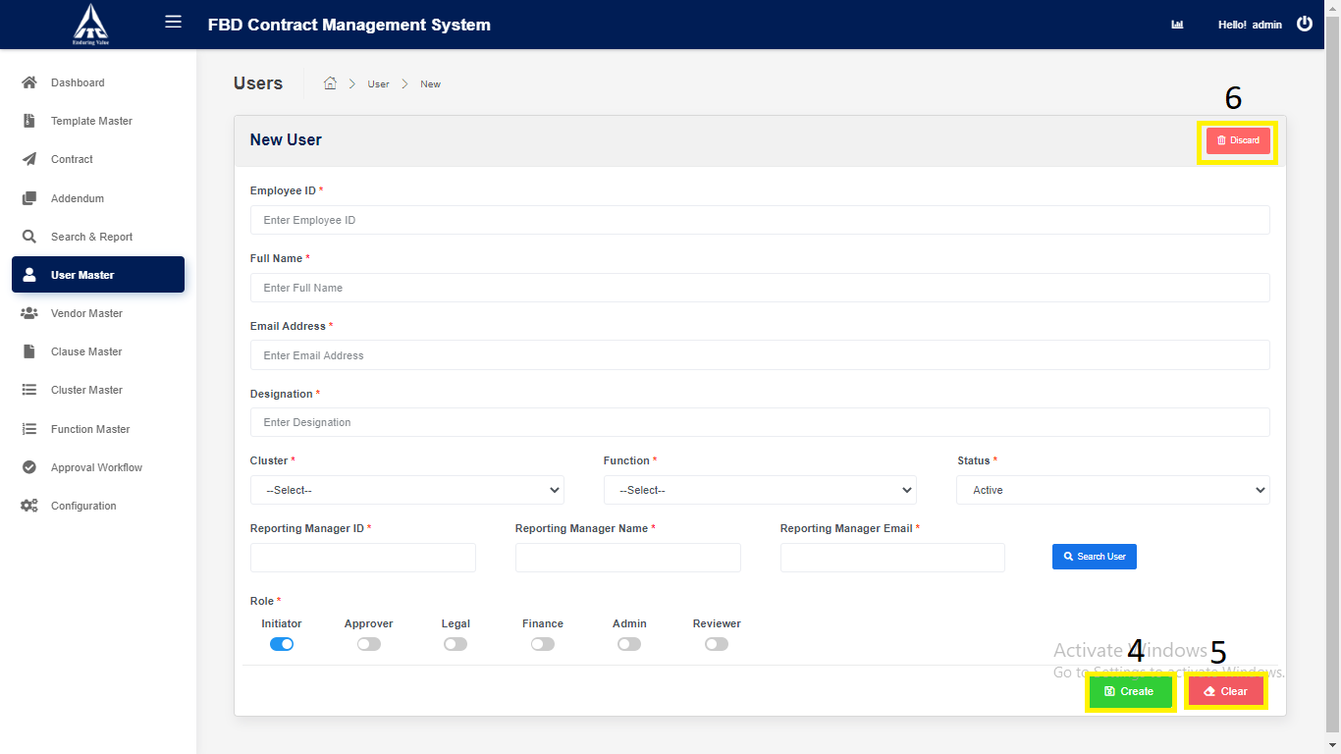

**2. Modify Existing User Master:**

1. Click on “**User Master**” in side menu.
2. Click on **View** icon to navigate to the **details** page.

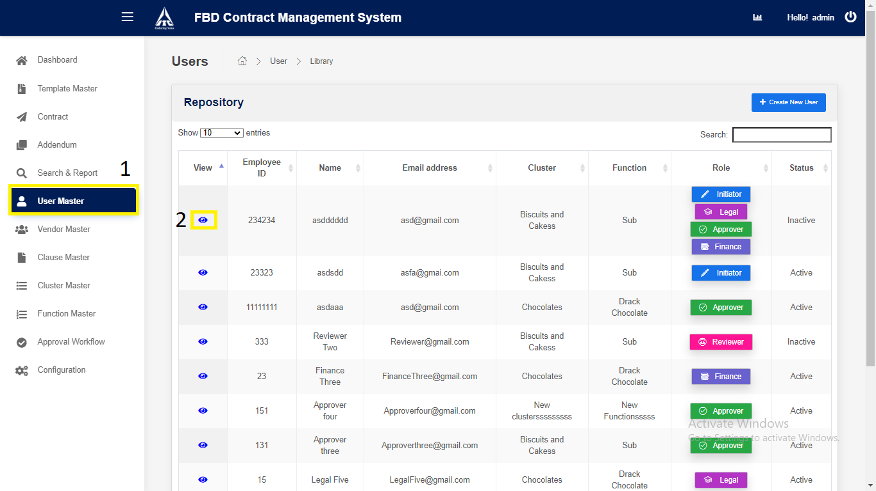

*Application will redirect to “****User Details****” page.*

1. Click on “**Edit**” button to **modify** the User Master.
2. **Edit** the details.
3. Click on “**Save**” button to **update** the User Master.

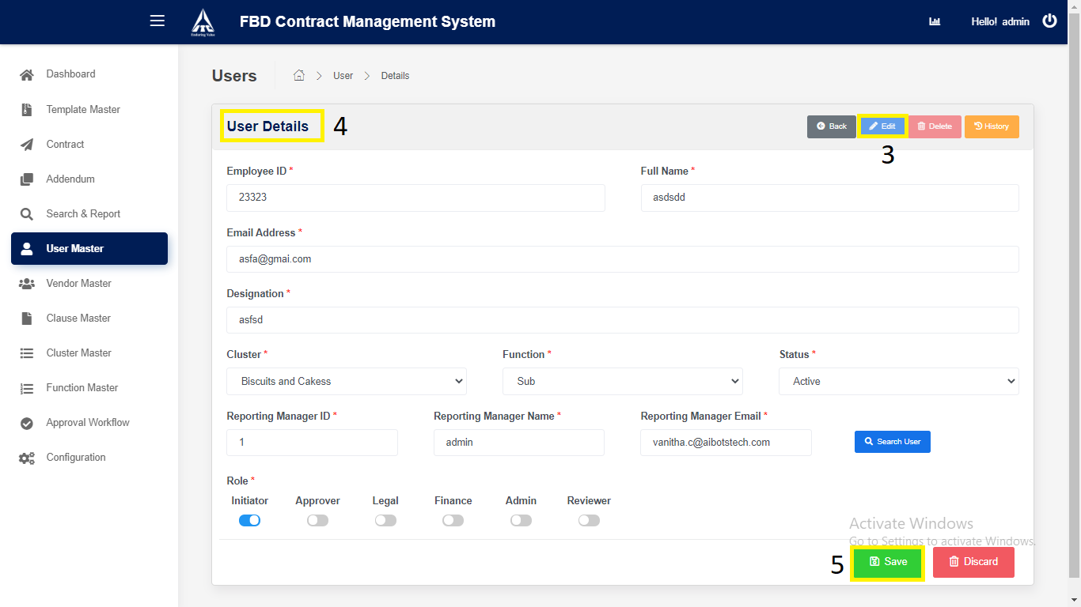

*Application will redirect to “****User Master Repository****” page.*

**3. User Master Deletion:**

1. Click on “**User Master**” in side menu.
2. Click on **View** icon to navigate to the **details** page.



*Application will redirect to “****User Details****” page.*

1. Click on “**Delete**” button to **delete** the User Master.

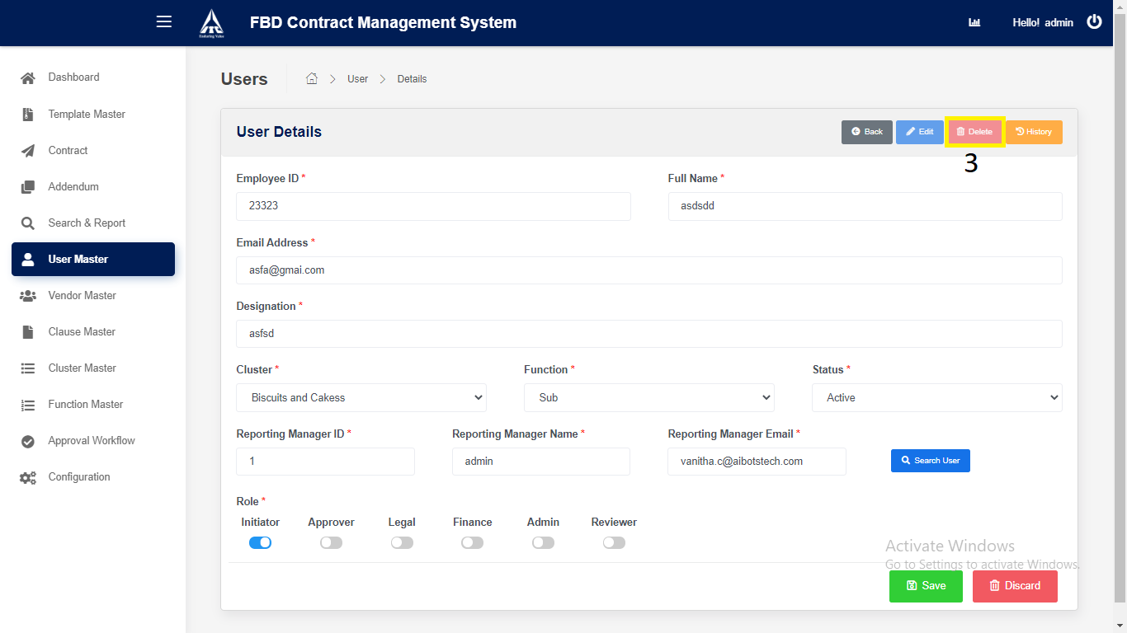

*Application will redirect to “****User Master Repository****” page.*

**Vendor Master**

1. **Vendor Master Creation:**
2. Click on “**Vendor Master**” in side menu.
3. Click on “**Create New Vendor**” button to **create** new Vendor Master.

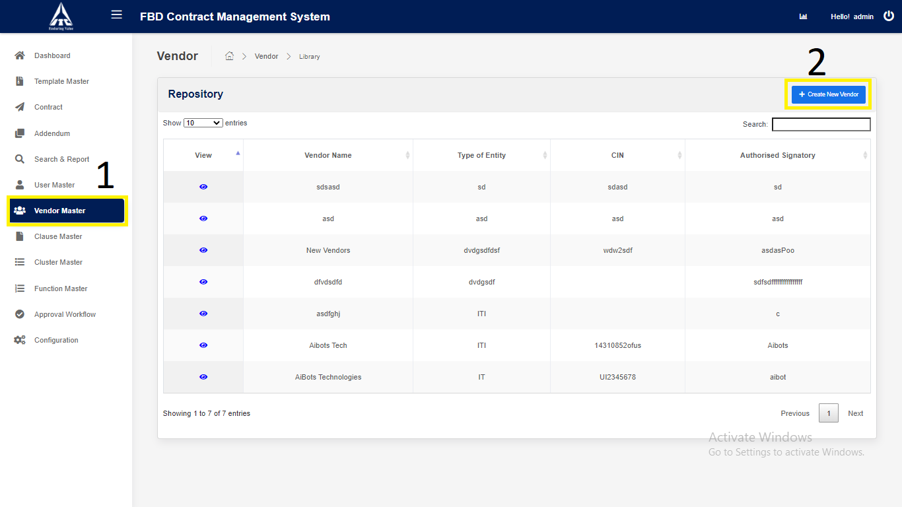

*Application will redirect to “****New Vendor****” page*

1. Enter the **Vendor** Details,
2. Select Type Of Entity as “**Company**”.

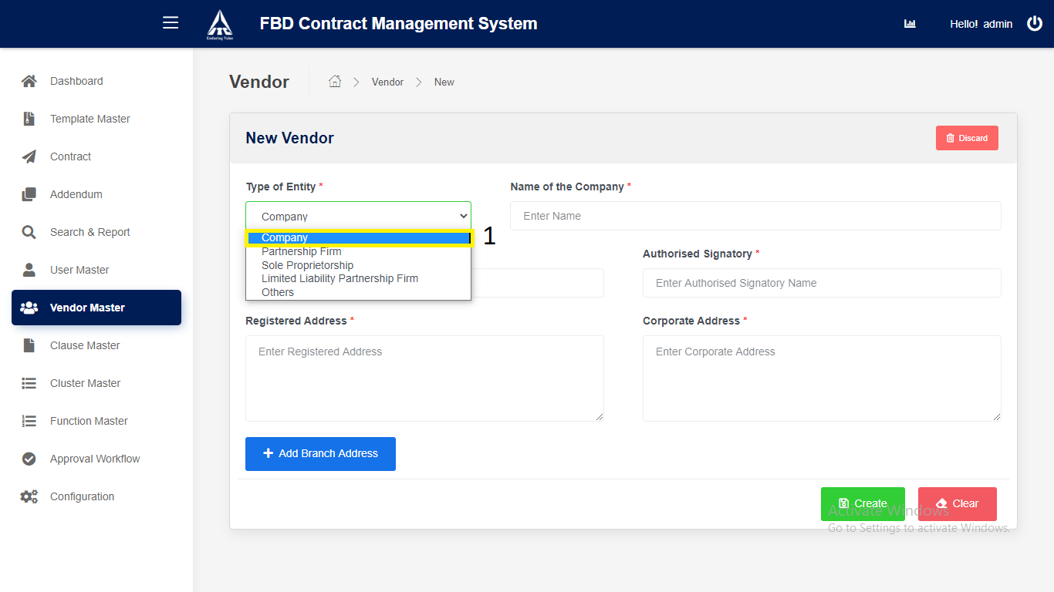

1. Enter “**Name of the Company**”.
2. Enter “**Corporate Identification Number (CIN)”.**
3. Enter “**Authorized Signatory”.**
4. Enter “**Registered Address”.**
5. Enter “**Corporate Address”.**
6. Click on “**Add Branch Address”.**
7. **Branch 1 Address.**
   1. Click on “**Add**”: New Branch address can be added.
   2. Click on “**Remove**”: Particular Branch address will be removed.
8. **Branch 2 Address.**
   1. Click on “**Add**”: New Branch address can be added.
   2. Click on “**Remove**”: Particular Branch address will be removed.
9. **Branch 3 Address.**
   1. Click on “**Add**”: New Branch address can be added.
   2. Click on “**Remove**”: Particular Branch address will be removed.
10. **Branch 4 Address.**
    1. Click on “**Add**”: New Branch address can be added.
    2. Click on “**Remove**”: Particular Branch address will be removed.
11. **Branch 5 Address.**
    1. Click on “**Remove**”: Particular Branch address will be removed.
12. Select Type Of Entity as “**Partnership Firm**”.

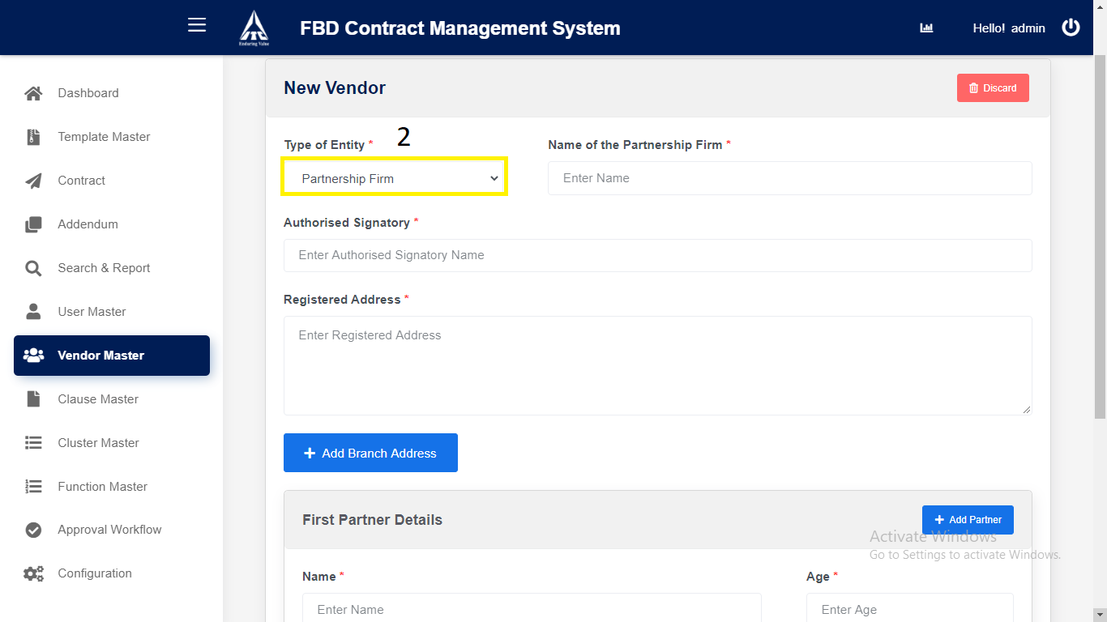

1. Enter “**Name of the Partnership Firm**”.
2. Enter “**Authorized Signatory”.**
3. Enter “**Registered Address”.**
4. Click on “**Add Branch Address”.**
5. **Branch 1 Address.**
   1. Click on “**Add**”: New Branch address can be added.
   2. Click on “**Remove**”: Particular Branch address will be removed.
6. **Branch 2 Address.**
   1. Click on “**Add**”: New Branch address can be added.
   2. Click on “**Remove**”: Particular Branch address will be removed.

3. **Branch 3 Address.**

* 1. Click on “**Add**”: New Branch address can be added.
  2. Click on “**Remove**”: Particular Branch address will be removed.

4. **Branch 4 Address.**

* 1. Click on “**Add**”: New Branch address can be added.
  2. Click on “**Remove**”: Particular Branch address will be removed.

5. **Branch 5 Address.**

* 1. Click on “**Remove**”: Particular Branch address will be removed.

1. Enter “**First Partner Details**”.
2. Enter “Name”.
3. Enter “Age”.
4. Enter “Father’s/Husband’s Name”.
5. Enter “Address”.
6. Click “**Add Partner**”. Second Partner Details can be added.

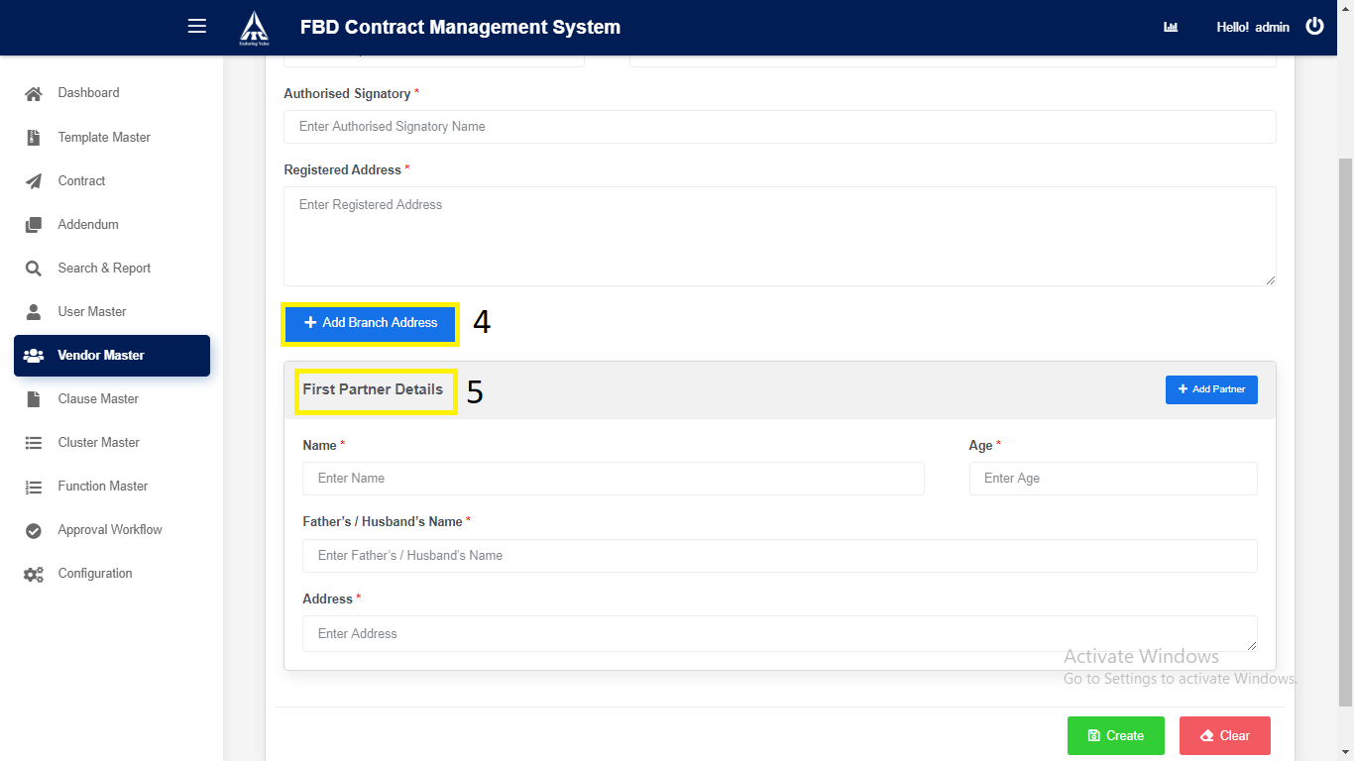

1. Enter “**Second Partner Details**”.
2. Enter “Name”.
3. Enter “Age”.
4. Enter “Father’s/Husband’s Name”.
5. Enter “Address”.
6. Click “**Add Partner**” Third Partner Details can be added.
7. Click “**Remove**” Particular Partner Details will be removed.

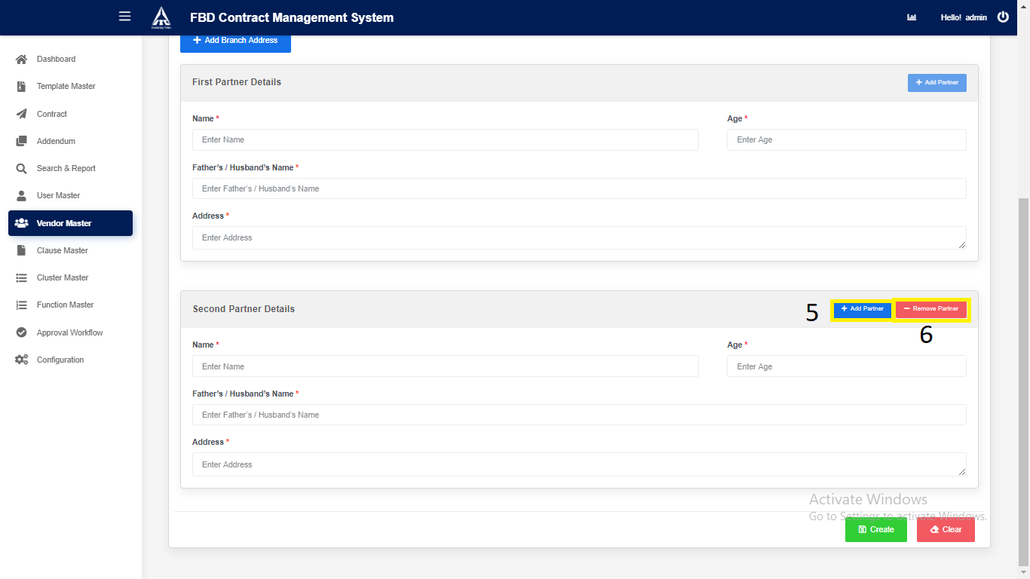

1. Enter “**Third Partner Details**”.
2. Enter “Name”.
3. Enter “Age”.
4. Enter “Father’s/Husband’s Name”.
5. Enter “Address”.
6. Click “**Add Partner**” Fourth Partner Details can be added.
7. Click “**Remove**” Particular Partner Details will be removed.
8. Enter “**Fourth Partner Details**”.
9. Enter “Name”.
10. Enter “Age”.
11. Enter “Father’s/Husband’s Name”.
12. Enter “Address”.
13. Click “**Add Partner**” Fifth Partner Details can be added.
14. Click “**Remove**” Particular Partner Details will be removed.
15. Enter “**Fifth** **Partner Details**”.
16. Enter “Name”.
17. Enter “Age”.
18. Enter “Father’s/Husband’s Name”.
19. Enter “Address”.
20. Click “**Add Partner**” Sixth Partner Details can be added.
21. Click “**Remove**” Particular Partner Details will be removed.
22. Enter “**Sixth** **Partner Details**”.
23. Enter “Name”.
24. Enter “Age”.
25. Enter “Father’s/Husband’s Name”.
26. Enter “Address”.
27. Click “**Add Partner**” Seventh Partner Details can be added.
28. Click “**Remove**” Particular Partner Details will be removed.
29. Enter “**Seventh** **Partner Details**”.
30. Enter “Name”.
31. Enter “Age”.
32. Enter “Father’s/Husband’s Name”.
33. Enter “Address”.
34. Click “**Add Partner**” Eighth Partner Details can be added.
35. Click “**Remove**” Particular Partner Details will be removed.
36. Enter “**Eighth** **Partner Details**”.
37. Enter “Name”.
38. Enter “Age”.
39. Enter “Father’s/Husband’s Name”.
40. Enter “Address”.
41. Click “**Add Partner**” Ninth Partner Details can be added.
42. Click “**Remove**” Particular Partner Details will be removed.
43. Enter “**Ninth** **Partner Details**”.
44. Enter “Name”.
45. Enter “Age”.
46. Enter “Father’s/Husband’s Name”.
47. Enter “Address”.
48. Click “**Add Partner**” Tenth Partner Details can be added.
49. Click “**Remove**” Particular Partner Details will be removed.
50. Enter “**Tenth** **Partner Details**”.
51. Enter “Name”.
52. Enter “Age”.
53. Enter “Father’s/Husband’s Name”.
54. Enter “Address”.
55. Click “**Remove**” Particular Partner Details will be removed.
56. Select “Type Of Entity as “**Sole** **Partnership**”.

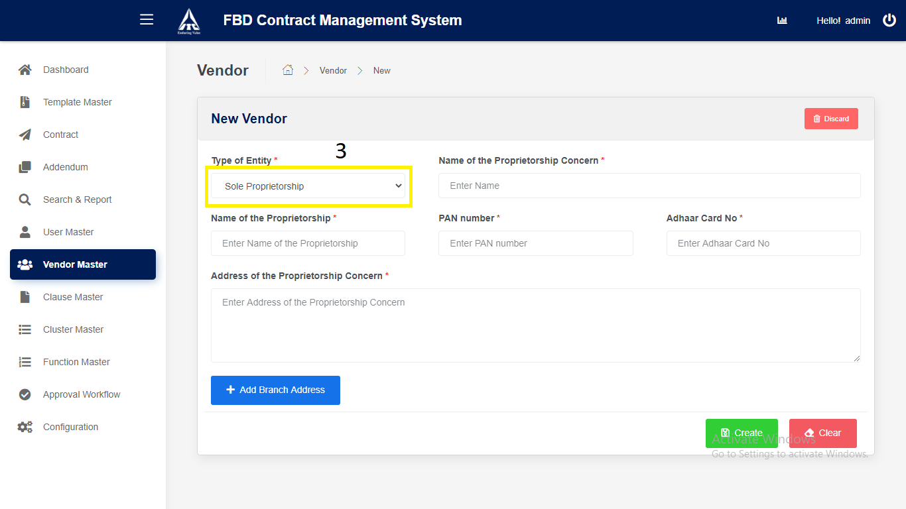

1) Enter “Name of the Proprietorship Concern”.

2) Enter “Name of the Proprietorship”.

3) Enter “PAN Number”.

4) Enter “Adhaar Number”.

5) Enter “Address of the Proprietorship Concern”.

6) Click on “**Add Branch Address”.**

1. **Branch 1 Address.**
   1. Click on “**Add**”: New Branch address can be added.
   2. Click on “**Remove**”: Particular Branch address will be removed.

**2. Branch 2 Address.**

* 1. Click on “**Add**”: New Branch address can be added.
  2. Click on “**Remove**”: Particular Branch address will be removed.

3. **Branch 3 Address.**

* 1. Click on “**Add**”: New Branch address can be added.
  2. Click on “**Remove**”: Particular Branch address will be removed.

4. **Branch 4 Address.**

* 1. Click on “**Add**”: New Branch address can be added.
  2. Click on “**Remove**”: Particular Branch address will be removed.

5. **Branch 5 Address.**

* 1. Click on “**Remove**”: Particular Branch address will be removed.

4. Select “**Limited Liability Partnership Firm”.**

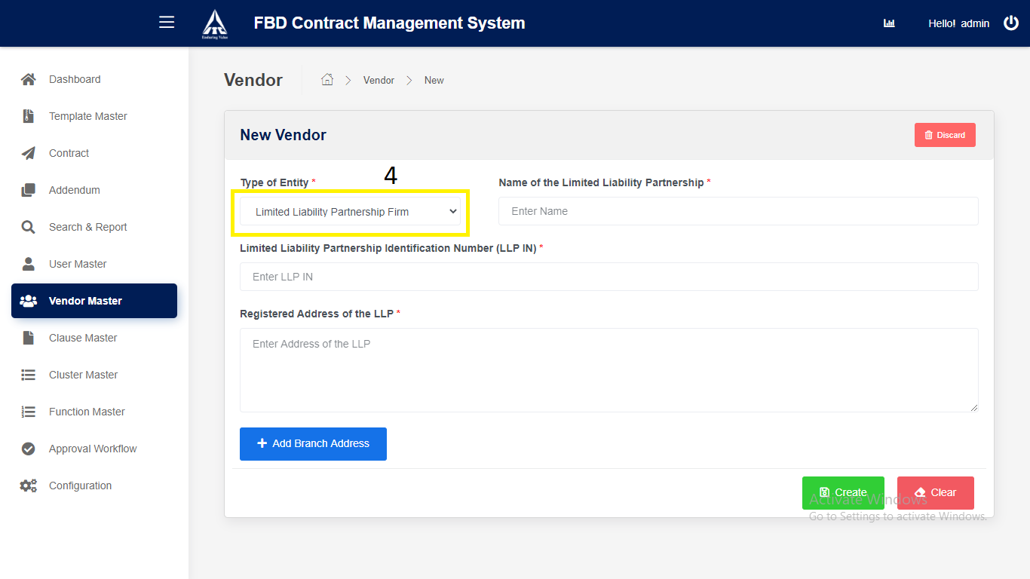

1) Enter “Name of the Limited Liability Partnership”.

2) Enter “Limited Liability Partnership Identification

Number (LLPIN).

3) Enter “Registered Address of the LLP”.

4) Click on “**Add Branch Address”.**

1. **Branch 1 Address.**
   1. Click on “**Add**”: New Branch address can be added.
   2. Click on “**Remove**”: Particular Branch address will be removed.

**2. Branch 2 Address.**

* 1. Click on “**Add**”: New Branch address can be added.
  2. Click on “**Remove**”: Particular Branch address will be removed.

3. **Branch 3 Address.**

* 1. Click on “**Add**”: New Branch address can be added.
  2. Click on “**Remove**”: Particular Branch address will be removed.

4. **Branch 4 Address.**

* 1. Click on “**Add**”: New Branch address can be added.
  2. Click on “**Remove**”: Particular Branch address will be removed.

5. **Branch 5 Address.**

* 1. Click on “**Remove**”: Particular Branch address will be removed.

1. Select “**Others**”.

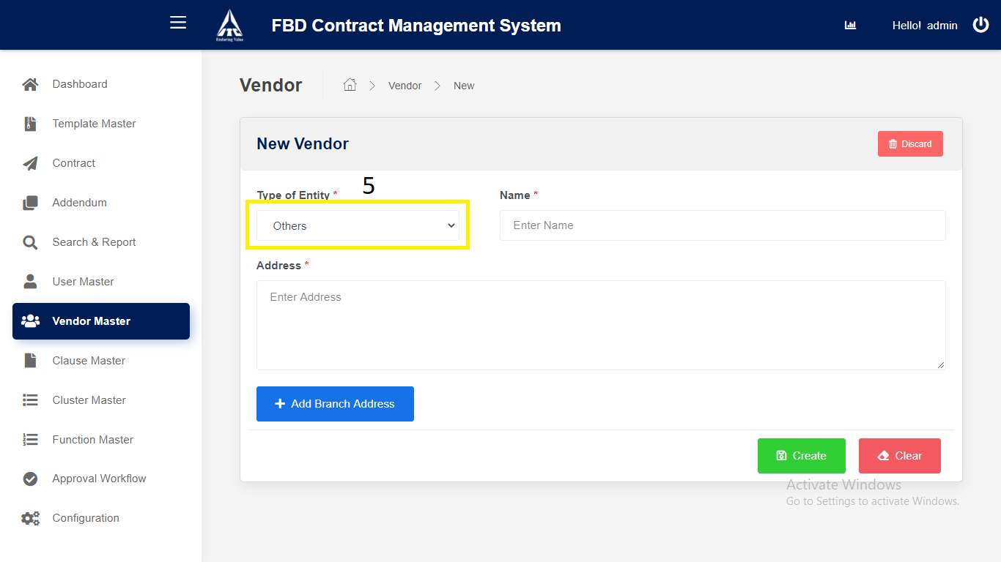

1. Enter “Name”.

2. Enter “Address”.

3. Click on “**Add Branch Address”.**

**1. Branch 1 Address.**

* 1. Click on “**Add**”: New Branch address can be added.
  2. Click on “**Remove**”: Particular Branch address will be removed.

**2. Branch 2 Address.**

* 1. Click on “**Add**”: New Branch address can be added.
  2. Click on “**Remove**”: Particular Branch address will be removed.

3. **Branch 3 Address.**

* 1. Click on “**Add**”: New Branch address can be added.
  2. Click on “**Remove**”: Particular Branch address will be removed.

4. **Branch 4 Address.**

* 1. Click on “**Add**”: New Branch address can be added.
  2. Click on “**Remove**”: Particular Branch address will be removed.

5. **Branch 5 Address.**

* 1. Click on “**Remove**”: Particular Branch address will be removed.

1. Click on “**Create**” button.

*Application will redirect to “****Vendor Repository****” page.*

1. Click on “Clear “button.

*Application will redirect to “****Vendor Create****” page*

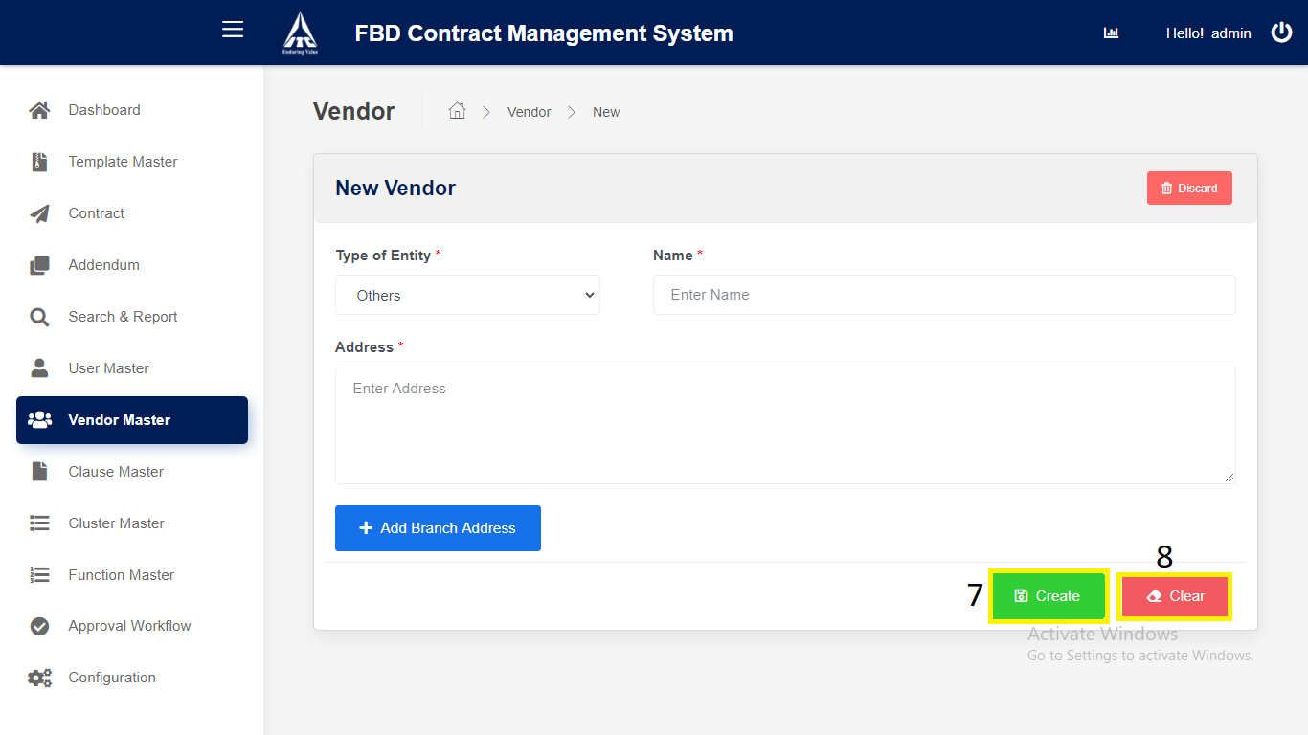

**2**. **Modify Existing Vendor Master:**

1. Click on “**Vendor Master**” in side menu.
2. Click on **View** icon to navigate to the **details** page.

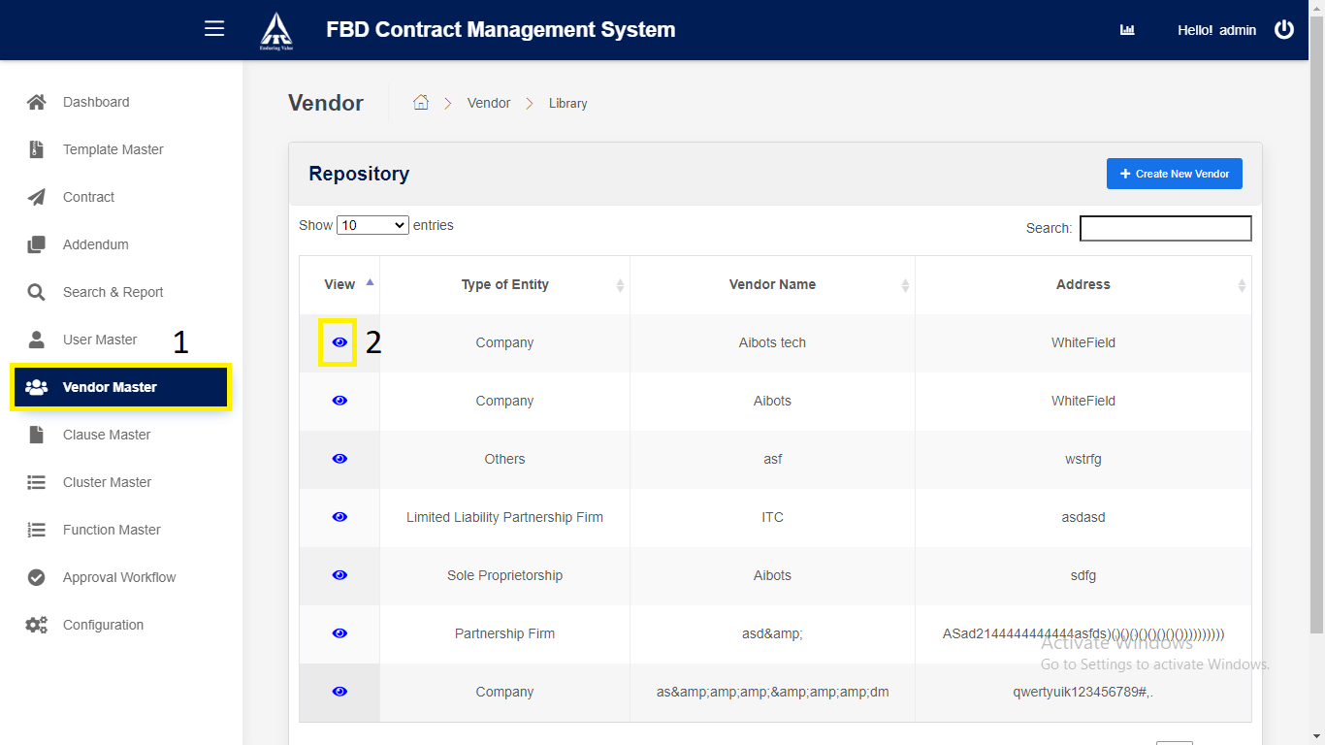

*Application will redirect to “****Vendor Details****” page.*

1. Click on “**Edit**” button to **modify** the Vendor Master.
2. **Edit** the details.
3. Click on “**Save**” button to **update** the Vendor Master.

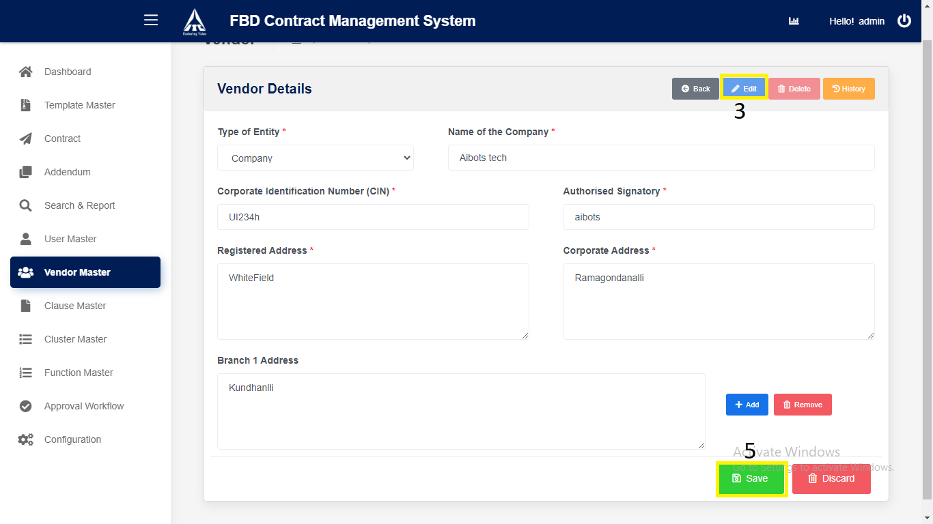

*Application will redirect to “****Vendor Master Repository****” page.*

**3. Approval Workflow Deletion:**

1. Click on “**Vendor Master**” in side menu.
2. Click on **View** icon to navigate to the **details** page.



1. Click on “**Delete**” button to **delete** the Vendor Master.

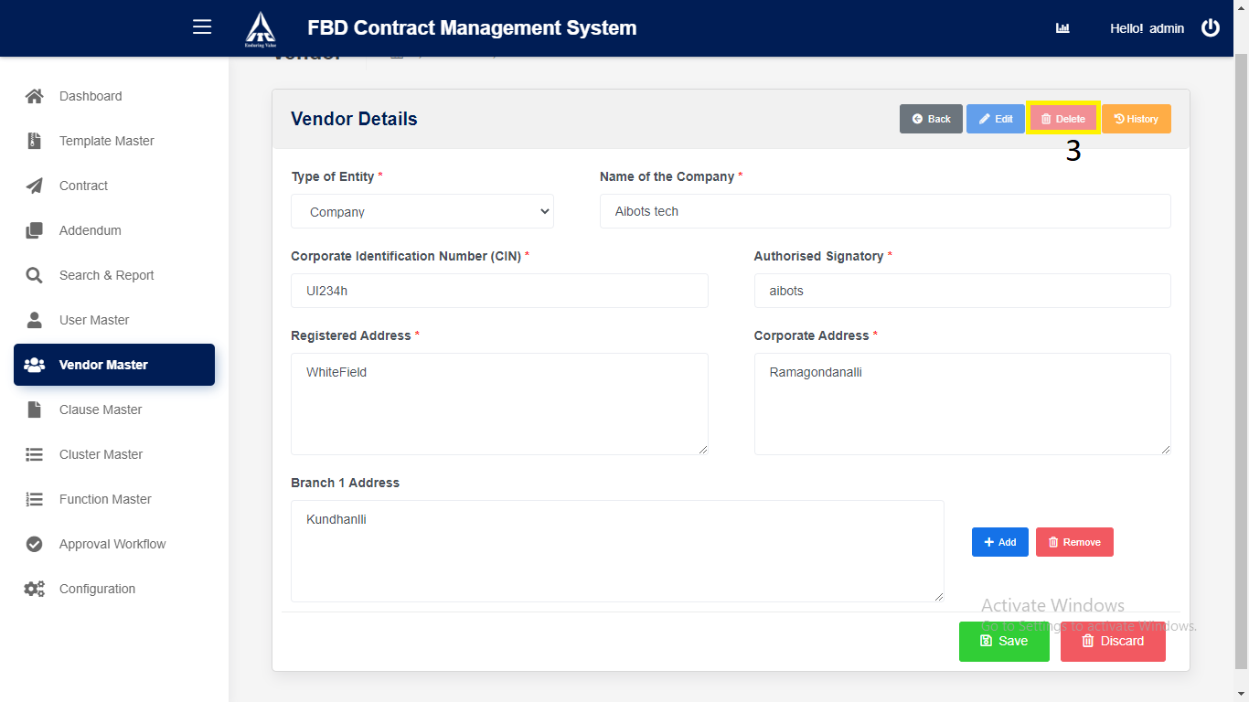

*Application will redirect to “****Vendor Master Repository****” page.*

**Clause Master**

**1. Clause Master Creation:**

1) Click on “**Clause Master**” in side menu.

2) Click on “**Create New Clause**” button to **create** new Clause Master.

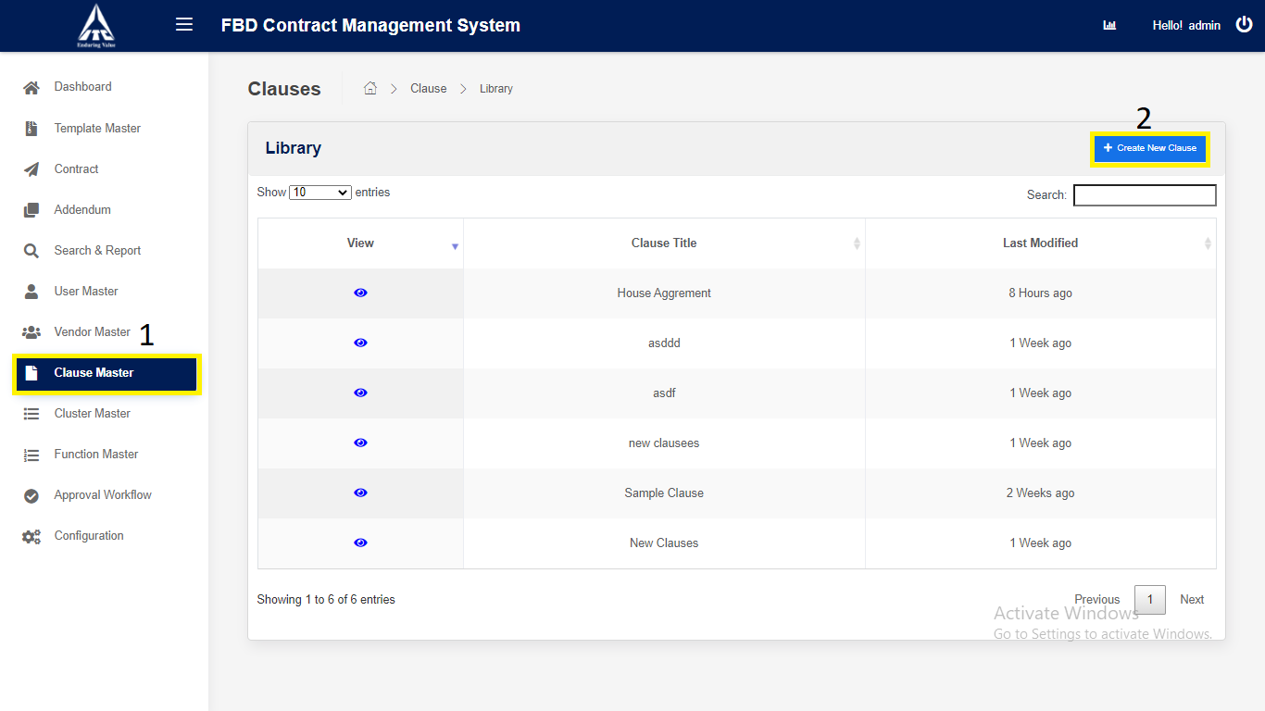

*Application will redirect to “****New Clause****” page.*

3) Enter **Clause Master** Details,

1. Enter “**Clause Tittle**”.
2. Enter “**Clause Description**”.
3. Enter “**Clause Text**”.

4) Click on “**Create**” button to save the **Clause Master**.

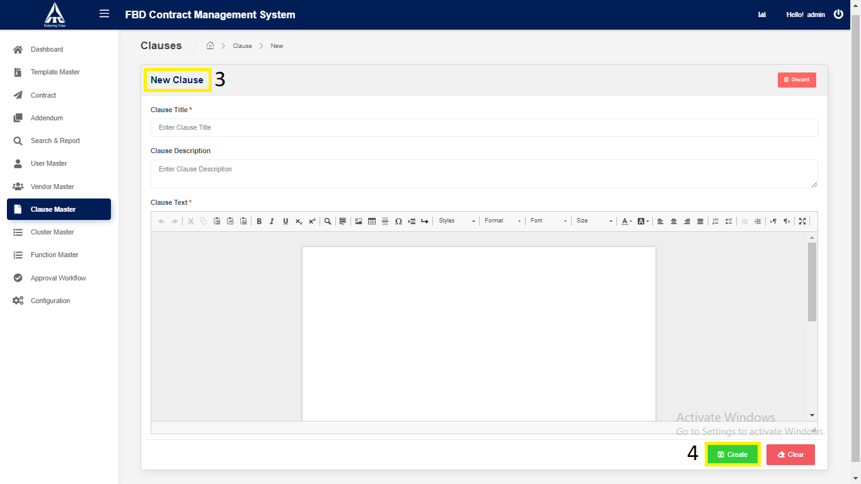

*Application will redirect to “****Clause Master Repository****” page.*

**2. Modify Existing Clause Master:**

1. Click on “**Clause Master**” in side menu.
2. Click on **View** icon to navigate to the **details** page.

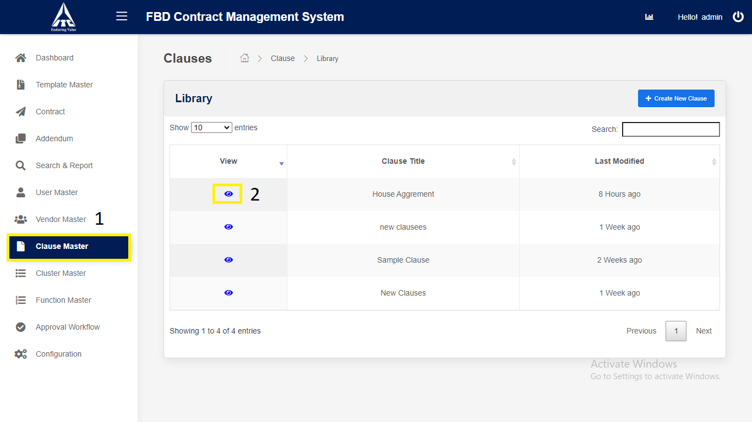

*Application will redirect to “****Clause Details****” page.*

1. Click on “**Edit**” button to **modify** the Clause Master.
2. **Edit** the details.
3. Click on “**Save**” button to **update** the Clause Master.

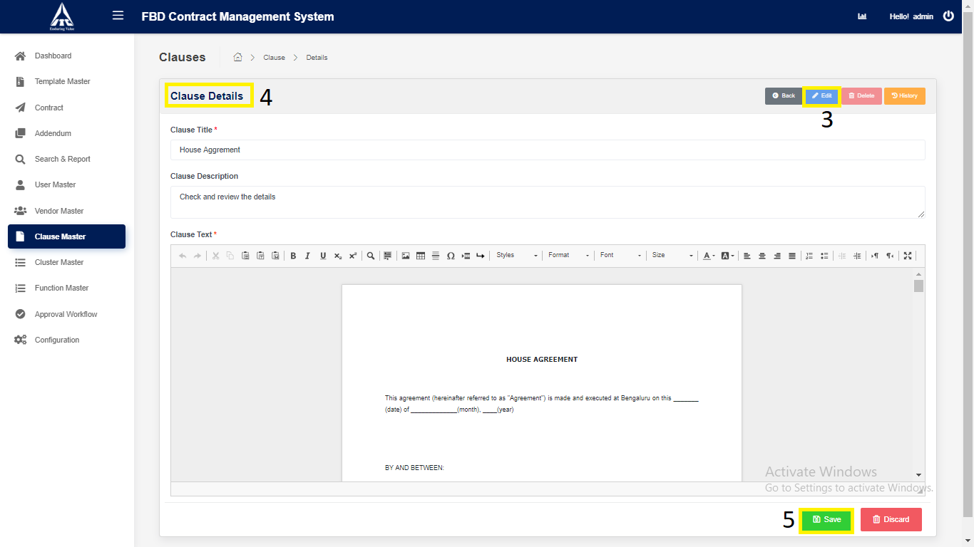

*Application will redirect to “****Clause Master Repository****” page.*

**3. Clause Master Deletion:**

1. Click on “**Clause Master**” in side menu.
2. Click on **View** icon to navigate to the **details** page.

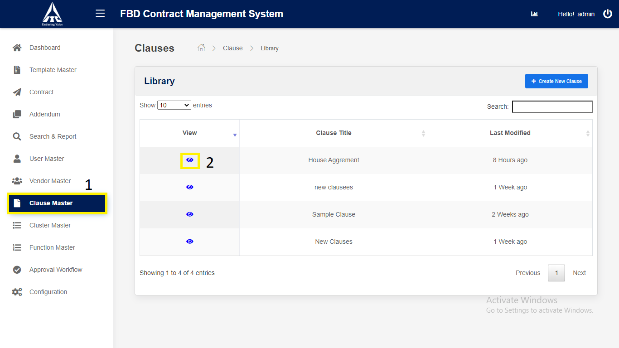

*Application will redirect to “****Clause Details****” page.*

1. Click on “**Delete**” button to **delete** the Clause Master.

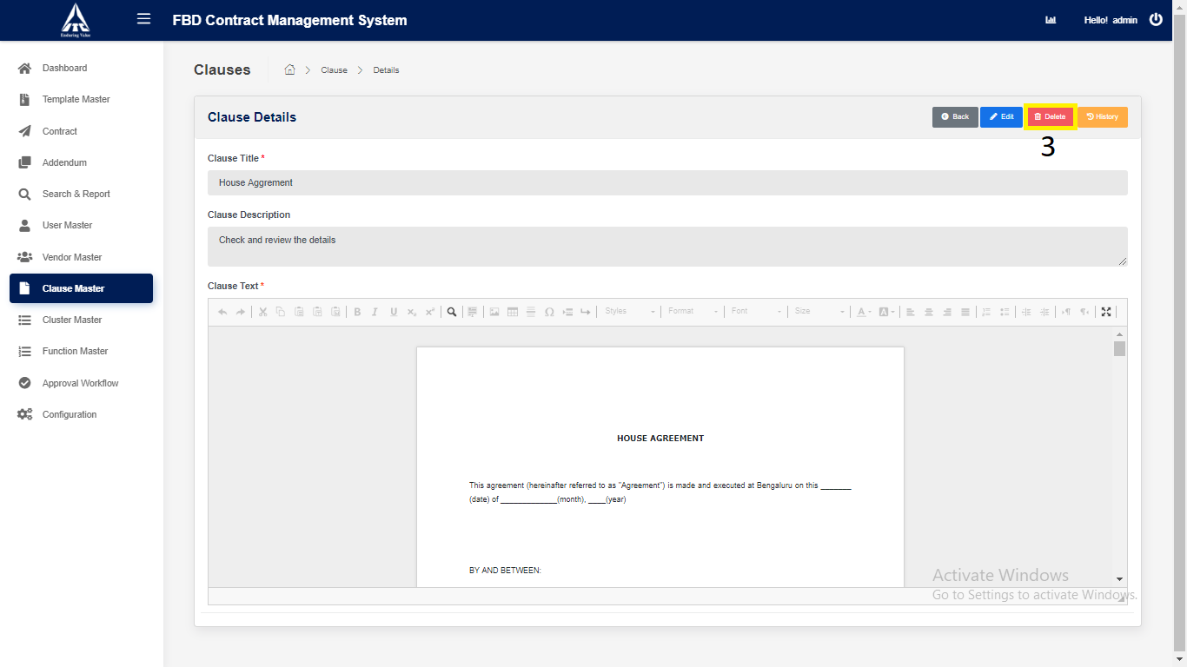

*Application will redirect to “****Clause Master Repository****” page.*

**Cluster Master:**

1. **Cluster Creation:**
2. Click on **Cluster Master** from Side Menu (Access to Admin Only).
3. Click on “**Create New Cluster**” button.

*Cluster Modal will be displayed.*

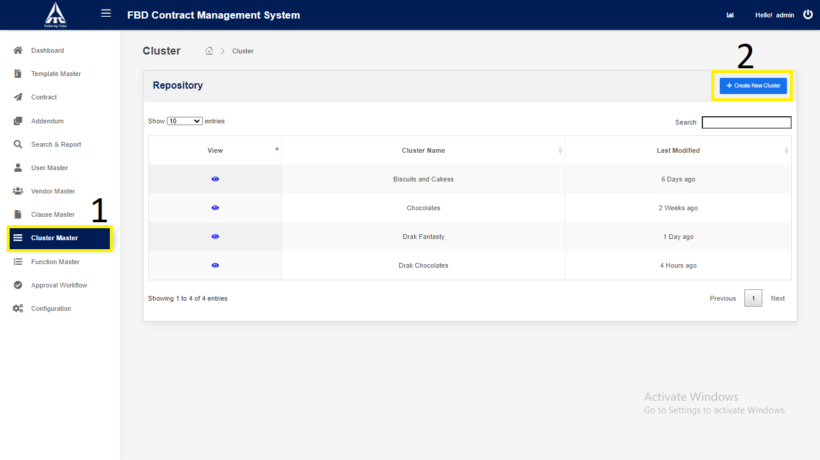

1. Enter the **Cluster** Details,

i. Cluster(Characters Only).

1. Click on “**Create**” button.

*Application will redirect to “****Cluster Repository****” page.*

1. Click on “**Cancel**”.

Clears all ClusterInput Fields.

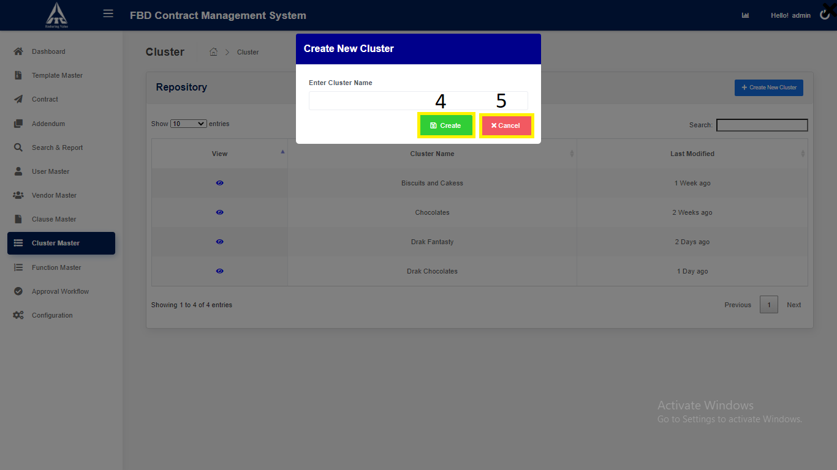

*Application will redirect to “***Cluster *Repository****” page.*

**2. Modify Existing Cluster Master:**

1. Click on “**Cluster Master**” in side menu.
2. Click on **View** icon to navigate to the **details** page.

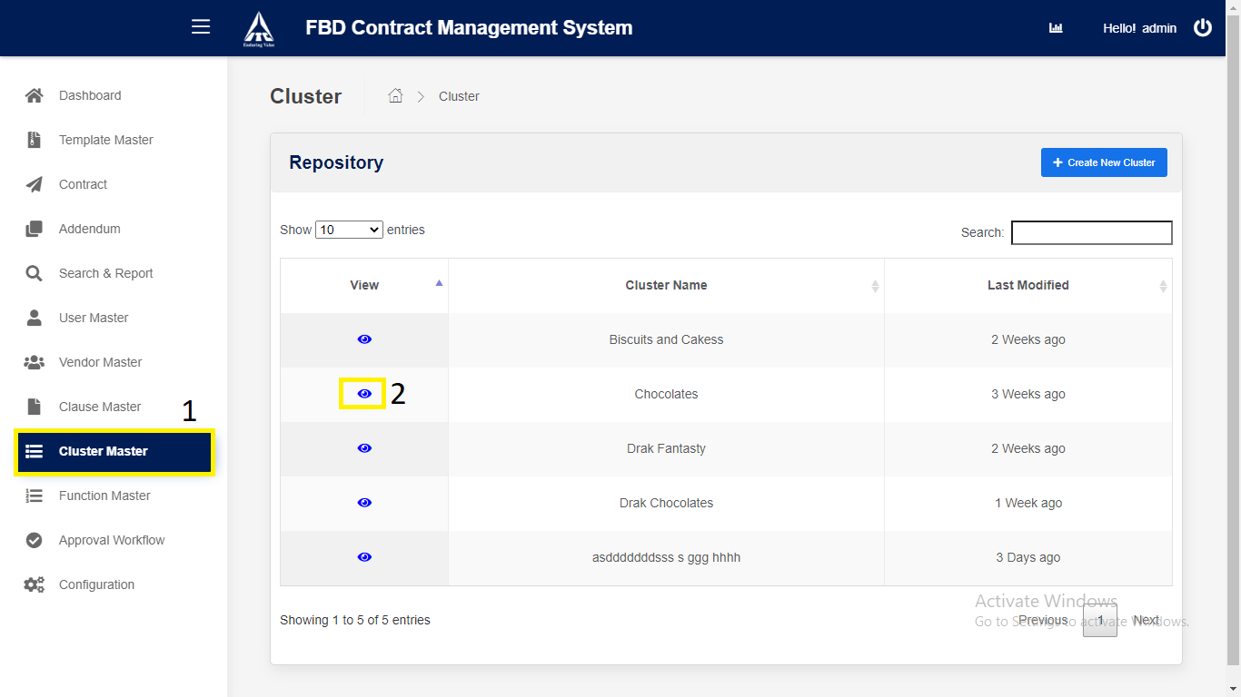

*Application will redirect to “****Cluster Details****” Modal.*

1. Click on “**Edit**” button to **modify** the ClusterMaster.
2. **Edit** the details.
3. Click on “**Save**” button to **update** the ClusterMaster.

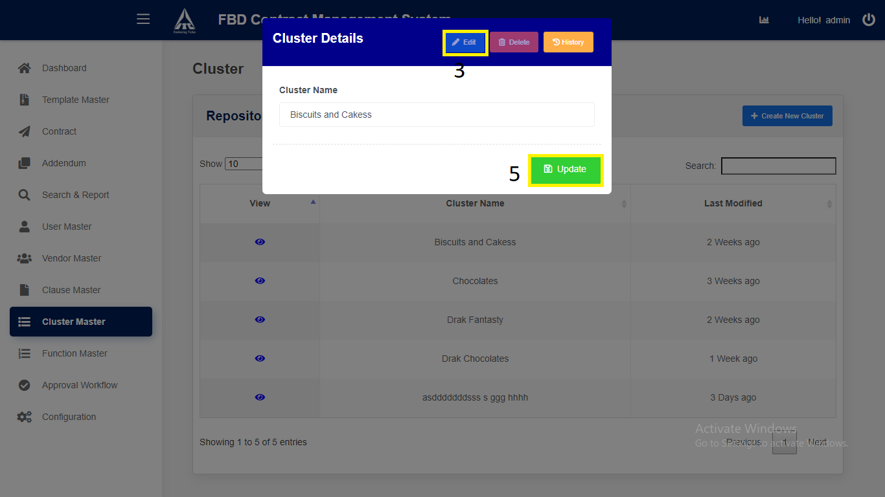

*Application will redirect to “****Cluster Master Repository****” page.*

1. **Cluster Master Deletion:**
2. Click on “**Cluster Master**” in side menu.
3. Click on **View** icon to navigate to the **details** page.

**

*Application will redirect to “****Cluster Details****” Modal.*

3) Click on “**Delete**” button to **delete** the Cluster Master.

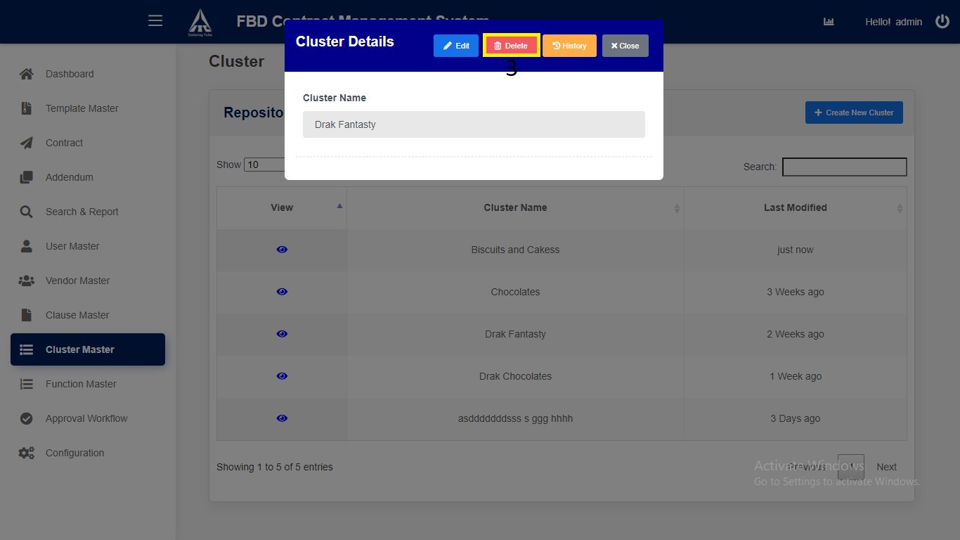

*Application will redirect to “****Cluster Master Repository****” page.*

**Function Master:**

1. **Function Creation:**
2. Click on **Function Master** from Side Menu (Access to Admin Only).
3. Click on “**Create New Function**” button.

*Function**Modal will be displayed.*

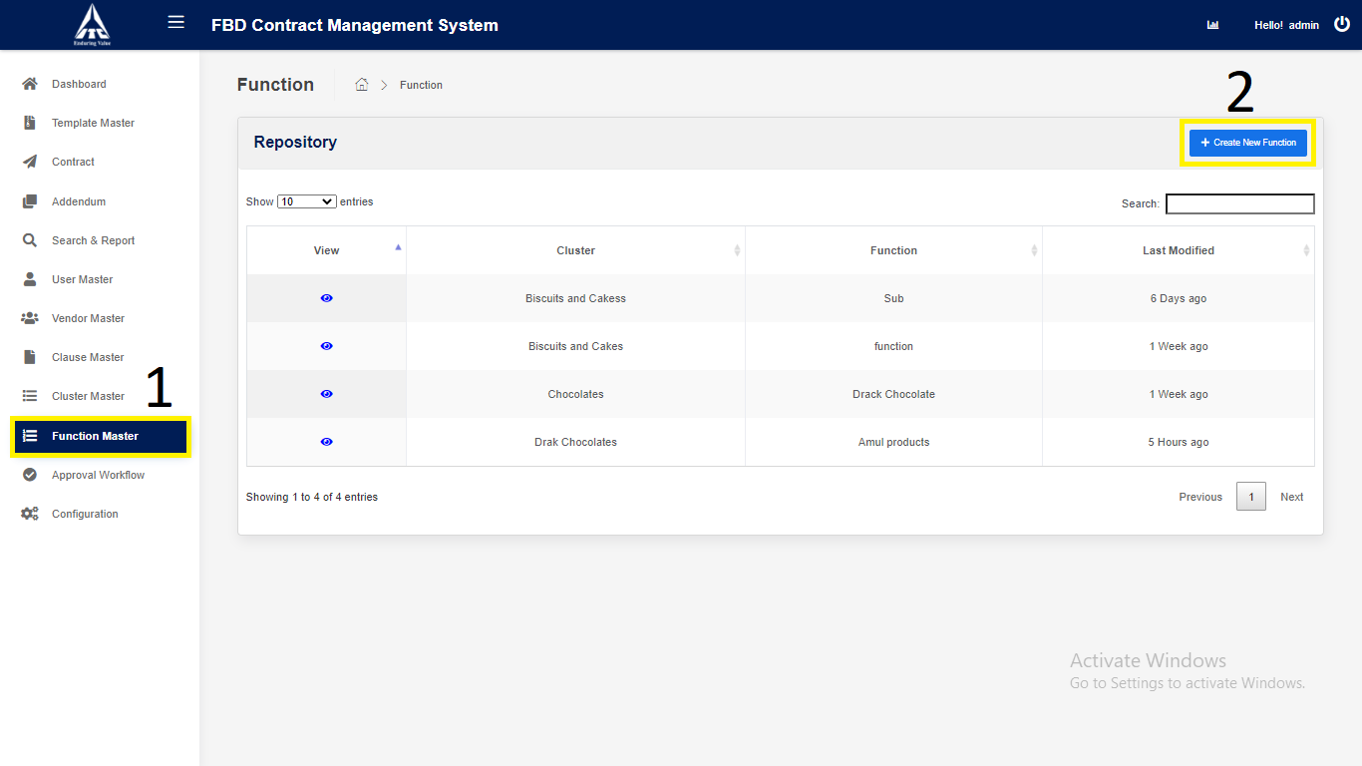

1. Enter the **Function** Details,

i. Cluster.

ii.Function (Characters Only).

1. Click on “**Create**” button.

*Application will redirect to “****Function* *Repository****” page.*

1. Click on “**Cancel**”.

Clears all FunctionInput Fields.

*Application will redirect to “****Function* *Repository****” page.*

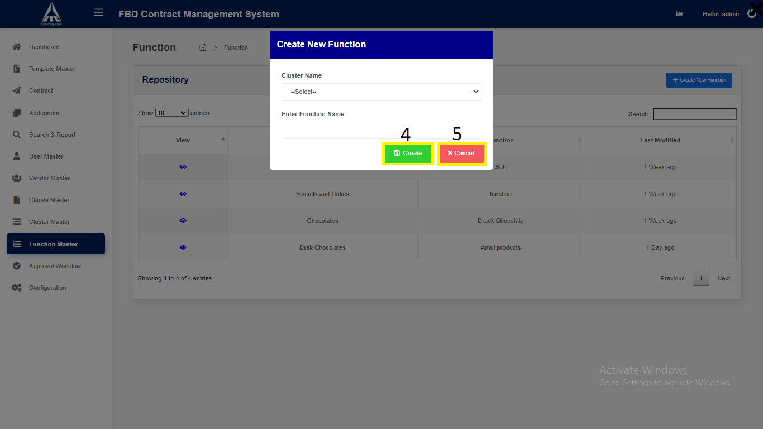

**2. Modify Existing Function Master:**

1. Click on “**Function Master**” in side menu.
2. Click on **View** icon to navigate to the **details** page.

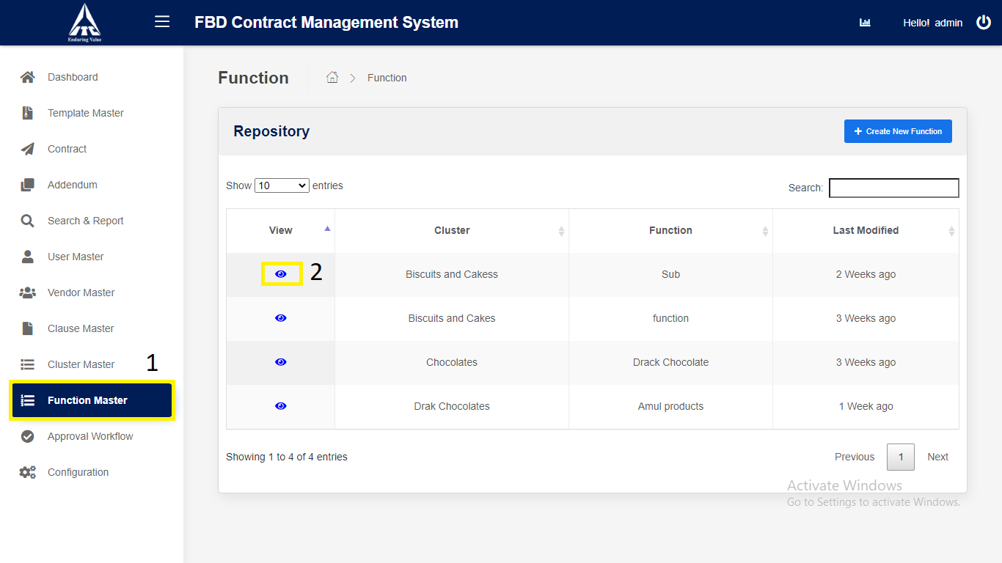

*Application will redirect to “****Function Details****” Modal.*

1. Click on “**Edit**” button to **modify** the FunctionMaster.
2. **Edit** the details.
3. Click on “**Save**” button to **update** the FunctionMaster.

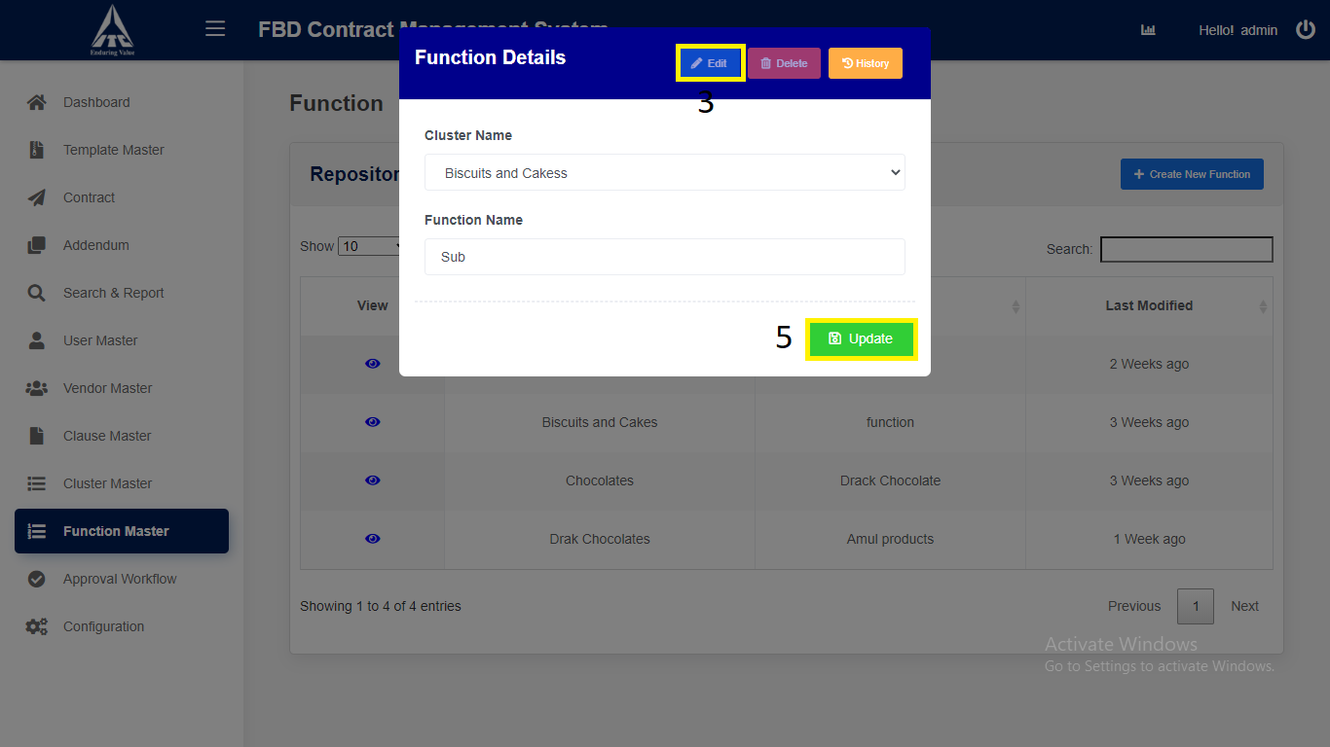

*Application will redirect to “****Function Master Repository****” page.*

1. **Function Master Deletion:**

1. Click on “**Function Master**” in side menu.

2. Click on **View** icon to navigate to the **details** page.



*Application will redirect to “****Function Details****” Modal.*

3. Click on “**Delete**” button to **delete** the Cluster Master.

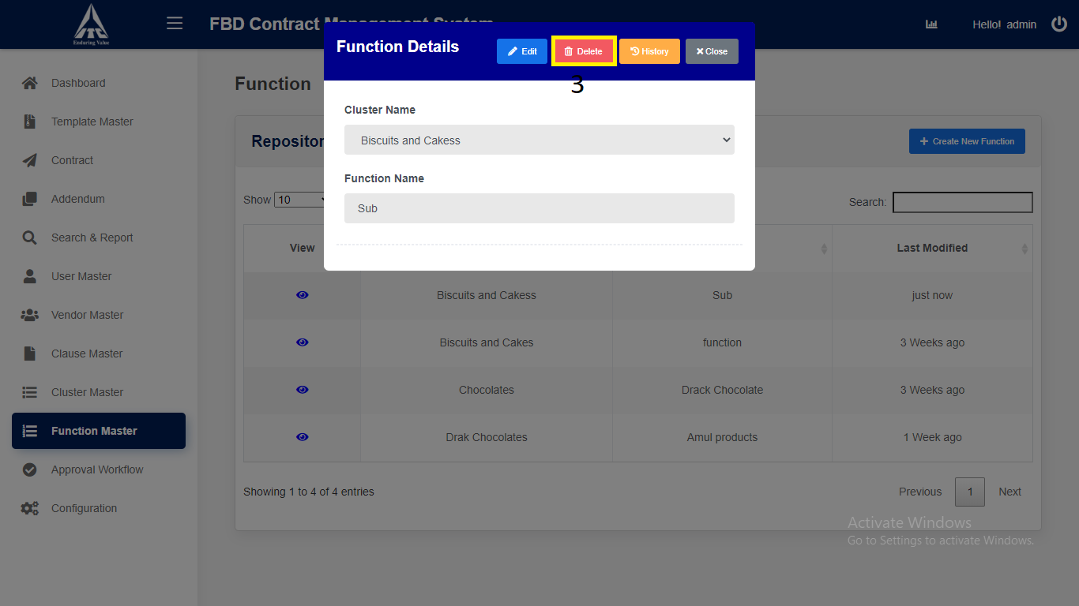

*Application will redirect to “****Function Master Repository****” page.*

**Approval Workflow**

1. **Approval Workflow Creation:**
2. Click on “**Approval Workflow**” in side menu.
3. Click on “**Create New Approvals**” button to **create** new Approval Workflow.

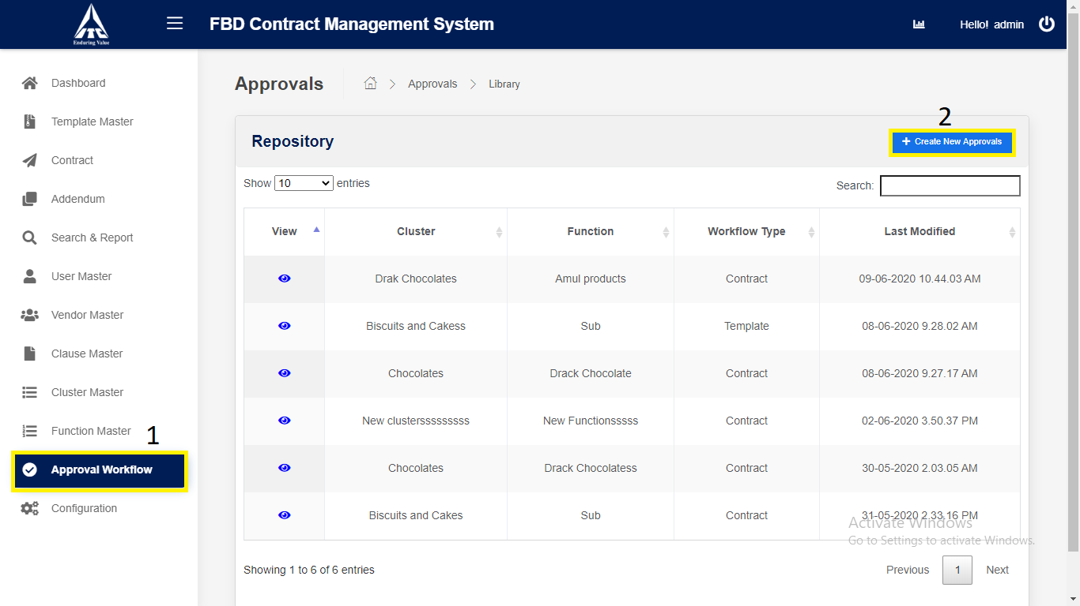

*Application will redirect to “****New Approvers****” page.*

1. Enter **Approval Workflow** details,
2. Select “**Workflow type**”.
3. Select “**Cluster**”.
4. Select “**Function**”.
5. Click on “**Search User**” button to search for the users.
6. Select “**Select By**” and Enter the **Information** in Search text box.
7. Click on “**Search**” button to search for the **users,** which matches the entered **information.**
8. Click on “**Select**”button to select the user as an Approver.
9. Click on “**Create**” button to save the **Approval Workflow**.

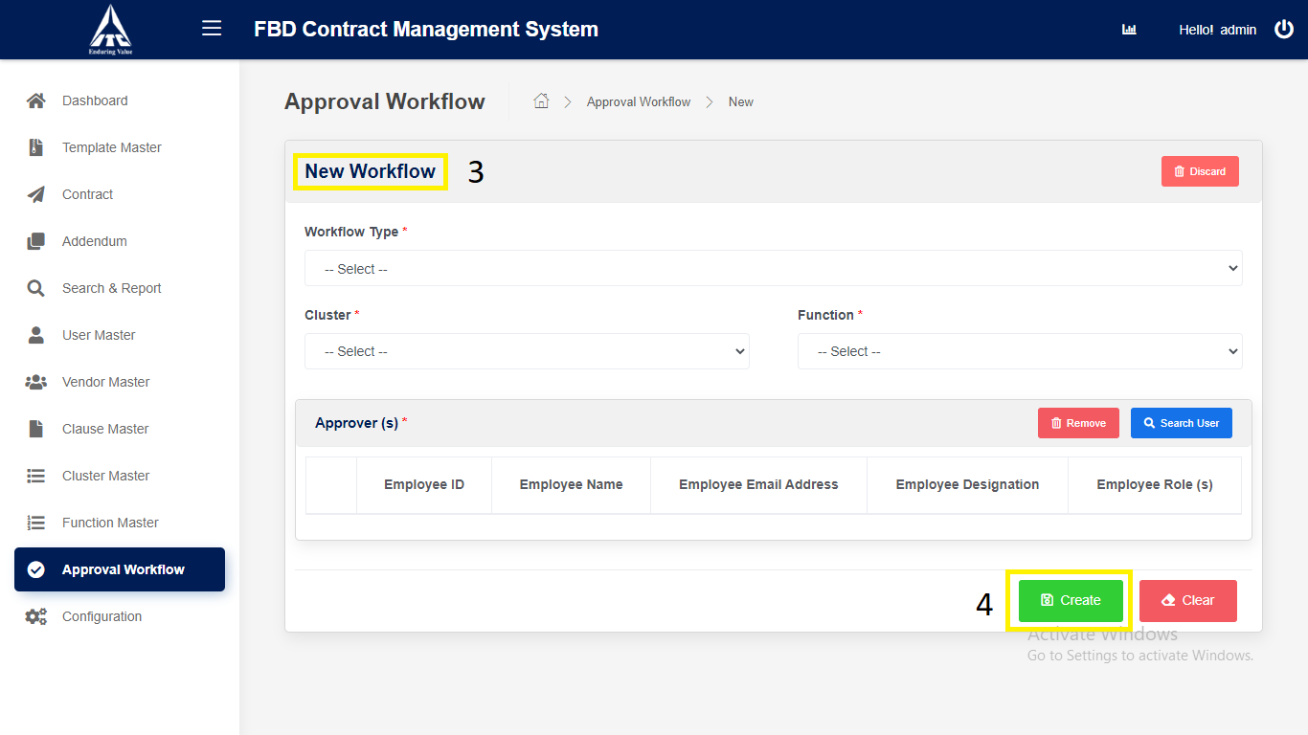

*Application will redirect to “****Approval Workflow Repository****” page.*

1. **Modify Existing Approval Workflow:**
2. Click on “**Approval Workflow**” in side menu.
3. Click on **View** icon to navigate to the **details** page.

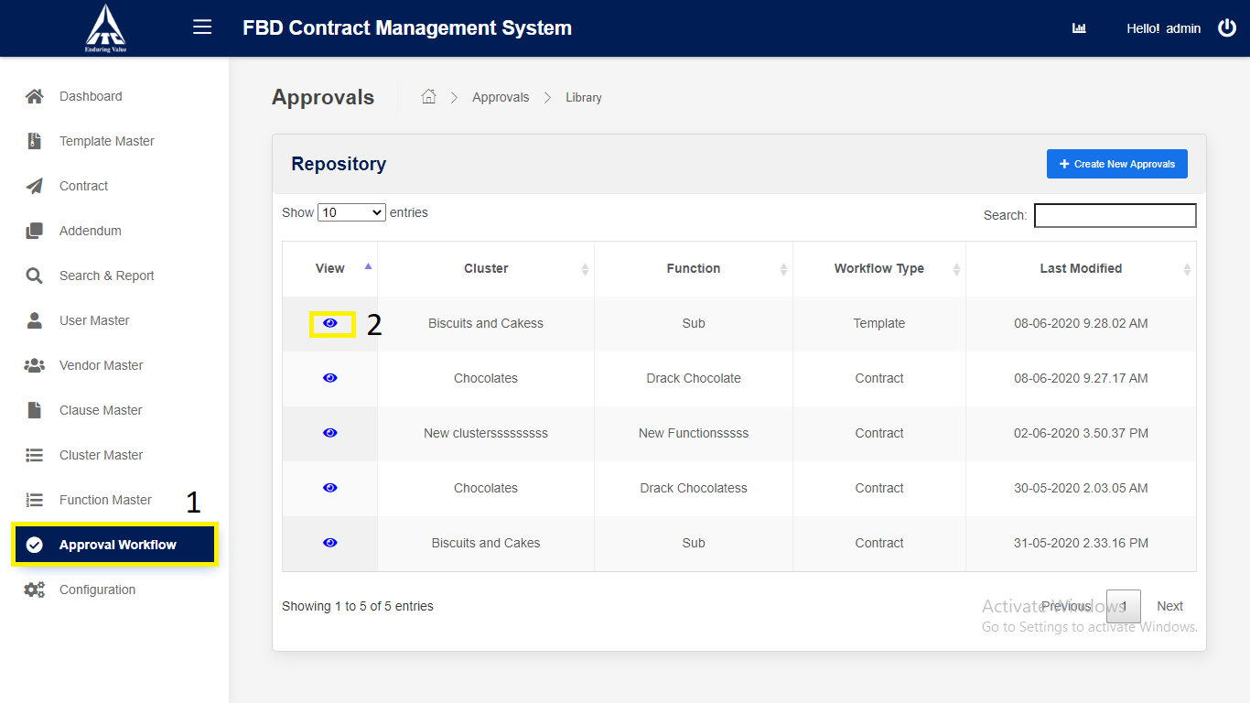

*Application will redirect to “****Approver Details****” page.*

1. Click on “**Edit**” button to **modify** the Approval Workflow.
2. **Edit** the details.
3. Click on “**Save**” button to **update** the Approval Workflow.

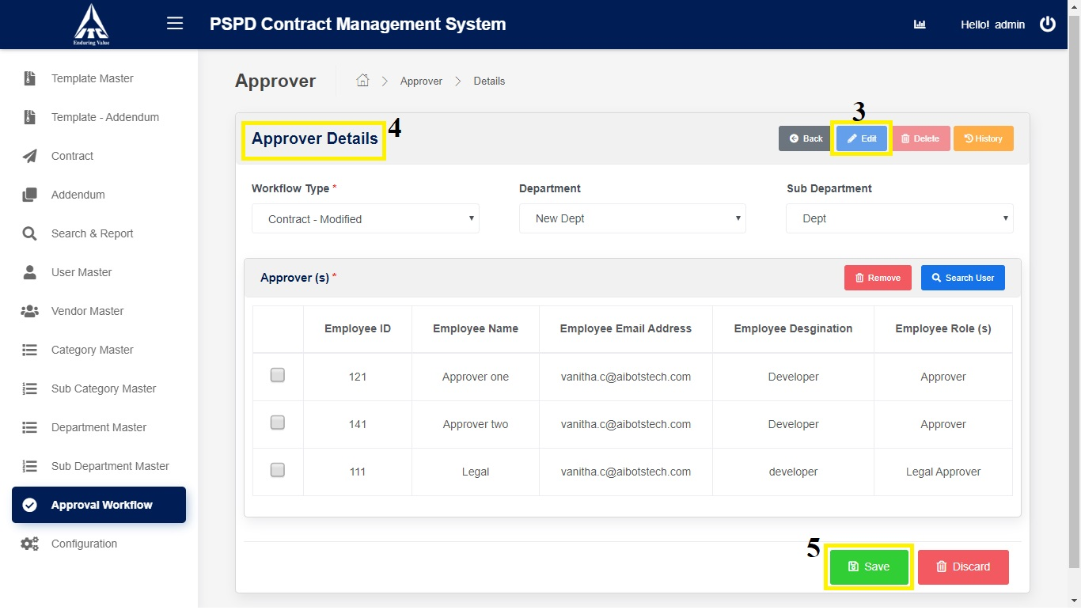

*Application will redirect to “****Approval Workflow Repository****” page.*

1. **Approval Workflow Deletion:**
2. Click on “**Approval Workflow**” in side menu.
3. Click on **View** icon to navigate to the **details** page.

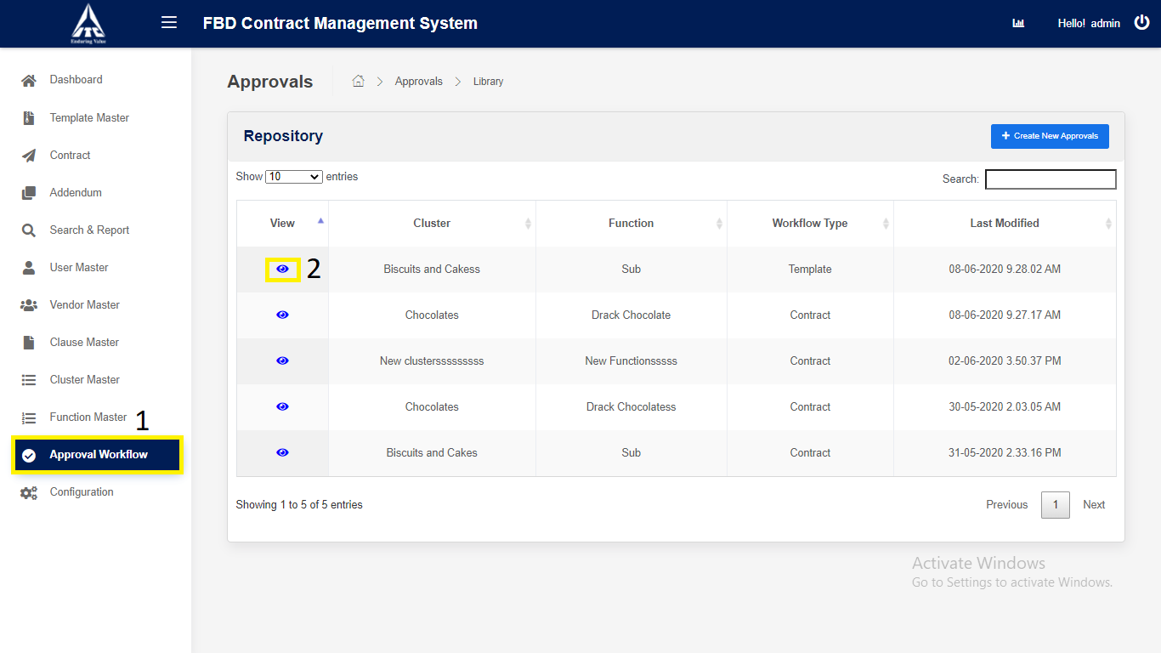

*Application will redirect to “****Approver Details****” page.*

1. Click on “**Search**”:

1. Reporting Manager **ID** (*Numbers Only*).

2. Reporting Manager **Name** (*Characters Only*).

3. Reporting Manager **Email** (*Characters Numbers and Email validation only*).

1. Click on “**Remove**”
2. Select the Checkbox and click on “**Remove**” Approval fields will

be removed.

1. Click on “**Delete**” button to **delete** the Approval Workflow.

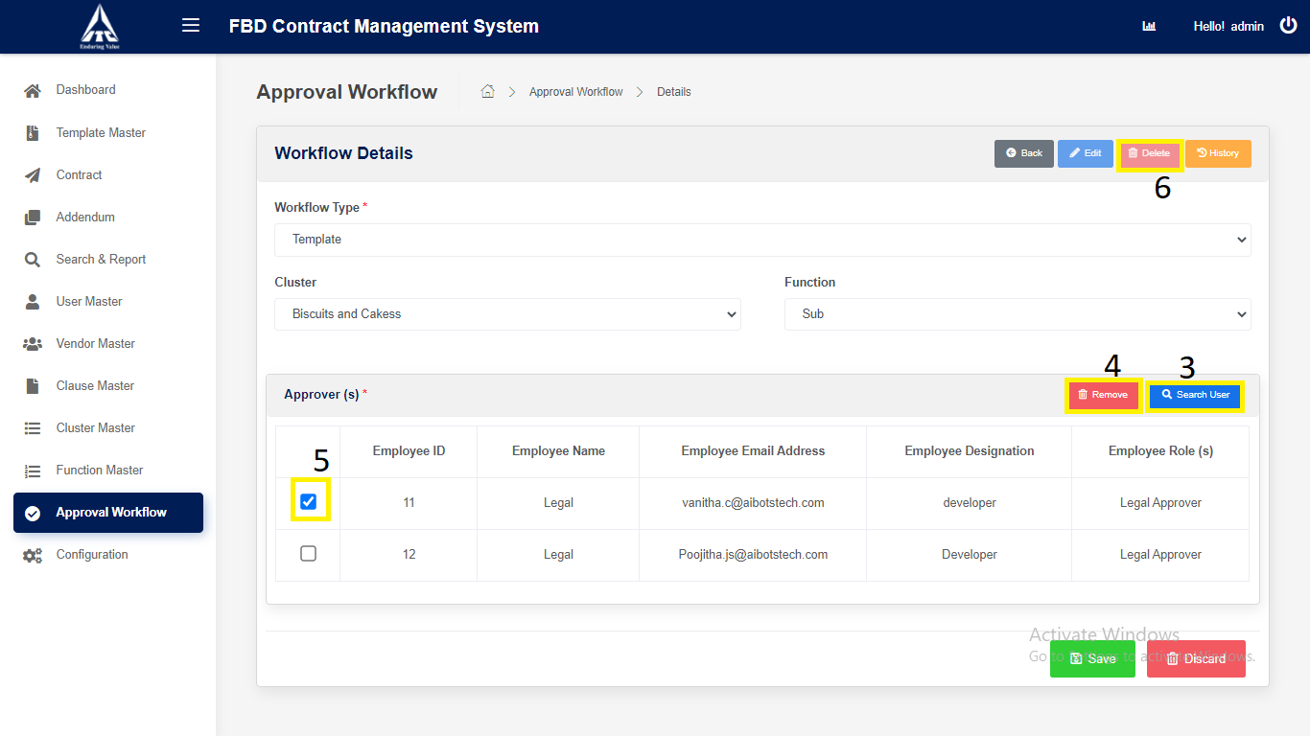

*Application will redirect to “****Approval Workflow Repository****” page.*

**Configuration**

1. Click on “**Configuration**” from Side Menu (Access to Admin Only).

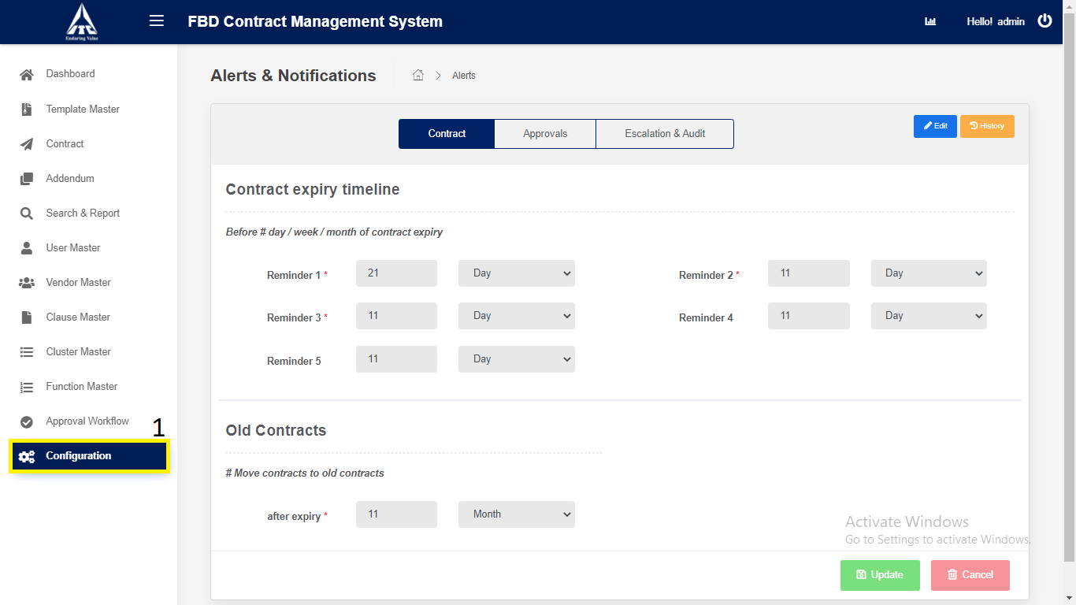

1. Click on “**Contract**” tab.

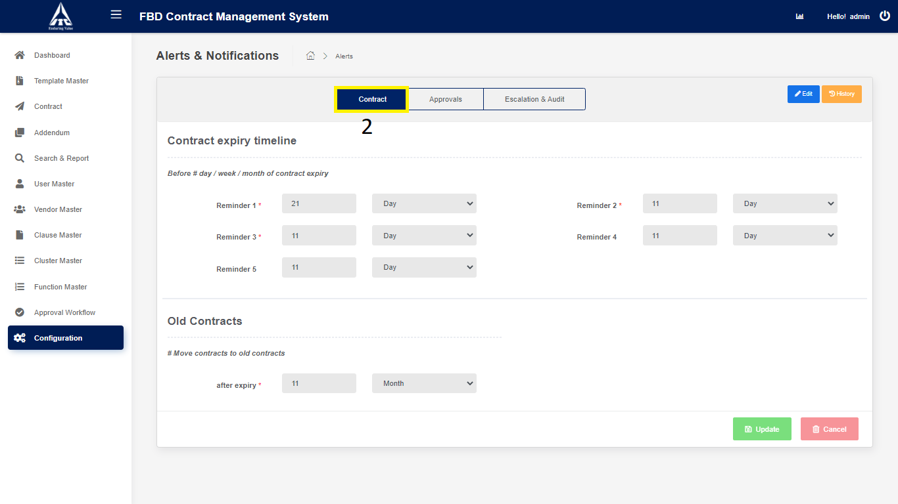

1. Click on **Edit**” button to **modify** the Contract expiry timeline & Old Contracts details.
2. Click on “**Update**” button to **update** the Contract expiry timeline & Old Contracts.
3. Click on “**Cancel**” button.

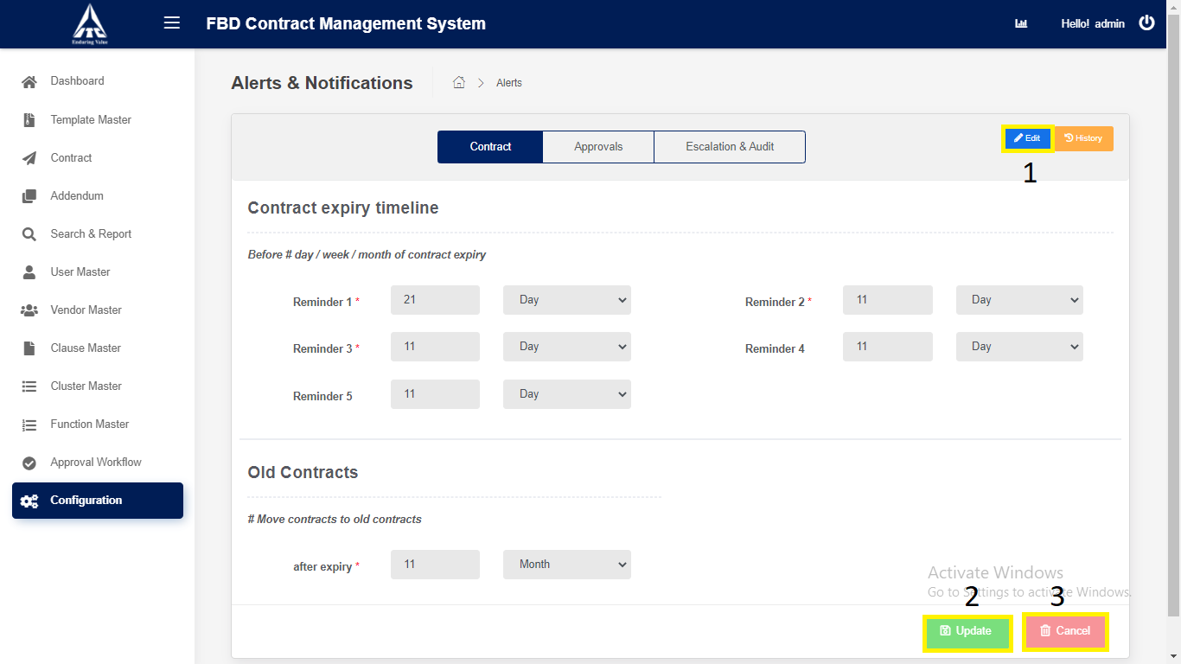

*Application will redirect to “****Configuration****” page.*

3) Click on “**Approvals**” tab.

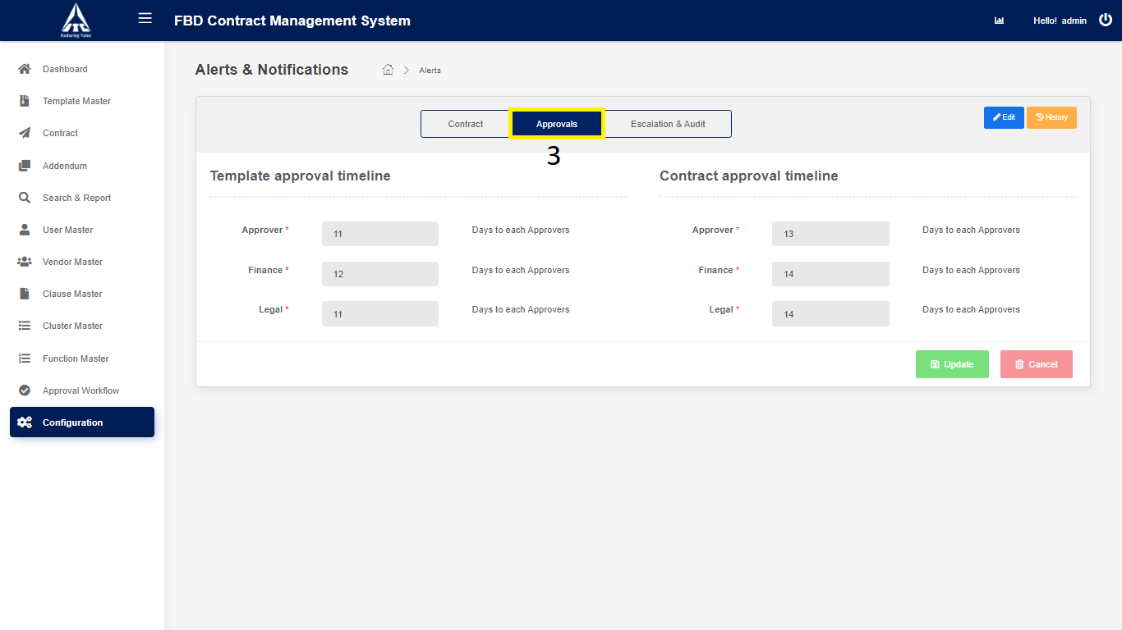

1. Click on **Edit**” button to **modify** the Template Approval timeline & Contract Approval timeline details.
2. Click on “**Update**” button to **update** Template Approval timeline & Contract Approval timeline.
3. Click on “**Cancel**” button.

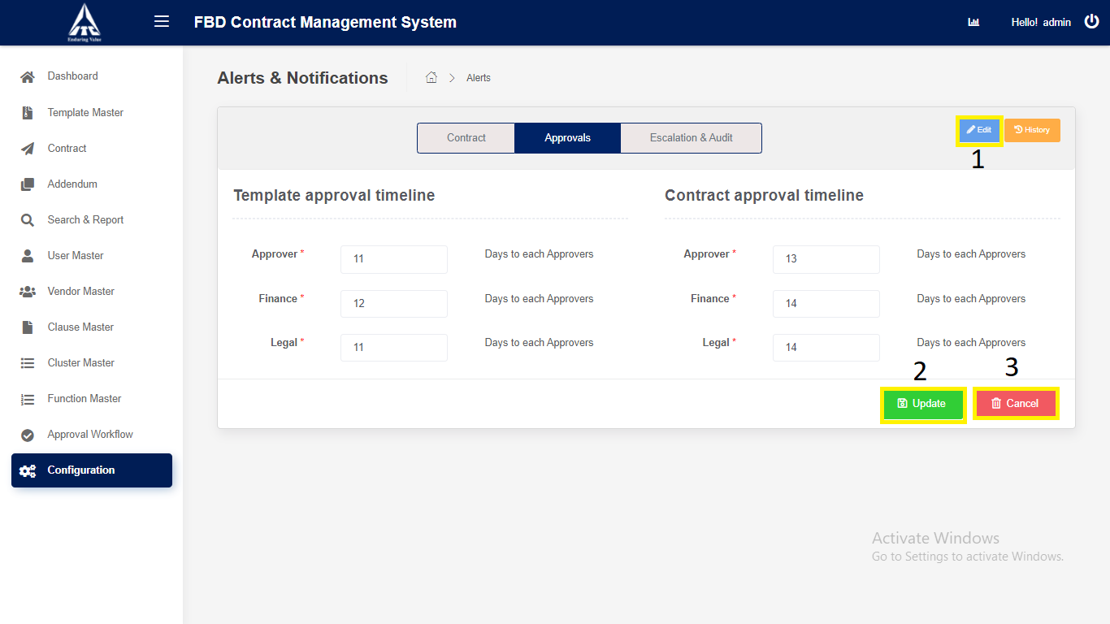

*Application will redirect to “****Configuration****” page.*

1. Click on “**Escalation & Audit**” tab.

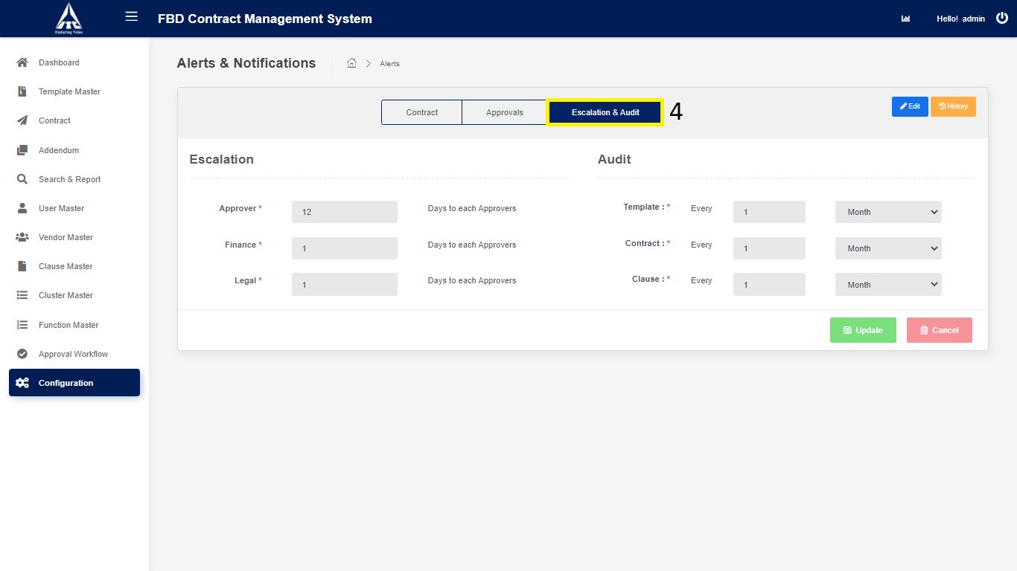

1. Click on **Edit**” button to **modify** the Escalation & Audit details.
2. Click on “**Update**” button to **update** Escalation & Audit.
3. Click on “**Cancel**” button.

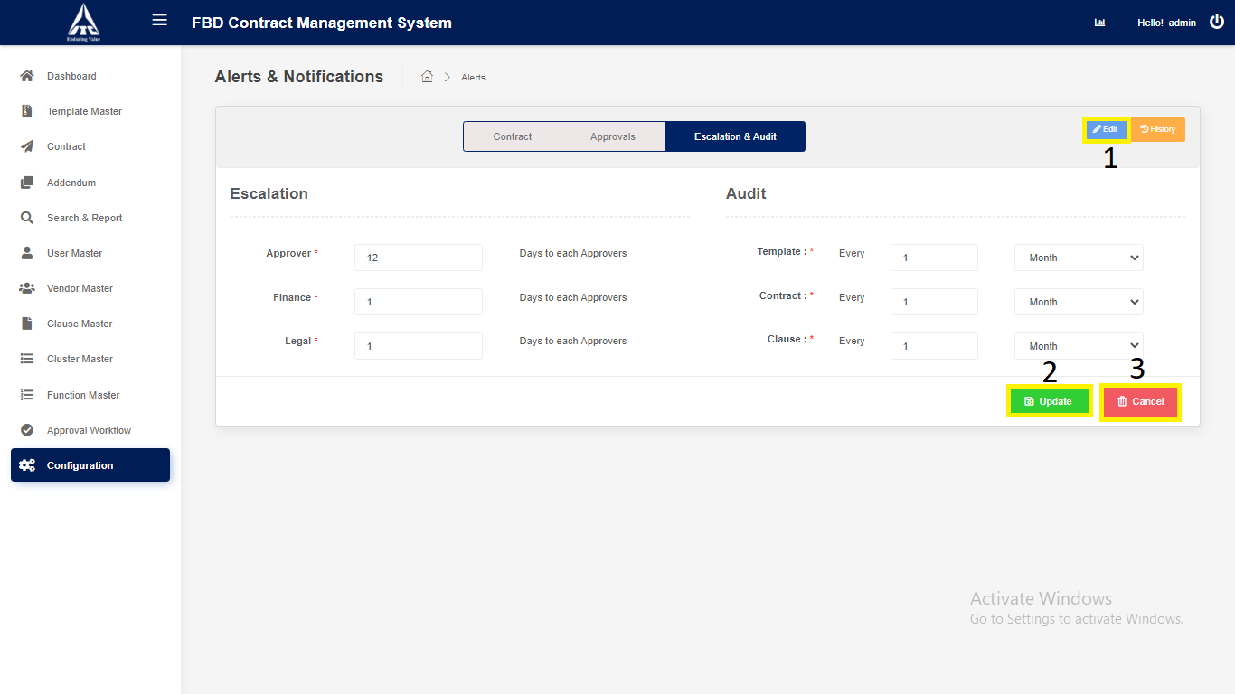

*Application will redirect to “****Configuration****” page.*